 | 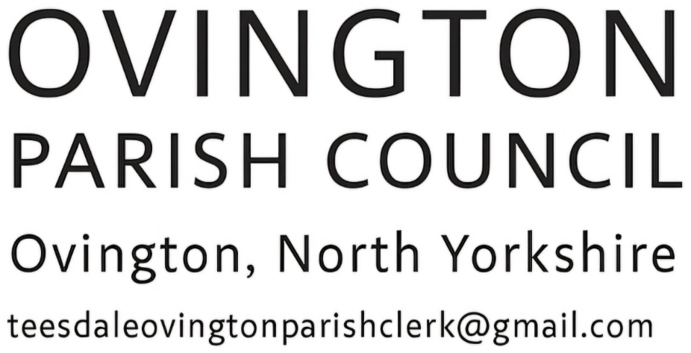

Ovington Parish Council
Annual Meeting
Tuesday 2nd June 2026
6.30pm Ovington Village Hall

Agenda
- Welcome and introductions
- Apologies
- Re-appointment of Chair and Vice Chair and Responsible Finance Officer (RFO)
- Appointment of clerk
- Consideration of interim/ temporary arrangements further to current clerk leaving
- Declaration of interests
- Chairman’s Annual Statement
- Review of standing orders and procedures
- Standing Orders for Ovington Parish Council
- Standing Financial Regulations – Practitioners Guide 2026/27
- Finance
- Budget for current financial year / AGAR return / Asset/risk register
- Community Engagement Project
  - Telephone Box update
  - Conservation Area
- A.O.B
- Date and time of next meeting.

