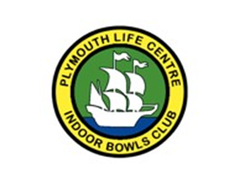
TRIPLES CHARITY TOURNAMENT
(In aid of Mission 2030– Primary Sclerosing Cholangitis support)
Sunday 8th March 2026

£18 per team of three.
We are seeking a maximum of 32 teams. Each team will play a minimum of 4 games (1 hour or 7 ends – on the bell).
The top 2 teams in each group will play off for a semi-final and then a final.
In order to maximise the monies raised for charity, we are requesting that each team kindly provide a raffle prize.
(To be donated by 1st Feb 2026)
REFRESHMENTS & RAFFLE TO BE HELD ON THE DAY
CLOSING DATE FOR ENTRIES 1ST February 2026
(entry forms on the PLCIBC website and in the bowls hall)

