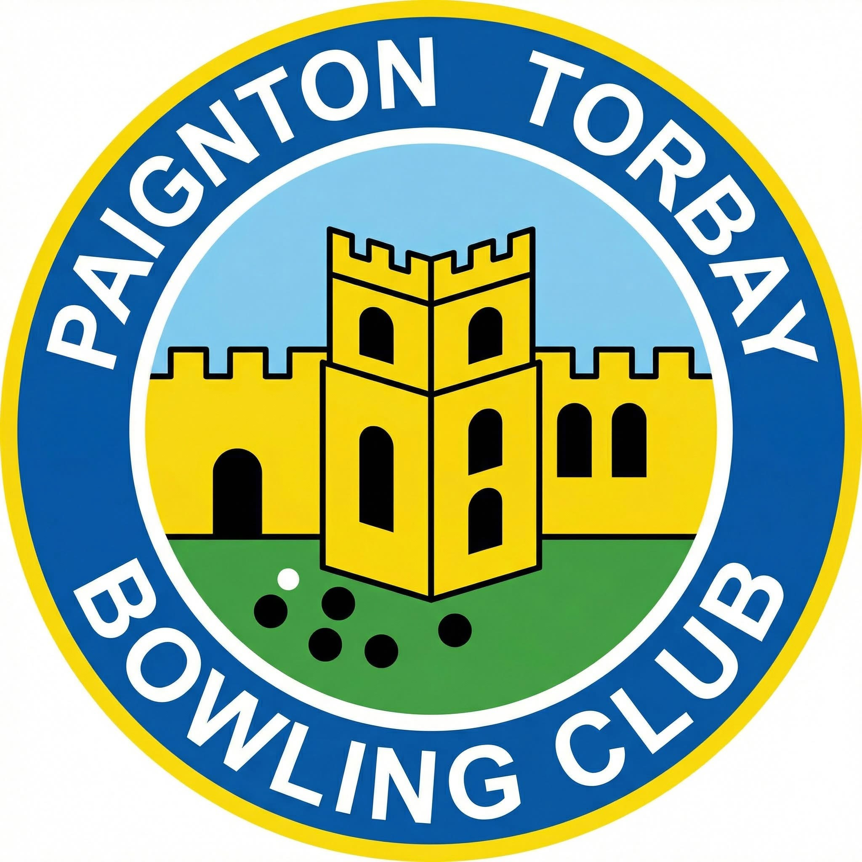


PTBC Open Day

Sunday 12th April, 2026

1.30pm to 4.30pm

Open Week
Monday 13th April
To
Sunday 19th April

10.00am to 1.00pm

We are located at
📍 Queens Park Road, Paignton.
TQ4 6AH

We are the Club with the mural on the wall.
Entrance at the top gate
or left hand side at bottom of car park.

📞 Club: 01803 557814

Bowling is a sport for all.
Paignton Torbay Bowling Club
A friendly, welcoming bowling club invite
you to join them.
So if you fancy trying something new,
come along and give bowls a try and have a game.
You will be very welcome.

