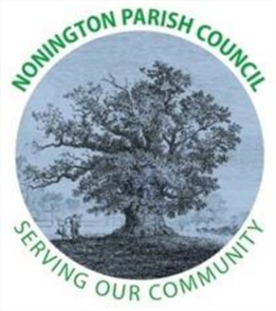

NONINGTON PARISH COUNCIL
Email: noningtonparishclerk@outlook.com Website: www.noningtonpc.org.uk

TO: ALL MEMBERS OF NONINGTON PARISH COUNCIL
Councillors are hereby summoned to attend an Ordinary Meeting of the Council to be held on
Wednesday 1st July 2026 at 19:00 in Nonington Village Hall

A G E N D A

- Chairman’s Welcome and Apologies for absence

- Declarations of Interest

- Confirmation of the Minutes of the Meeting held 3rd June 2026

- Review of Previous Action Points

- Public Forum

- Finance

- Planning

- Highways and Footpaths

- Playground, Field and Pond

- Councillor and Police Reports

- Items for discussion not on the Agenda

- Date of the next meeting: Wednesday 3rd September 2026

