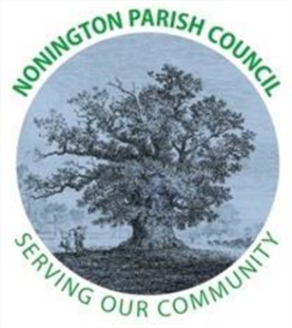

NONINGTON PARISH COUNCIL
Email: noningtonparishclerk@outlook.com Website: www.noningtonpc.org.uk

TO: ALL MEMBERS OF NONINGTON PARISH COUNCIL
Councillors are hereby summoned to attend an Ordinary Meeting of the Council to be held on
Wednesday 3rd December 2025 at 7.00pm in Nonington Village Hall

A G E N D A

- Chairman’s Welcome and Apologies for absence

- Declarations of Interest

- Confirmation of the Minutes of the Meeting held 5th November 2025

- Review of Previous Action Points

- Public Forum

- Finance

- Planning

- Highways and Footpaths

- Playground, Field and Pond

- Councillor Reports

- Items for discussion not on the Agenda

- Date of the next meeting: Wednesday 7th January 2026

