Minutes of the Meeting of Bowes Parish Council
held at Bowes School on 23rd January 2024

Present
Cllr Carlisle, Cllr Tipping, Cllr White and Mrs H Overfield.

- Apologies
Cllr Redfern and Cllr Hughes

Minutes of the Meeting
held Tuesday 12th December 2023 agreed to be a true record, approved by Cllr Tipping, seconded
by Cllr Carlisle.

- Matters arising (unless dealt with later in the agenda)
Byways order – Unfortunately Durham County Council are unable to provide landowner addresses for Sleightholme Moor Road as this would breach GDPR guidance. Regarding the point of changing the status of the route, the application to record the route on the Definitive Map was submitted by a member of the BHS, and they were able to do so due to section 53 of the Wildlife and Countryside act 1981. Legal advice determined that due to the application of them NERC ACT 2006 the highest status we could record the route was Restricted Byway, rather than as a Byway open to all traffic as in North Yorkshire.
Clerk to reply “ the Councillors asked "how the designation can be observed if we don't know who the land owner is?" as earlier correspondence suggested we write to the landowner to ask their permission to continue to use the road.

We also wondered what right the BHS has to dictate the use of public highways that have been used by local people for many years.

4. Finance & Accounts – See summary below
Receipts since last meeting £44.96 Interest £66.00 allotment rent £120 sale of 2 plots.
Expenses since last meeting £122.28 Hugo Fox website

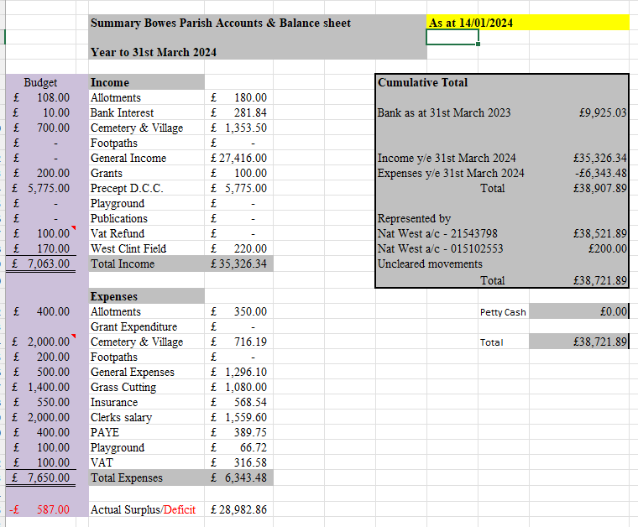

Accounts approved by Cllr Carlisle, seconded by Cllr Tipping.

5 Planning
DM/23/03496/PA – Bowes Cross Farm – Prior approval for erection of a poly tunnel. No observations

6. Correspondence
Nothing to report.

7 Cemetery & Village maintenance
The cemetery is looking good although there are lots of elderberry shoots springing up that will have to be dealt with in the spring.

8 Allotments –
The roadside wall on the left hand side of the allotments needs reviewing when the weather improves.

9 Play Park
Nothing to report.

10 Parish Paths
The gates at both ends of Bull banks don’t close properly as they have rotted near the ground.
Cllr White to consider this for the next round of grant applications.

11 AOB
Parishioners have been chased by a bull whilst walking the footpath past Swinholme. Clerk to contact the landowner and ask if they could take steps to prevent this from happening again.

Meeting closed at 20.15.
It was felt the above would have a positive effect.

