

CHARLTON PARISH COUNCIL
MINUTES OF THE MEETING HELD ON
Monday 20th October 2025 at Charlton Church Foxcotte Room at 7.00pm

Present: Cllr Ward Chairman, Cllr Woods (Vice Chairman), Cllr Curry, Cllr Mockford, Cllr Summers
In attendance: E Attwood – Clerk
1 Member of the public

- Apologies for Absence – Cllr Tasker, Cllr Wilson, Cllr Brown, Borough Councillor Lashbrook & County Councillor Donnelly

- Declarations of Interest
None

3. Minutes - Resolved: The minutes of the Parish Council meeting held on 15th September 2025 were confirmed as a correct record and signed by the Chairman of the meeting. All members agreed.

4.Public participation – A Resident commented on the following.
- Highways have cleaned the drains but can’t clear the soakaways. The member of public commented that they had written to Highways to advise them the properties are still at risk of flooding.
5.Clerk’s Report
- Tree survey awarded to Ground Lord.
- Willow tree pollard complete at Charlton Waterside
- Both fix term deposit accounts reinvested in 95-day notice business account.
- Cllr Summers training completed.
- Cllrs Brown, Mockford & Curry training booked for January.
- All Cllrs should now have access to members area of website for action tracker.
- Register of interest forms now lodged with TVBC for new Cllrs.
- Wreath ordered for Remembrance Sunday.
- All invoices now paid for newsletter advertisements.

6. County Cllr Donnelly – No report

7.Borough Cllr L Lashbrook – None

8.Community Hub update – Cllr Ward had been engaging with TVBC about an alternative proposal for a community hub. Resolved: Cllrs approved £30,000 to remain earmarked for the community hub while the current project is hold, while the possibility of a further project is being discussed.

9.Finance -
9.1The bank balance as of 30th September 2025 was as follows:
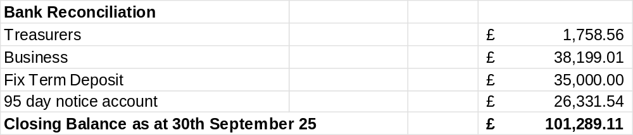
Resolved: Councillors approved the financial statement and payments for 30th September 2025.

9.2 Approval of September 2025 payments.

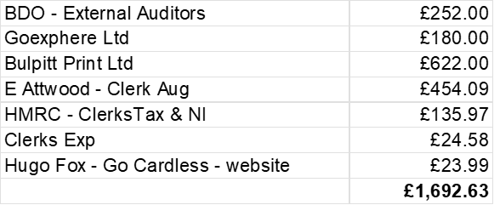

Approval of October payments to date.

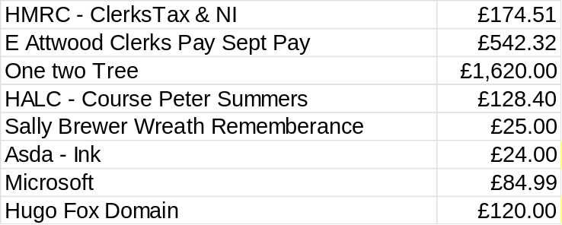

Resolved: Cllrs approved September, and October payments to date.

9.3 Community Hub Outstanding Payments
Cllr Ward reported that he had contacted Absolute Architecture and that they had not responded, so the assumption is all invoices are paid. Precept was previously raised to pay towards Community Hub. Cllr Ward suggested rewarding the litter pickers

9.4 Approval to purchase wreath for Remembrance Sunday. Resolved: Cllrs approved purchase of the wreath for the Remembrance Sunday.

9.5 Approval to purchase Christmas tree. Resolved: Cllrs approved purchase of the Annual Christmas tree

9.6 Budget 26/27
Councillors discussed the budget, and some adjustments were made to the draft. The Clerk will circulate the updated budget.

10.Planning
The Clerk reported on the following 25/02396/CPLN 2 Ethelbert Drive Charlton
Resolved: Parish Councillors have no objections to this planning application.

Resolved:
Local Plan update sees appendix A

11.Councillor Reports
11.1Traffic Liaison – Cllr Ward asked Cllrs to identify new locations for the speed indicator devices. He would like to hand over the management; it was suggested a laptop was purchased for the purpose.

11.2 Footpaths & Rights away/Lengthsman scheme- Appointing a new Lengthsman – This work should be completed within the next week. Cllr Ward is hoping to set up a make Charlton beautiful group. He reported TVBC are happy to issue litter pickers with appropriate PPE & bags.

12.3 Emergency Resilience Planning – In progress
12.4 Charlton Waterside – The tree survey will be completed soon.

12.5 Charlton Village Community Association – Cllr Ward reported that the Annual General meeting was recently held, and Officers appointed. Future events include a quiz, St Georges day and the Christmas Fayre and lights. Cllr Curry will set up an Instagram page for the CVCA.

12.6 Communication update with proposals – A domain has been purchased, and they are currently working with the person hosting the site and hope to have it up and running soon.

12.7 Action Tracker – The Clerk has set up the members area for the action tracker on the website, but it is not possible for Cllrs to edit, this can only be achieved through being held in google drive.
- Correspondence & Meetings. The following items were received.
- A member of the public requested allotments in Charlton but there is no land available.
14. Items for next months
Purchase of laptop to download speed indicator devices.
Reward Litter Picker volunteers.
External Auditor quote
Riverbank repairs
Spend remaining grant of £100 lengthsman.

- Date of next meeting: Please note new time & date. The next Council meeting will be held on Monday 17th November 2025 in the Foxcotte Room at St Thomas Church at 7pm.

Appendix A
Test Valley Association of Parish & Town Councils 27th September 2025 Local Plan
The discussion on the local plan broadly summarised the process; the housing requirement; and how the local plan fits within the context of Devolution and Local Government Reorganisation. This note is a summary of what was discussed however it does not cover all the points raised and responded to during the three workshops.
The consultation on the draft Local Plan (Reg 18) was completed on 5th September. The current timeline is to consult on the on the final draft Local Plan (Reg 19) in early summer 2026 and submit later in 2026. Once submitted to the Secretary of State (Planning Inspectorate) the timeline is under their control. We anticipate adoption in late 2027.
The Government instruction is that Planning authorities will be required to adopt new local plans within 30 months of starting the process. This will be applied to all those authorities who have not submitted a plan by 31st December 2026. If TVBC were not to submit before then we would need to start the local plan process again. This would lead to a longer period of uncertainty and lack of co-ordination.
The Council’s frustration with the Government increased housing requirement is well documented. The table below shows how the housing requirement increased from 524 dwellings/ year to 934 dwellings/ year following the Government’s publication of the new housing methodology in December 2024.
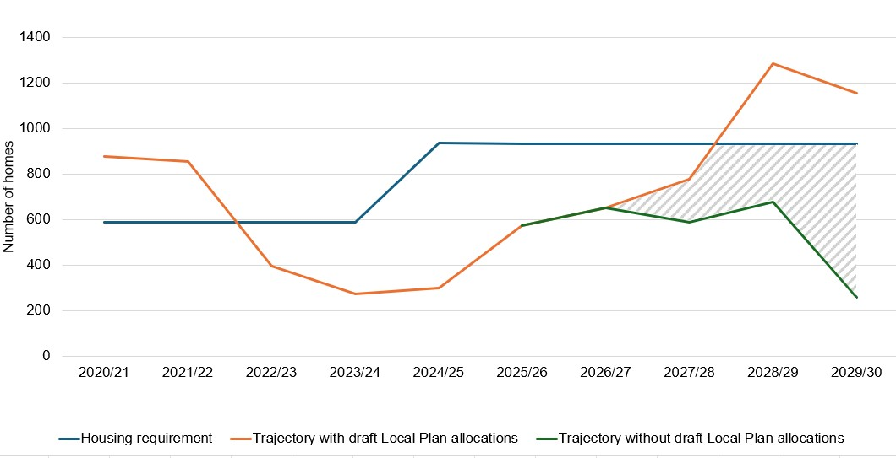
The orange and green lines show the estimated trajectory of the draft local plan with and without the proposed allocations.
As a result of the increase in housing requirement the Council’s housing land supply reduced from 6 years to 2.4 years, with no transitional arrangements.
The consequence is that significant weight is given to speculative planning applications for housing on sites which have not been identified in the local plan (adopted or draft) or in neighbourhood plans that have made allocations. The hatched area on the graph shows the reliance on the draft allocations to meet the housing requirement and where there will be a continued and increasing risk of speculative applications being permitted.
This does not mean that all residential applications would be permitted and that the local plan or neighbourhood plans do not have weight. A recent planning appeal decision at Spencers Farm, Kings Somborne is a good example where a proposal on an allocated neighbourhood plan site was dismissed because it was not consistent with the made policies of the neighbourhood plan and local plan.
The below table sets out the housing requirement and sources of supply contained in the draft local plan. The Council will keep the sources of supply under review.
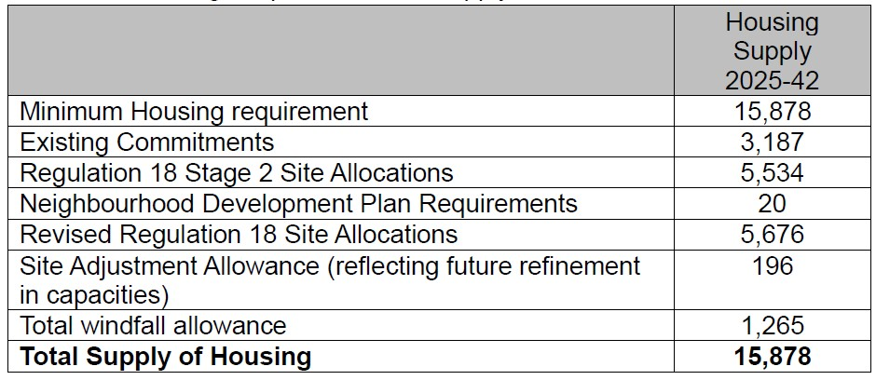
The policies in a local plan are required to look ahead over a minimum of 15 years post adoption. Inevitably the further into the future you plan the more uncertainty there is. However, the situation is more complex because of Devolution and the creation of the Mayoral Combined Authority. Mayoral elections are scheduled for 2026. They will have the responsibility to introduce Spatial Delivery Strategies which will cover strategic housing and economic growth. The situation is made even more complex because of Local Government Reorganisation is expected to come into being in 2028. This will mean the creation of new unitary councils on a different geography and considering different planning issues. Together this makes producing a local plan over the period to 2042 a challenge. However, Governments position is that Council’s should continue to produce local plans at pace.

: Land at Spencer's Farm, Stockbridge Road, King's Somborne 25th September File ref 23/03267/OUTS.

