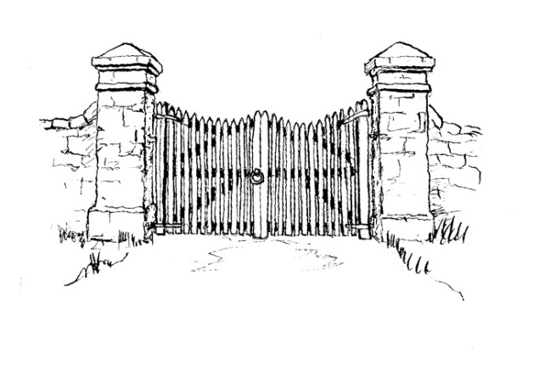
Culworth Newsletter

February & March 2026

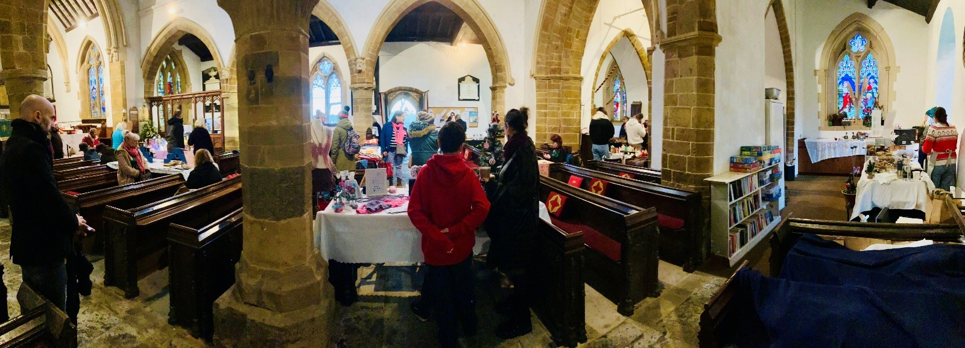
Culworth Christmas Shopping Trail – A Huge Success!
The Culworth Christmas Shopping Trail on 6th December was a fantastic day and a real celebration of our community. Over 1,000 visitors explored the village and enjoyed an impressive range of artisanal products, with lots of people commenting on the quality of what was on offer.
Distinctive elements included Martin Rowling demonstrating his craft in his forge; poet Jen Feroze writing bespoke poems; Nicole Thurgur running paper sculpture classes and Luke Bailey showing us his whittling skills. These, and the trail format, with friendly resident volunteers welcoming and guiding visitors across multiple venues across our village, made the event feel unique and truly special. Even the huge HS2 diversions, which caused extra traffic and challenges for exhibitors and visitors alike, didn’t dampen the day - and the weather even behaved better than expected!
A massive thank you to the small but dedicated planning team, the volunteers who mucked in on the day, the exhibitors who put their trust in the event, and the villagers for their patience and good humour with the extra traffic. Thanks also to the Parish Council and HS2 for their generous donations which made the event possible. Also, to the Rolt family and the McKenzies for lending space in their homes and selling refreshments which generated a significant portion of the takings. Altogether we raised over £2,000, shared between the school, the church, and putting the event on again next year.
We’re now looking ahead to December this year! I’m actively looking for more space so if you’d consider opening part of your home as a venue for refreshments or exhibitors, I would really love to hear from you. Or if you’re an artisan who sat out last year and would like to take part, please get in touch. Invitations have gone out already and spaces fill up fast, so don’t miss out.
Put it in your diary now: Sunday 6th December. Whether you fancy joining the planning team, helping with social media or signage, volunteering on the day as a guide or car park attendant, baking cakes and mince pies, or just soaking up the festive fun, this is a day not to be missed!
Ginny Staniford

Culworth Village Café
There will be a village café on Saturday 7th February from 10.30am till 12 in the Village Hall. Refreshments are free but donations are invited towards Village Hall upkeep. The following one will be on Saturday 7th March. Please come along and meet your fellow villagers. The coffee morning hosted by the Parish Council on 3 January was very well supported and a fantastic sum was raised in aid of Parkinson’s Disease Research.
Carols on The Green – Christmas Eve
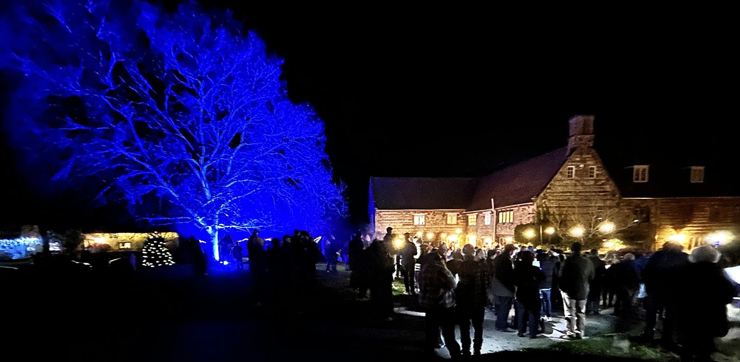The village tradition of gathering on The Green at 6pm on Christmas Eve to sing carols and partake in mulled wine and refreshments was well supported again, with an estimated 150 people joining the festive fun, superbly led by Simon Theobald, and Petrina & Simon Martin.
Annual Litter Pick – Saturday 7th March
Please meet at 10am at The Forge, where Martin Rowling will hand out Hi-Viz jackets, bin bags and litterpick sticks, as well as assigning the areas to be covered. Full bags can be left along the route for later collection. You will be amazed (and saddened) by the volume collected. If you want to undertake any clearing before or after the Saturday, please let Martin know. 01295 760571.

News from St Mary’s Culworth
The churchyard will soon be a mass of snowdrops and primroses. Please take time to enjoy their beauty. We also have a splendid library inside with hundreds of books for all tastes. Everyone is most welcome to come and borrow them for a good read during these long winter evenings. Many thanks to Christine Emmett who keeps it tidy and up-to-date.
Our church is still in an interregnum – no resident priest. We do however have a really magnificent group of retired clergy living locally who come and take the services in the benefice that require an ordained minister.
The pattern of services is as follows:
1st Sunday 10am Benefice Holy Communion– alternating churches in the benefice
6pm Evensong Culworth
2nd Sunday 11am Family Service
3rd Sunday 10am Mattins
4th Sunday 9.30am Holy Communion
5th Sunday 10am Benefice Holy Communion
During the interregnum, please contact the church wardens or the Rural Dean for any information on christenings, weddings and funerals etc. Rural Dean; Father Matthew Robinson- 01295 811364 (fathermatthew.r@icloud.com). The Vicarage, Church Avenue, Kings Sutton OX17 3RJ.
Help Needed - Our church and churchyard rely on volunteers to keep it clean and beautiful. Could you spare some time to help? A list is on the table in the church. If you could help with the cleaning and/or churchyard mowing we would be most grateful. Please fill in any times you could help or contact me (jenny_howse@hotmail.com), 01295 768110.
There are a few months when we could do with another volunteer to clean the church, which is just a matter of putting the Dyson round and a bit of dusting. The churchyard is mown every two weeks. We bought a new mower last year which is kept at the forge. Martin makes sure it is ready to use each time.
Spring Clean - Every year we have a Church Spring Clean to welcome Easter. This year the Spring Clean will take place on Tuesday 31st March between 10 and 12. If you’ve a spare hour please come and help us clean the church. Dusters and polish provided or bring your own! We will start about 10am. If you would like to help but can’t come on that Monday, or if you feel you would rather do something on your own, there is a list of jobs to do on the table inside the church. Anyone at any time is very welcome. Any more info please ring Jenny (01295 768110).
Lent Quiz Tuesday 17th February - There has been an informal quiz on Shrove Tuesday in the village hall for many years. We will continue the tradition this year. The quiz starts at 7pm and please can you bring your own nibbles and drinks to fortify the brain. Teams of 4 to 6. Entry £4 a head with the money donated to St Mary’s Church and Culworth Village Hall. Any further info call Jenny (01295 768110).
Lent Lunches - There will be only one Lent Lunch this year on Tuesday 17th March in the Village Hall from 12 till 2pm. As usual it will consist of a variety of home-made soups, homemade bread and a variety of puddings. We hope people will be generous with their donations which in the past have been sent to Send a Cow, Banbury Foodbank, Water Aid and The Red Cross. This year’s charity will be the Parkinson’s UK. Over the past number of years Parkinson’s UK have helped several people in Culworth with both practical and emotional support. They also provide funds for research into Parkinson’s.
Culworth Benefice Services:  February & March 2026  Sunday 1st February – 10am Benefice Holy Communion Chipping Warden (CP)  6pm Evensong Culworth  Sunday 8th February - 9.30am Holy Communion Chipping Warden (EC)  9.30am Morning Prayer Moreton Pinkney  11am Family Service Culworth  Sunday 15th February - 9.30am Holy Communion Moreton Pinkney (GS)  10am Mattins Culworth  Sunday 22nd February - 9.30am Holy Communion Culworth (EC)  10am Mattins Chipping Warden  11am Holy Communion Edgcote (EC)  Sunday 1st March – 10am Benefice Holy Communion Moreton Pinkney (EC)  6pm Evensong Culworth  Sunday 8th March - 9.30am Holy Communion Chipping Warden (GS)  9.30am Morning Prayer Moreton Pinkney  11am Family Service Culworth | Sunday 15th March - 9.30am Holy Communion Moreton Pinkney (CP)  10am Mattins Culworth  Sunday 22nd March - 9.30am Holy Communion Culworth (EC)  10am Mattins Chipping Warden  11am Mattins Edgcote (GS)  Sunday 29th March Palm Sunday – 10am Benefice Holy Communion Edgcote (EC)  EASTER 2026  Easter Sunday 5th April - 9.30am Holy Communion Chipping Warden (CP)  9.30am Holy Communion Moreton Pinkney (EC)  11am Holy Communion Culworth  11am Holy Communion Edgcote (CP)  Clergy Key  - E.C. – Rt Rev Ed Condry  - G.S. – Rev Greg Shaw  - P.B. – Rev Phillip Ball  - R.O. – Ven. Richard Ormston  - C.P. – Rev Celia Parkes

Village Hall Film Night
Friday 20th February. Doors open at 6.30pm - we will be showing the film 'I Swear', a biographical drama about the life of John Davidson who suffered from Tourette's syndrome. There is some bad language, but it is in context. The film has been nominated for BAFTA awards.
Tickets from Julie - 0776 973 0668 - jules.tinn@gmail.com. £15 (to include supper); £7.50 film only
Culworth Snappers

The first meeting of 2026 on 22 January covered the topic of Rust and produced an excellent and varied selection of images. The photograph on the left is from this topic, but do check out the Culworth Snappers Facebook page, where a selection of images from our latest subject is regularly updated.

January also saw 16 members and friends enjoying a post-Christmas meal at The Red Lion, where a good time was had by all.

The 26th February and 26th March topics are “After Dark” and “People at Work”, which should be great challenges for the Snappers. If you are interested in joining us or just want to come along and see what it’s all about, we generally meet at Forge Coffee at 7.30pm on the last Thursday of the month.

Dates for your Diary

Sunday 1st February – 10am Benefice Holy Communion at Chipping Warden
Sunday 1st February – 6pm Evensong at Culworth
Thursday 5th February – 7pm Parish Council Meeting, Village Hall
Saturday 7th February – Village Café 10.30am – 12noon, Village Hall
Sunday 8th February - 11am Family Service at Culworth
Tuesday 10th February – 10am – 12noon, Coffee & Chat, Village Hall
Sunday 15th February – 10am Mattins at Culworth
Tuesday 17th February – 6pm Shrove Tuesday Quiz in Village Hall
Friday 20th February – 6.30pm Film Night in Village Hall – “I Swear”
Sunday 22nd February – 9.30am Holy Communion at Culworth
Thursday 26th February – 7.30pm, Culworth Snappers at Forge Coffee – “After Dark”
Friday 27th February – Bingo Night in Village Hall – details to be confirmed

Sunday 1st March – 6pm Evensong at Culworth
Thursday 5th March – 7pm Parish Council Meeting, Village Hall
Saturday 7th March – Village Café 10.30am – 12noon, Village Hall
Saturday 7th March – 10am Annual Litter Pick from The Forge
Sunday 8th March – 11am Family Service at Culworth
Tuesday 10th March – 10am – 12noon, Coffee & Chat, Village Hall
Sunday 15th March – 10am Mattins at Culworth
Tuesday 17th March – 12 – 2pm, Lent Lunch, Village Hall
Sunday 22nd March – 9.30am Holy Communion at Culworth
Thursday 26th March – 7.30pm Culworth Snappers at Forge Coffee – “People at Work”
Sunday 29th March – Palm Sunday 10am Benefice Holy Communion at Edgcote
Tuesday 31st March – 10am – 12noon, Church Spring Clean at St Mary’s

Saturday 4th April – Village Café 10.30am – 12noon, Village Hall
Sunday 5th April – Easter Sunday 11am Holy Communion at Culworth

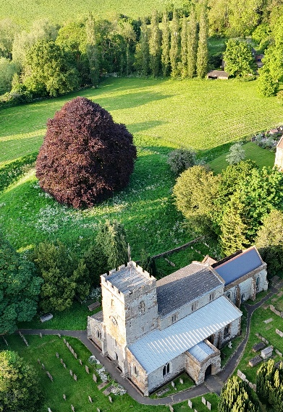
Parish Trees

Some of you may have spotted us out and about examining the trees that are under the care of the Parish Council. We have enlisted the help of Andy Coltman (Coltman Forestry) and between us we have been carrying out the latest tree safety report.

We have inspected a total of 48 trees under our care, ranging in maturity and species. Each tree is significant as part of the village and its community, and it is important to ensure the safety of every one. The starting point for this is undertaking a full inspection to identify any potential factors that could be causing harm to their health and wellbeing. Alongside managing the health of the trees, public safety is the priority.

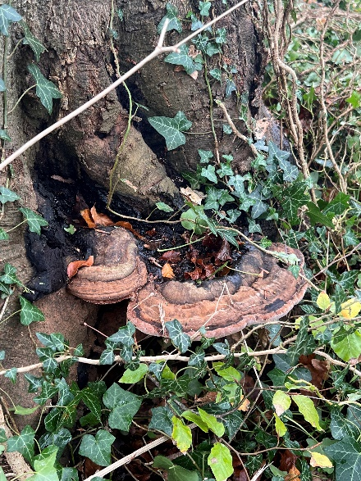
The inspections have been carried out using several methods, the main being a visual inspection. Every tree has been examined from ground level for structural integrity, height, defects, hazards, vitality and how it is interacting with the surrounding environment. Each tree has then been scored based upon its condition followed by a note of recommendation on any requirements for remedial work. Did you know that there is a British standard for all tree work? BS3998:2010 (Tree work – recommendations) and this covers tree surveys!

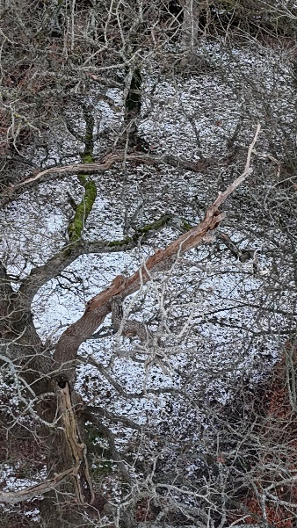
After the inspection, Andy created a report with all his findings. This then informs a 2–3 year plan of maintenance that we will work with to maintain those trees that are the responsibility of the parish council.
Figure 1 Ganoderma Australe growth on a Common Beech tree

We are in the process of updating this whole process and are inputting this data onto GIS mapping software. This is to help improve the accuracy of our work, facilitate record keeping and make it easier to plan for future works that may be required.

If you have any questions regarding the trees within the parish or would like to know more about the current tree survey, please feel free to contact me. Alternatively, you can join us at the next parish council meeting.
Figure 2 Deadwood in the canopy of a mature Oak tree, ready for removal.

Rob Stuart

Culworth Hill Field Trust (CHFT) Progress Briefing Note

Overview: Our priorities are:
- Firstly, to build a new revised Community and Recreation Facility as soon as possible, on the cricket field site, designated for that purpose, for which we have an existing planning permission.
- Second to carry out a feasibility study to convert or “reorder” our church to facilitate wider community use to enable it to viably continue its primary purpose as a place of worship.

The New Community and Recreation Facility:
- Architects have been appointed and initial plans have been prepared, based on the floor plan agreed with the Culworth Village Hall Trust (VHT) and the Culworth Cricket Club.
- Our project manager’s initial cost estimate for the new facility is £350k. We are getting quotes from two building contractors to confirm this.
- A preferred contractor will then be chosen, and their input will be taken into consideration before finalising the budget.
- An application will then be made to get an amended planning permission for the new facility.
- A planning application for residential planning permission for the existing village hall site is being prepared and will be submitted shortly.
- Once we have an amended planning permission, building costs have been firmed up, and we have a firm programme for the delivery of the new Community and Recreation Facility, the VHT will market the existing village hall site. It has an estimated net sale value of between £150k and £170k. At this stage we will approach potential funders to raise the balance of the funds.

Church Conversion “Reordering” (for wider community use):
- We have had very helpful feedback from the diocese, and in principle support from
- Bishop of Peterborough, to carry out the initial feasibility study.
- A digital survey of the church has been prepared.
- The Parochial Church Council (PCC) has appointed the church architect to prepare
- drawings and sketches for the proposed alterations to the church.
- An initial feasibility report will be presented to the Peterborough Diocese when all of
- the above work has been completed.

Briefing and Consultation: When all the above work has been completed, the plans for the two separate projects will be publicly displayed to residents to seek their feedback.

John Duggan
Chair Culworth Hill Field Trust (CHFT)


News from The Red Lion
We’re excited to begin a fresh chapter at The Red Lion as its new owners.
In taking over this much-loved village pub, our priority is simple: to preserve the heart and character of The Red Lion while gently building something that serves the whole community. We have started by opening in the evenings, and we are introducing a wider selection of beers (wines are coming up next), and next we’re slowly getting ready to serve Sunday roasts. Over the coming months, we have plans to:
- Create a welcoming atmosphere for locals and visitors alike
- Host regular community events—from quizzes and live music to seasonal celebrations
- Continue serving good food and well-kept drinks
- Develop the barn and pub into a vibrant hub for meeting, relaxing, shopping and enjoying village life
- Support local suppliers and producers, bringing the best of Northamptonshire to your table
We’ve spent our first two months listening, learning, and settling in—and we’re incredibly grateful for the warm support we’ve already received.
Our vision is simple: The Red Lion should be more than a pub—it should be a place where friendships grow, stories are shared, and the community comes together.

We look forward to welcoming you soon and getting to know you properly.
Alex & Alexandra
The Red Lion, Culworth – Your village pub, your community space.


THE RED LION – OPENING HOURS & EVENTS
Opening Hours
Monday – Thursday: 11:30 – 21:00 (Lunch and Dinner)
Friday & Saturday: 09:30 – 22:30 (Breakfast, Lunch & Dinner)
Sunday: 11:00 - 17:00 Drinks & Lunch

February Events
• Wed 4 February: Quiz Night – Test your knowledge and enjoy a fun evening!
• Sun 8 February: Six Nations Screening in the Barn – Cheer on your team in style!
• Sat 14 February: Valentine’s Day Special – Treat someone special to a cozy evening.
• Tue 17 February: Pancake Day – Sweet and savoury pancakes served all day!
👉 For full details and more upcoming events, follow us on Instagram and Facebook.
www.instagram.com/theredlionculworth
www.facebook.com/TheRedLionCulworth


West Northamptonshire Council is introducing a booking system for its Recycling Centres.

Are you ready for the new booking system being introduced at Recycling Centres across West Northants?
It launches on 3 November this year, with the aim of reducing queues and easing pressure on local roads.
You’ll be able to book a slot online, or over the phone if you prefer. Bookings can be made up to two weeks in advance or on the day at least 30 minutes before arrival.
Find out more at https://www.westnorthants.gov.uk/household-waste-recycling-centres-hwrc
If you’re planning to visit any of West Northamptonshire’s Recycling Centres on or after 3 November, you must book a slot first. The booking system opens on 20 October, allowing you to reserve a slot online. You can also book by phone if you prefer.

Neighbourhood Watch

Culworth is now part of the national Neighbourhood Watch network, giving residents the opportunity to work together to keep Culworth safe. By joining, you’ll receive regular updates on local crime, be part of a supportive community, and help deter crime through increased awareness. Neighbourhood Watch is also about looking out for one another and building stronger connections amongst neighbours. You can sign up or contact Amy Harrison (the scheme coordinator) for more information by following this link: https://www.ourwatch.org.uk/scheme/182785/culworth-neighbourhood-watch

Culworth Parish Council

The Council has a new Parish Clerk, Peter Coville, known to many of you in the village. Please support him in his new role. He can be contacted via clerk@culworthparishcouncil.gov.uk
See below for the list of responsibilities your Councillors have:
Councillor | Responsibilities
Andrew Wilby | Chair, Finance Committee, CHFT Representative
Andy Field | Vice-Chair, Finance Committee, Village Maintenance
Amy Harrison | Finance Committee, Communications, School Liaison
Jose Rowling | Finance Committee, HS2 Representative, Internal Audit
Clive Waller | Planning Committee, Hill Field & Facilities Maintenance
Rob Stuart | Planning Committee, Footpaths & Trees Maintenance
Catherine Ruffley | Community Events & Social



West Northamptonshire Council is the single unitary council responsible for providing a range of public services to residents and businesses in the areas of Daventry, Northampton and South Northamptonshire. These services include:

- collection of your household waste
- maintenance of parks and open spaces
- street cleaning
- environmental health
- planning services
WNC also delivers the ex-NCC services of Education, Highways, Adult Social Care and Libraries. Culworth is in Rural South Northamptonshire Ward, represented by Councillor Alison Eastwood. Please contact her for WNC issues on alison.eastwood@westnorthants.gov.uk or 07967867726.

Minutes of Parish Council Meetings

These are available on the Culworth Parish Council website (Hover over the link, Press CTRL & click): Culworth Parish Council

Hard copies can be obtained from the Parish Clerk on request.

Whilst the Parish Council funds the publication of the newsletter, the views expressed in it may not be those of the Parish Council. The editor reserves the right to make adjustments to text and formatting of submissions for readability.

Please send items for the next newsletter to wilbyjoanne@gmail.com
If anyone would like to take on the role of Newsletter Editor, please do get in touch with the Parish Clerk or Joanne Wilby.
Want to know what is happening in the village?
The Parish Council’s website (the Culworth Village website) as above. Or search online for:
Culworth Village News & Information Facebook
Culworth Facebook
Culworth Community Facebook
Nextdoor Culworth
Red Lion website and Facebook
Forge Coffee website

Mondays to Fridays 8:45am-4pm
Saturdays 9am-4pm
Sundays 9am-3pm

Thanks for all your support.

Available to rent for events and parties

For all our events, check our website: https://www.forgecoffee.co.uk/whats-on or follow us on Instagram (@forge_coffee) or on Facebook (https://www.facebook.com/forgecoffeeshop)

Mumfords Butchers


Serving the local community for over 90 years
Fresh meats and fruit and veg delivered to your door

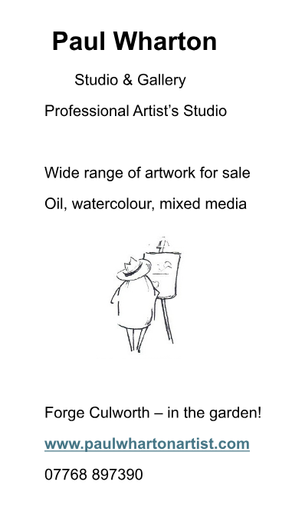




Pilates Solutions: Julie Russell
Hi everyone - I am a Culworth resident, and I am excited to be returning to Sulgrave Village Hall to teach regular Pilates Classes.
For more information you can visit my website www.pilates-solutions.co.uk
If you are interested in joining or would like to ask me any questions my mobile number is 07778 673677. Email address julierussell007@gmail.com.



Do you have a local business? Please tell us about it via the village newsletter.

