Lowther Garth formerly known as the Lowther Arms Inn, Beaumont
The choice of name for the pub was a popular one in the area, being within the Barony of Burgh, when the Lord of the Manor was the Earl of Lonsdale, a title held by the Lowther family; as can be seen by existence of the Lady Lowther Arms, now a residential property, over in Sandsfield.

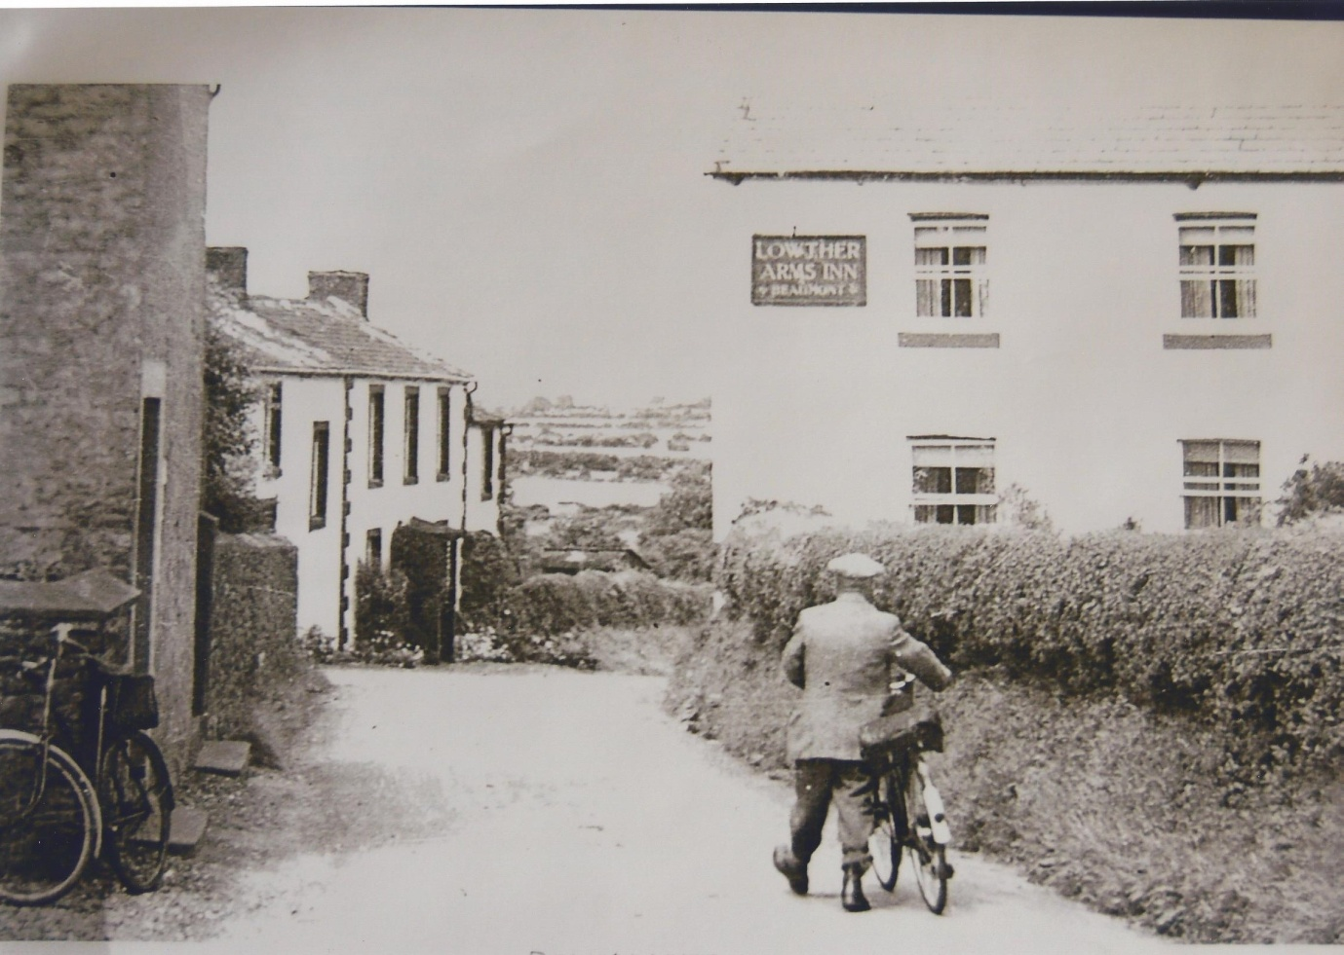

Lowther Arms Inn on the right. Photograph taken early 1900’s

It is not known at present the exact age of the original building, but it seems from various pictures to have been altered several times, the only clue to its age is the old court cupboard that is still in place in the main living room today, dated 1693. In one publication, dated 1903, it is said that the pub had to be re-built to meet the needs of the navvies constructing the Carlisle canal. The canal was started in 1819 and opened in 1823 to improve coastal facilities for craft from Liverpool, Ireland and Scottish ports already trading with the city via the Solway Firth and the River Eden. However researches can go back to records dating 1821. The Inn is thought to be Father Crackenthorp’s Inn which features in Sir Walter Scott’s novel Redgauntlet written in 1824.

The Lowther Arms Inn was said to have had seven bedrooms, four drinking rooms, a drinks cellar and stabling block for three horses. Hannah Barnes was the licensee at this time and in 1878 she was convicted of unlawful opening and was fined 5S with 1S costs. On her death in 1881, as Hannah Barnes died intestate, a new license was granted to William Harrison.

In 1882 the landlord was Thomas Percival.

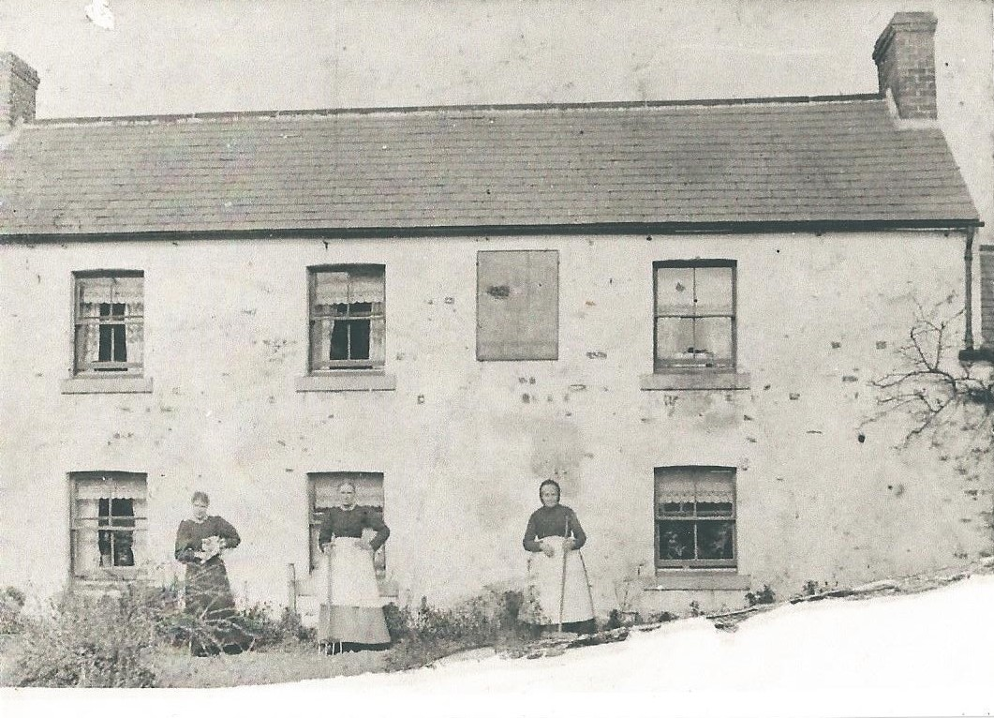
Photograph of Lowther Arms with Jane Armstrong the landlady on the right with daughter Bella and grand-daughter Jane taken about 1890.

Jane Armstrong was the most illustrious landlady of the Lowther Arms. Her husband John had been the miller at Monkhill and had become tenant of the Lowther arms on his retirement. On his death in 1892, Jane, aged 77, took over the tenancy until 1903 when she was 88 when she sold the tenancy. You could regularly see her driving to and from Burgh-by-Sands to collect coal in her vehicle which at the time was an Argyll. She was even seen behind the wheel of her car on her 100th birthday.

In 1910 the landlord was George Johnston.

With the decision to nationalise pubs on both sides of the Solway in 1916, the Central Control Board compulsory purchased the Lowther Arms but instead of closing it they kept it open and incorporated it into the Carlisle and District State Management in Scheme in 1921. In 1935 Norman and Annie Bird took over the running of the pub. It is said by customers of the Lowther Arms that as one entered the pub through the door there was no bar, just wooden benches around the room and drinks were served in ;jam jars’ that they used to get out of the court cupboard, drinks were carried through 2 or 3 at a time with the licensees fingers in the jars. It was also remembered that Mrs Bird used to serve ‘tattie pot’ every Wednesday.

In 1957 the Lowther Arms Inn was closed.

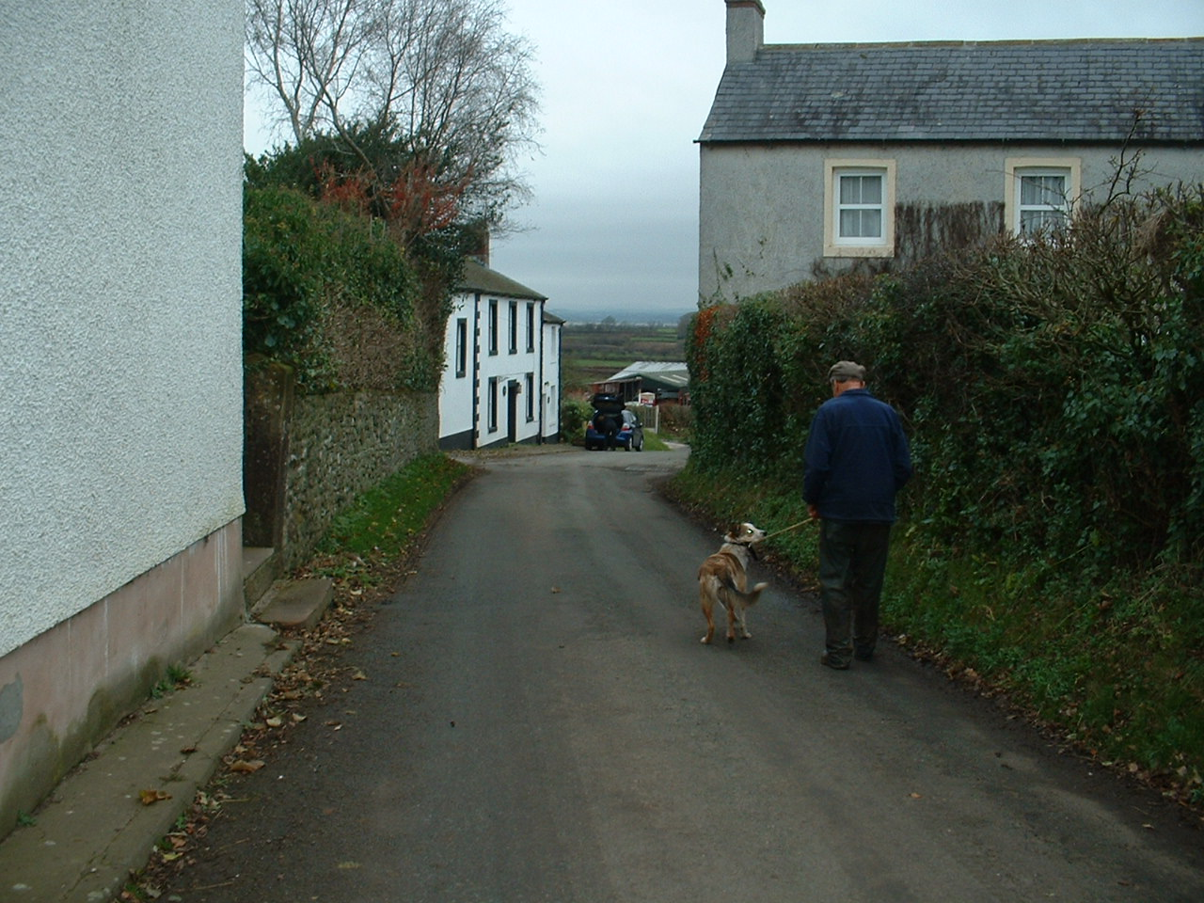

View of Lowther Garth with Beaumont resident John Baxter. Photograph taken December 2013.

