
The Parish Council of Irchester
Clerk  Nikki Daft MILCM  45 Park Road  Irthlingborough  Northants  NN9 5PW |  | Telephone 01933384180  Parishclerk123@gmail.com

Dear Councillor August 2016

You are hereby summoned to attend the Ordinary meeting of Irchester Parish Council to be held in the Village Hall, School Lane, Irchester on Wednesday 31st August 2016 at 7.15p.m.

Yours faithfully
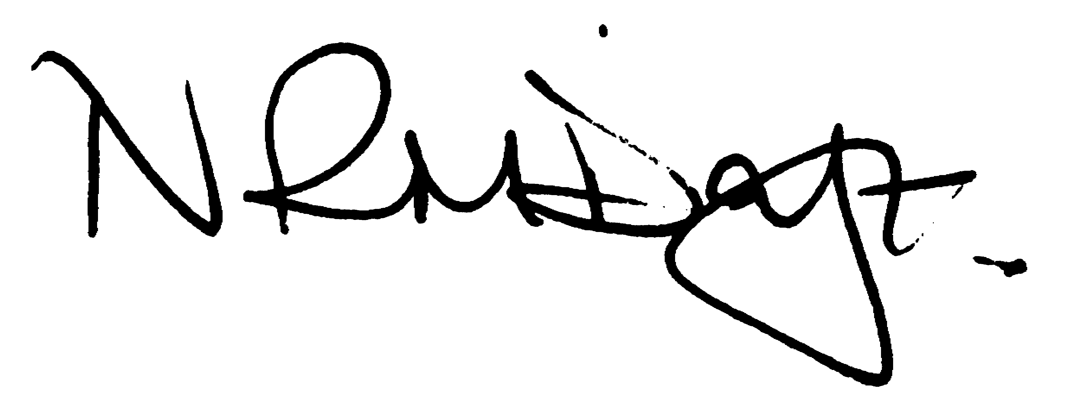

Nikki Daft – Parish Clerk

AGENDA

To receive a demonstration from Morelock regarding a mobile Vehicle Activated Sign and Data logging.

APOLOGIES AND ACCEPTANCE OF APOLOGIES

16/33 NOTIFICATION OF ANY DISCLOSABLE PECUNIARY INTERESTS OR OTHER INTERESTS
Only in respect of matters which are to be considered by members below. (Disclosures previously declared and registered need not be repeated).

16/34 PUBLIC QUESTIONS, POLICE REPORT AND NCC UPDATE

Public participation may continue until for 15 minutes after which the public must not take part at any other time during the meeting. Request should be made to the Chair if any member of the public wishes to make a recording of any part of the meeting. All audible sounds to be switched to silent unless otherwise agreed at the start of the meeting. A report only can also be given by the Police and NCC representatives

16/35 MINUTES

a) To approve the minutes of the meeting held on 29th June 2016 as true records

16/36 RESOLUTIONS AND ACTIONS - MATTERS FROM PREVIOUS MINUTES
Agenda | Task | By | Completed/comments
June | VAS demo | Clerk | Emailed
 | Box Cutting of the cemetery | Clerk | Ordered
 | Street Dr re grass verges | Clerk | Reported
 | Proludic replacement part | Clerk
 | Park Inspection rota | Clerk | Completed
 | Weeds War memorial investigate | Clerk
 | NHW Signs | Clerk
 | Letter Bowls Club | Clerk
 | Order bins/micro phone system | Clerk
 | Cut back bottom tree growth on lime trees | Lengthsman | Requested
 | Remove ivy from cemetery notice board | Lengthsman | Requested

16/37 FINANCIAL/POLICIES

- To Approve Payments for July and August 2016 (Clerk)
- To receive information regarding the current financial statement (Clerk)
- To agree the authorisation of the bacs payments
- To receive recommendation from the Finance Advisory group regarding bank account details.

16/38 RECREATION GROUNDS

- To receive and agree the reports/repairs/damage to the recreation grounds (JD)

16/39 HIGHWAYS

- To agree any items that need to be added to the next agenda

16/40 LITTLE IRCHESTER/KNUSTON

- To agree the Highway Warden report, previously circulated. Matters arising will be added to the next agenda

16/41 PLANNING

To receive an update on the recent appeal enquiry

16/42 NEIGHBOURHOOD PLAN

- To receive an update on the NHP

16/43 CEMETERY/WAR MEMORIAL

- To receive the Registrars report, previously circulated, and decide if details should be added to the next agenda

16/44 COMMUNITY

- To receive an update on the Best Village Competition
- To discuss the positioning of the defibrillator for Little Irchester

16/45 CORRESPONDENCE

To consider information received from incoming correspondence and decide on agenda items for the next meeting.

16/46 EXCUSIVE TO PUBLIC AND PRESS

16/47 APPRAISAL

To discuss the Councils Goals and Objectives for the forthcoming year and to review the Clerks Job Description in order for the Chair to carry out the annual appraisal.

