
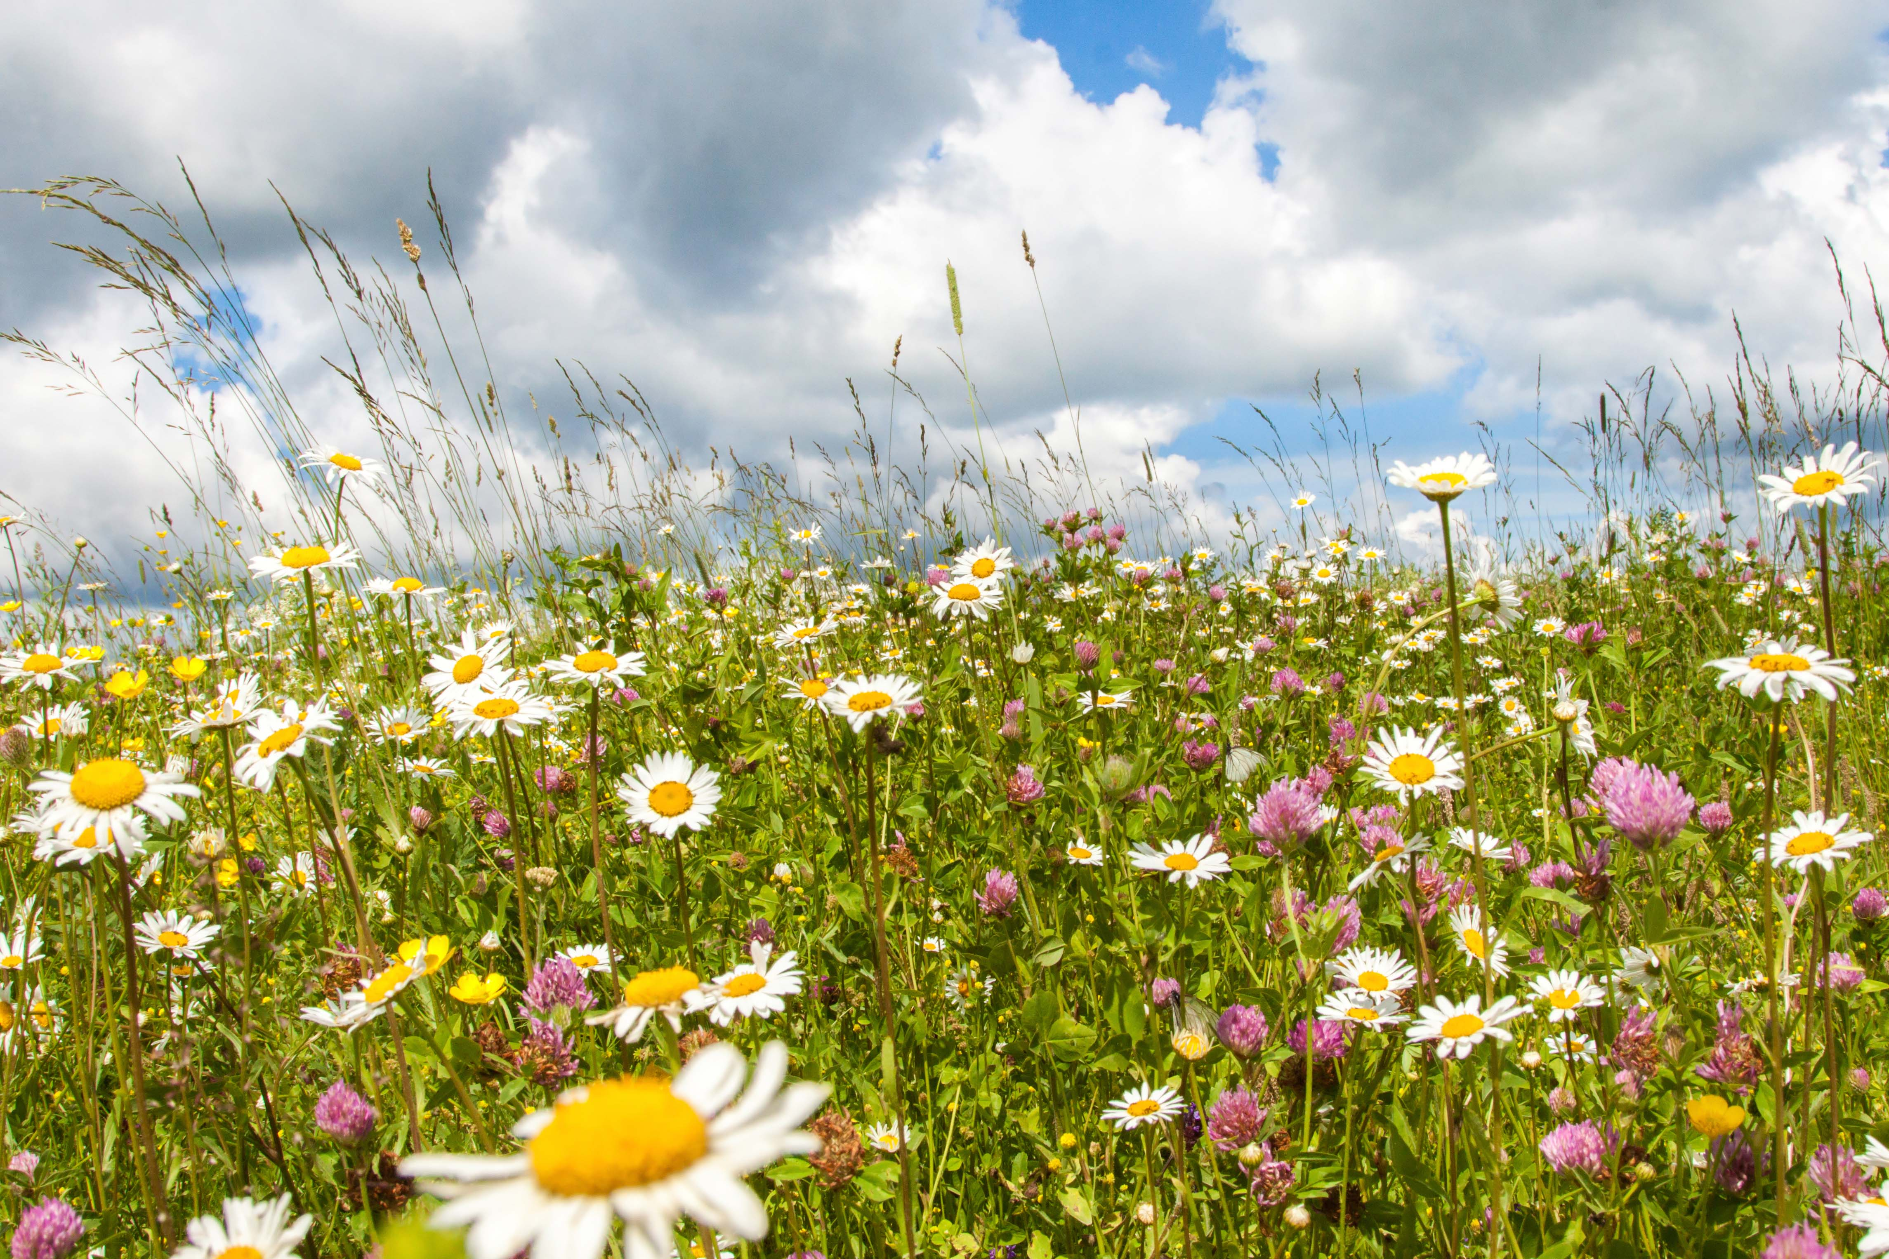
WINCHESTER CITY COUNCIL
BIODIVERSITY ACTION PLAN UPDATE JULY 2022

We have successfully created species-rich grassland habitat with wildflower species specifically selected for the Striped Lychnis moth at Chilcomb Recreation Ground.
Topfield Open Space in Kingsworthy is being managed by the Council for biodiversity and access following residents’ wishes expressed at previous consultation events. A public information update event is being held in July to keep locals informed of the Council’s work and engage with locals on future management.

The survey season has begun with botany, reptile, amphibian and butterfly surveys well underway. The centre of West Hill Cemetery is full of pyramidal orchids and palmate newts were recorded in our pond at Greenacres for the first time.
We are continuing with the second year of our pilot road verge project. These verges are looking fantastic with Oxeye daisy, bird’s-foot trefoil and red clover in full bloom. These provide a much needed refuge and bounty of nectar for our pollinators.

