PETROCKSTOWE PARISH COUNCIL
Parish Clerk: Fiona Lowe, Rose Farm, Petrockstowe, Okehampton EX20 3HQ
Phone: 01837 811749 E-mail: petroc.clerk@hotmail.com

Dear Councillors
You are duly summoned to attend the Petrockstowe Parish Council Annual General Meeting to be held at 8pm on Tuesday 17th May 2016, at Baxter Hall, Petrockstowe, to discuss the following business.

AGENDA

- Apologies of Absence. To receive any apologies

- Minutes. To consider the approval of the minutes of the Annual Parish Meeting and Parish Council Meeting of 19th April 2016, having been previously supplied.

- Election of Officers.

- Public Session.

- Financial Matters.
- Financial Report for Audit
- Clerks hours – Review

- Planning. Attached listing of planning with objections for the period 19th March to 17th May 2016.

- Councillors Reports for information.
- Recreation Ground – Cllr Kelsey
- Play Area – Cllr Jeffs
- Baxter Hall – Cllr Harris
- County / District – Cllrs Boyd / Wiseman
- Police Report – PSCO Baxter

- Matters arising from previous minutes.
- CPRE Devon ‘Our Outdoor’ Competition 2016 – Cllr Kelsey
- War Memorial – update by Clerk
- Website – update by Clerk
- Queen’s 90th Birthday Commemorative medals – Update by Clerk

- Current Business.
- Electoral Review of Torridge
- Code of Conduct – Review

- Matters Arising for Future Agendas.
Date of next Parish Council Meeting to be 19th July 2016.

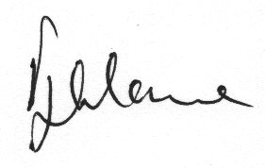

Fiona Lowe
Parish Clerk
11/05/2016

