PETROCKSTOWE PARISH COUNCIL
Parish Clerk: Fiona Lowe, Fourwinds, Fore Street, Witheridge, Tiverton EX16 8AH
Phone: 07989 638315 E-mail: petroc.clerk@hotmail.com

Dear Councillors
You are duly summoned to attend the Petrockstowe Parish Council Planning Meeting
to be held at 7.00pm on Tuesday 15th February 2022, in the kitchen at Baxter Hall, Petrockstowe, to discuss the following business.

AGENDA

- Apologies of Absence

- Declarations of interest

Planning Council is asked to discuss the below planning application/s and inform the Clerk of its comments to forward to Torridge District Council. Any planning applications received after the distribution of this agenda will also be considered.

  - Application. Ref: 1/1276/2021/FUL Date: 3rd February 2022 Proposal: Application for approval of technical details for a single dwelling and associated works following grant of permission in principle. Location: Land South Of 1 North Town, Petrockstowe, Devon.

  - Application. Ref: 1/0023/2022/FUL Date: 25th January 2022 Proposal: Erection of two no. dwellings to replace existing vegetable packing shed and Hay Barn in lieu of 1/0859/2019/AGMB Location: Hallwood Farm, Petrockstowe, Okehampton, Devon

Council is asked to receive planning application decisions made by Torridge District Council. Council is asked to note the below decision:
Decision. Ref: 1/1429/2021/FUL Date: 3rd February 2022 Proposal: Retention of oil tank Location: Aish Barton, Petrockstowe, Okehampton, Devon. GRANTED

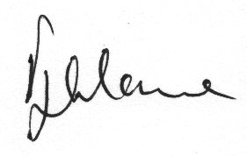

Fiona Lowe
Parish Clerk
03/02/2022

