LITTLE MARLOW PARISH COUNCIL

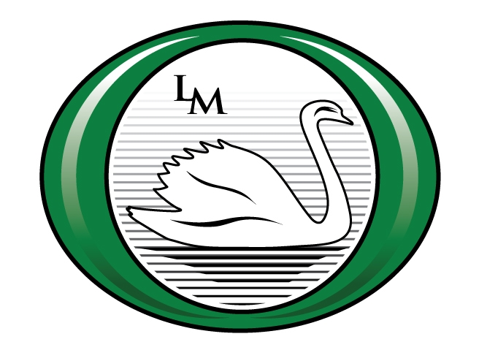

Clerk to the Council: Mrs Emma Marsden MILCM
Community Office, The Pavilion, Church Road, Little Marlow, Bucks, SL7 3RS
Telephone: 01628 890301
e-mail: clerk@littlemarlowparishcouncil.org.uk
 #littlemarlowpc

Annual Report on Devolved Services
from Little Marlow Parish Council to 31st March 2017

Little Marlow Parish Council (LMPC) undertook Devolved Services in Tranche One from Buckinghamshire County Council (BCC). There was considerable dialogue regarding the initial setting up of the Contract between Parish Councils and BCC – therefore Little Marlow Parish Council did not undertake all of the services until July 2015.

The budget provided by BCC was £1765.52 per annum to provide Devolved Services.

Little Marlow Parish Council spent the following budget provided by BCC on the following areas:

£ 510.00 Rights of Way
£ 490.00 Grass Cutting
£ 1000.00 Sign permission / removal and cleaning
£ 390.00 Slip clearance
£ 2390.00 Total Expenditure to 31st March 2017

LMPC provided the additional funds of £624.48 shortfall to provide this service. Moving forward into the 2017/2018 season we estimate that our costs will rise significantly particularly within grass cutting.

LMPC received one complaint via Twitter regarding a section of grass in a central reservation by the Marlow Fire Station. This wasn’t LMPC grass however LMPC did cut it and subsequently it was passed it back to BCC.

LMPC issued two letters to Parishioners on excessive hedges. Of which one resident required a 2nd letter sending.

LMPC issued five permits for signage on the highway.

