
CHARLTON PARISH COUNCIL
MINUTES OF THE MEETING HELD ON
Monday 20th April 2026 at Charlton Church Foxcotte Room at 8.40pm
(late starting due to runover of Annual Parish Meeting)

Present: Cllr Ward Chairman, Cllr Woods, Cllr Wilson, Cllr Rawlingson, Cllr Summers
E Attwood – Clerk
Members of Public 0

- Apologies for Absence Approved – Cllr Brown (Resigned), Cllr Curry (Resigned), Cllr Tasker, County Cllr Donnelly (attended Annual Parish Meeting
- Declarations of Interest
None
3. Minutes - Resolved: The minutes of the Parish Council meeting held on 16th March 2026 were confirmed as a correct record and signed by the Chairman of the meeting. All members agreed.
4.Public participation – None
5.Clerk’s Report -
Visit to auditors to deliver books made 10/04/2026
Clerk will collect report and books tomorrow
Two mandatory policies have been added to website, ICO scheme of publication update to correct one downloaded from ICO website
Website accessibility statement added to supplement Hugo Foxes accessibility tools, both required to achieve assertion 10 on AGAR.
No update re traffic safety yet from Cllr Donnelly
Tree inspection on T7 will be carried out in the summer when in full leaf
VAT Claim completed
End of year payroll process completed
Newsletter invoices paid up to date.
Cllr Brown & Cllr Curry have both resigned.
The contract for the Lengthsman has been signed & returned, small deduction for National Insurance for the administrator.
6. County Cllr Donnelly – Cllr Donnelly reported at Annual Council meeting he was chasing Highways for meeting & sensor wire for Hatherden Road

7.Finance -
7.1The bank balance as of 31st March 2026 was as follows:

Resolved: Councillors approved the financial statement and payments for March 2026.

7.2 Approval of the end of year accounts 1st April 2025 – 31st March 2026
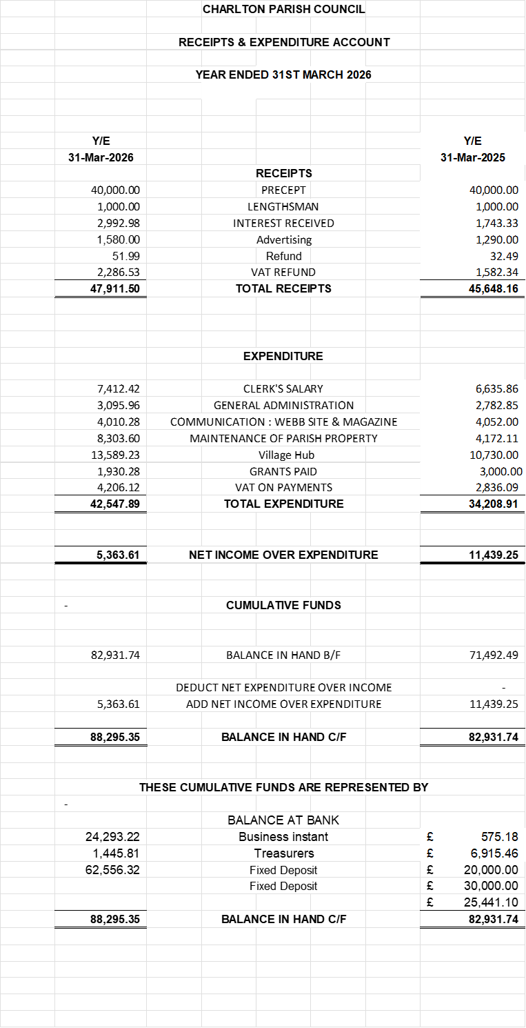

7.3 Approval of March 2026 payments.

Andover Glass works | £424.58
E Attwood Clerks Pay Feb 6th | £468.87
HMRC - Tax &NI | £142.33
E Attwood Feb Exp | £14.58
Bulpitt Print Ltd Dec Newsletter | £641.00
Bulpitt Print Ltd March Newsletter | £641.00
Go Cardless - Hugo Fox E mails | £23.98
Go Cardless - Hugo Fox Website | £23.99

Approval of April 2026 payments
HMRC TAX & NI | £142.33
E Attwood salary March | £468.69
Lightatouch- Tim Light Internal Auditor | £400.00
E Attwood Expenses March Plus Auditor travel | £64.98
HALC Subs | £680.00
Resolved: Cllrs approved March 2026 & April 2026 payments to date.

7.4 Approval of Accessibility Statement
Resolved: Parish Councillors approved the Accessibility Statement
7.5 Approval of Scheme of Publication
Resolved: Parish Councillors approved the Scheme of Publication

8.Planning – 26/00769/FULLN Tillers Patch 41Foxcotte Road
Demolition of existing garage and erection of new garage and workshop building and associated external works with new entrance gates and boundary wall with revised access to Highway
Resolved: The planning advisory group will formulate an answer. Post meeting
Parish Councillors have no objection to this planning application.

9.Date of next meeting: Please note new time & date. The Annual Council Meeting will be held on Monday 11th May 2026 in the Foxcotte Room at St Thomas Church at 7pm.

