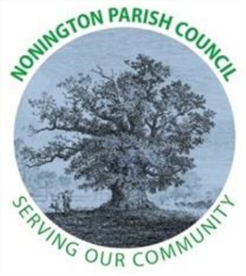

NONINGTON PARISH COUNCIL
Email: noningtonparishclerk@outlook.com Website: www.noningtonpc.org.uk

TO: ALL MEMBERS OF NONINGTON PARISH COUNCIL
Councillors are hereby summoned to attend an Ordinary Meeting of the Council to be held on
Wednesday 2nd July 2025 at 7.00pm in Nonington Village Hall

A G E N D A

- Chairman’s Welcome and Apologies for absence

- Declarations of Interest

- Confirmation of the Minutes of the AGM Meeting held 4th June 2025

- Review of Previous Action Points

- Salt Bins
- School issues – cigarettes/parking
- Hedging
- Buses
- Signs in Grass – Pinners Hill
- Trees down – Butchers lane; leafy lane
- Vacancies on Parish Council (1) – New Councillor

- Public Forum

- Finance
Balance as of 27th June 2025
Current Account: £11717.00 (opening) £10,923.73 (27/06/2025)
Savings Account: £18,324.77

Payments 01/06/25 27/06/2025 (£793.27)
Hugo Fox £11.99 (website)
Envisage £296.40 (Grass/Hedge Maintenance)
Elgars £5.00 (Playground Rent)
Med UK £479.88 (defib batteries)

- Planning

- Highways and Footpaths

- Playground, Field and Pond
- H&S assessment by PC
- Rospa – scheduled July inspection (date tbc)

- Items for discussion not on the Agenda

- Date of the next meeting: Wednesday 3rd September 2025

