
BRIZE NORTON PARISH COUNCIL
Clerk to the Council: Mrs Jo Webb
18 Chichester Place, Brize Norton, OX18 3PD
Telephone: 07899 938938
E-mail: clerk@brizenortonparishcouncil.co.uk 25th February 2025

To the Members of Brize Norton Parish Council

You are hereby summoned to attend the next meeting of Brize Norton Parish Council to be held at Brize Norton Pavilion on Monday 3rd March 2025 at 7.00pm.

Members of the public may make representations to the Council which will be covered under Point 4 – Public Participation. The meeting will adjourn for this item. Members of the public may speak for a maximum of three minutes each during the period of public participation, in line with Standing Orders. Matters raised shall relate to the items on this agenda. Members of the public may ask questions to the Council, but may not receive a decision until the matter has been debated and a decision taken. Please seek out the Parish Clerk to register before the start of the meeting if you wish to speak so the Chairman can welcome you.

Yours sincerely

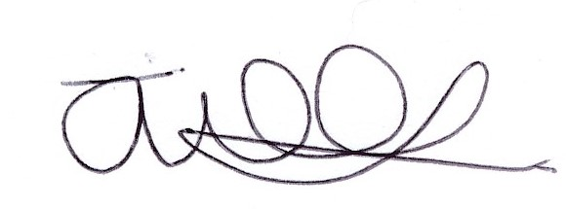

Jo Webb
Clerk to Brize Norton Parish Council

Agenda

- Apologies.
- Declarations of interest: Councillors are asked to declare an interest regarding items on the agenda this evening.
3) Minutes: To approve the Minutes of the last meeting of the Council on Monday 3rd February 2025.
4) Public Participation: Please see information above.
5) District and County Councillors’ reports for information only.
6) Councillor reports:
6.1 Cllr Goble - Chairman’s Report
6.2 Cllr Goble - Brize Meadow detailed plan sub committee
6.3 Cllr State - Highways committee
6.4 Cllr Goble - Neighbourhood Plan Steering Group
6.5 Clerk – AGAR for year ended 31 March 2024 – External auditor report
7) Discussion and Decisions:
7.1 Churchyard grass cutting
7.2 Review and appoint Internal Auditor
7.3 End of year audit training for Clerk
7.4 Brize Breeze
7.5 .gov and accessible website
7.6 Asset Register
7.7 Community benefit related to proposed solar farm
7.8 Memorial engraving
7.9 Service/repair of hedge cutter
7.10 Minster Lovell Cricket Club – Schedule of charges for 2025
8) Progress Reports:
8.1 Cllr Woodward - Buildings maintenance
8.2 Cllr Way - Village maintenance
8.3 Cllr Way & Cllr Fothergill - Play Parks
8.4 Cllr Woodward – Elder Bank Hall extension
8.5 Clerk – Allotment pest control
8.6 All Cllrs - Outstanding actions list
9) Planning: Review of new planning applications and progress on outstanding applications (on attached
Appendix)
10) Finance:
10.1 To consider payments to be made (on attached appendix).
10.2 To examine the bank accounts (income and expenditures).
11) Other correspondence to note (Clerk to alert Councillors to any specific concerns).
12) Date of next meeting – Monday 7th April 2025.

AGENDA ITEM 9
NEW PLANNING APPLICATIONS:

25/00330/LBC  25/00329/HHD  24/03278/FUL  25/00270/HHD |  | Mr Peter Granville  Yew Tree Cottage  60 Station Road  Brize Norton  Mr Peter Granville  Yew Tree Cottage  60 Station Road  Brize Norton  Witney Solar Limited  Land (E) 431186 (N) 208772  Witney Road  Brize Norton  Mr & Mrs Steve Johnson  Karimar  Burford Road  Brize Norton | Internal and external alterations to erect two single-storey extensions along with enlarging an existing window opening to create a new external doorway. Internal alterations to include reconfiguration of the second staircase  Registered: 17th February 2025  Respond: 13th March 2025  Erection of two single-storey extensions along with enlargement of an existing window opening to create a new external doorway  Registered: 17th February 2025  Respond: 13th March 2025  Construction and operation of a ground-mounded solar farm with battery energy storage system (BESS) and associated infrastructure, access, ancillary works and landscaping  Registered: 30th January 2025  Respond: 3rd March 2025  Erection of single storey front extension  Registered: 3rd February 2025  Respond: 27th February 2025

PENDING PLANNING DECISIONS:

24/03147/FUL  24/01809/FUL  R3.0075/24  24/00023/APPEAL  APP/D3125/W/  24/3344330  23/01738/POB28  24/02837/FUL |  | Foxbury Farm  Burford Road  Brize Norton  Crocodiles of the World  Burford Road  Brize Norton  Oxfordshire County Council  Vacant site located to the south of Brize Meadow Lodge Care Home and to the east of and accessed from Monahan Way, Carterton  Messrs McShane, Thomas, Yule and Harris  Land Parcel to North East of Carterton Football Club  Swinbrook Road  Land East of Monahan Way  Carterton  Mr Aniket Chhipa  Plot 4  Viscount Industrial Estate  Station Road  Brize Norton | Erection of a replacement water storage pump house and GRP housing unit for new electrical transformer  Registered: 6th January 2025  Respond: 29th January 2025  Awaiting Decision  Construction of new crocodile house and creation of 47 additional parking spaces  Registered: 29th August 2024  Respond: 20th September 2024  Under Consideration  Development of the site to provide a two-storey community safety centre and smoke house training facility, with associated access, parking, training yard and landscaping.  Registered: 24th July 2024  Respond: 14th August 2024  Development of 5 age restricted dwellings with re-sited access conveyance of part of site as nature recovery network land (outline application with all matters reserved)  Appeal start date: 2nd July 2024  Respond: 6th August 2024  Appeal in progress  Proposal to vary obligations contained schedules 6,7 and 10 of the extant S106 Agreement for our East Carterton (Brize Meadow) development (in association with application 14/0091/P/OP.  Registered: 23rd June 2023  Respond: 20th July 2023  Under Consideration  Erection of four industrial units and associated works  Registered: 5th December 2024  Respond: 14th January 2025  Under Consideration

DECIDED PLANNING DECISIONS:

24/02869/HHD |  | Mr Mircea Onciul  19 Britius Road  Brize Norton | Erection of a canopy  Registered: 8th January 2025  Respond: 31st January 2025  Approved: 21st February 2025

AGENDA ITEM 10.1
ORDERS FOR PAYMENT:

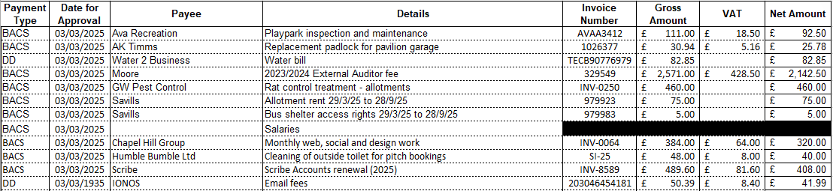

PAYMENTS RECEIVED:

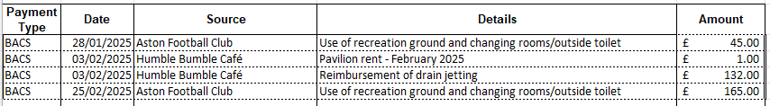

AGENDA ITEM 10.2
Reconciliation to Bank Account:

