Wiltshire Councillor Gerry Murray Parish council May report
- General waste strategy
- Shaftesbury HRC negotiations
- Fly tipping
- Road maintenance
- Community Lottery
- Variety barn

Wiltshire Council is preparing for new waste regulations being introduced by central government in 2027. Public engagement, which is not a formal consultation, has now been running for several weeks and has received over 6,000 responses. If you are a Tistalk listener I have done an extensive interview on this in the latest issue. If you’re not yet a Tistalk listener I recommend it.
Kerbside collections:
At present, households receive a total of 78 kerbside waste and recycling collections each year: 26 blue bin recycling collections, 26 grey bin residual waste collections, and 26 black box glass collections. Garden waste is collected as an optional paid service, providing 26 collections per year for residents who are unable to compost at home.
From 2027, weekly food waste collections will be introduced, along with an expansion of recycling to include soft plastics. The garden waste service will remain optional and chargeable. As a result, households will receive a total of 122 collections per year: 26 blue bin recycling collections, 52 food waste collections, 26 black box glass collections, and 18 grey bin residual waste collections.
The intention is to significantly reduce the amount of waste placed in grey bins to reduce land fill and incineration and to increase Wiltshire’s overall recycling rate to 60%. This will be supported by a sustained public education programme. A recent trial in Chippenham showed that more than 50% of material in grey bins could have been recycled or placed in food waste bins under the new system, demonstrating the scale of potential improvement.
HRCs
- HRC booking systems in Wiltshire and Dorset
The Wiltshire Council booking system (free to Wiltshire residents) pilot for the household recycling centres will launch on the council website on the 8th September and will be operational on the six sites that have been identified on the 14th September. This includes Salisbury but not Warminster. As you will know the Dorset Council recycling booking system has now been in operation for several weeks.
At the cabinet meeting on 29th April the Cabinet member for Environment Paul Sample reported that negotiations with Dorset on use of the Shaftesbury HRC by Wiltshire residents had stalled as Dorset had asked for an annual payment of £200,000. At current charging rates that would pay for 23,529 visits!! This is obviously completely unrealistic. After the meeting I intervened with the Cabinet member and suggested a new approach to Dorset based on block buying 500 visits at a time in advance and comparing with data on use by Wiltshire residenthey are currently gathering from their new booking system . He promised to discuss this with the Director for waste services and come back to me on this within 3 weeks. Further I now have a commitment from Ian Thorne the leader of Wiltshire Council to intervene on this matter if it is not resolved in the near future. He was good enough to confirm this in public at the cabinet meeting.

Fly tipping
Wiltshire Council Council has a well-established, approach, to tackling illegal waste activity through our “We’re Targeting Fly-tippers” (WTF) and “Stop at Source” (SAS) campaigns, which have been running successfully since 2022.In the Graphic below the Council’s performance is compared against neighbouring authorities and as you can see Wiltshire is top of the league in responding to Fly tipping incidents.

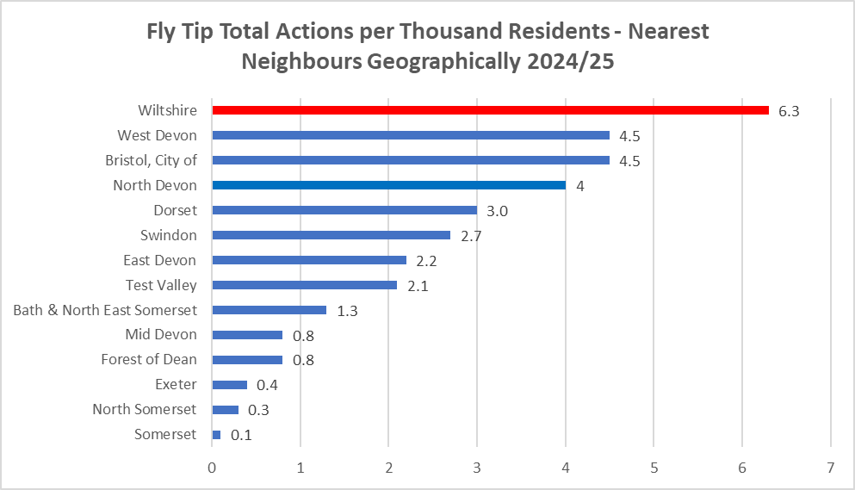

Road maintenance
The DRAFT road maintenance schedule for 26/27 has just been published for consultation with members of the Council . I have raised concerns about our representation on the list. In particular
- Hazeldon Lane West Tisbury:

- Road between Billhay Bridge and the Pyt House Tennis Club:

- The Avenue Tisbury

- Court Street Tisbury

These are candidates for complete resurfacing not pothole patching.

The consultation is open for another week please forward any other candidates to me. Once again this is not for pothole patching but complete resurfacing

Community Lottery
Wiltshire Community Lottery is a new initiative from Wiltshire Council. on schedule for the first draw to be in beginning of June.
For funds raised from Wiltshire participants, the allocation per £1 ticket is approximately:
- 50p to local good causes, supporting Wiltshire-based organisations.
- 10p to a central fund for Wiltshire Council.
- 18.2p for running costs, including banking, marketing, and general lottery administration.
- 18.2p to the prize pot, ensuring attractive prizes for players.
- 3.6p VAT, which will be reclaimable by the Council.

Details available at www.wiltshirecommunitylottery.co.uk
Planning Application Variety Barn PL/2025/01804 (Tisbury and West Tisbury )
Excellent co-ordinated effort by Tisbury PC and neighbours on Hinden Lane resulted in refusal by Southern Area Planning committee of this rather rogue application in the Cranbourne Chase National Landscape . The vote was unanimous for refusal which I’ve never seen before. The planning significance was:
1 The proposal would fail to conserve or enhance the character and scenic beauty of the Cranborne Chase and West Wiltshire Downs National Landscape, and would harm its special qualities, including its status as an International Dark Sky Reserve, through the increased visual prominence and the light spill potential. (a bit of a first)
- No evidence that the applicant could comply or organise compliance by others with the Highway Safety condition (a rather complicated Grampian condition )
Decision likely to be contested at appeal. Very much worth studying for those that are concerned about the AONB National Landscape

