A newsletter from the Borough Councillors for the Test Valley Borough Ward of Mid-Test Councillors Alison Johnston, Ian Jeffrey, and Stewart MacDonald

New Mayor for Test Valley

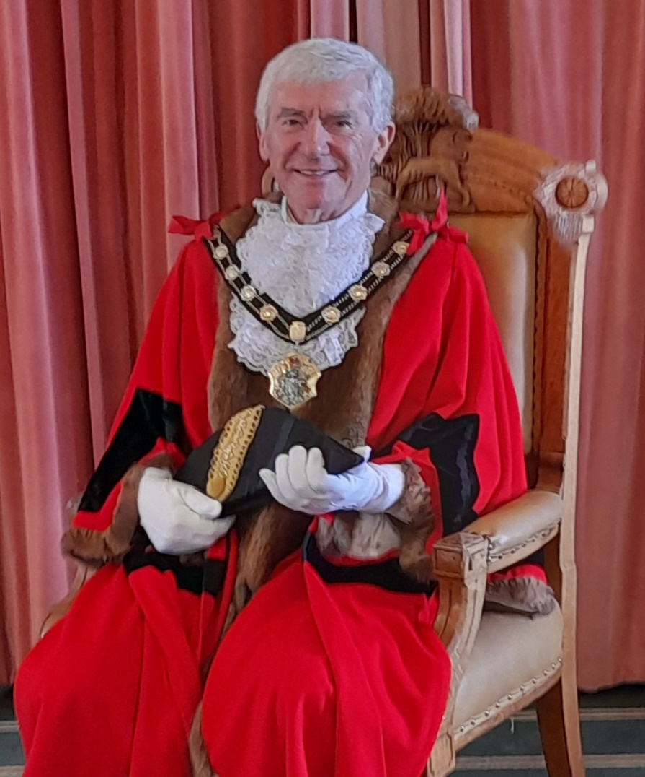

Following Test Valley’s Annual Full Council meeting on Wednesday 22 May, Councillor Ian Jeffrey was elected as the new Mayor for Test Valley.

Councillor Jeffrey, who represents Mid Test Ward on Test Valley Borough Council, will be supported by the Mayoress, Mrs Maura Jeffrey.

The new Mayor and Mayoress take over the roles from the outgoing Mayor and Mayoress Councillor Phil Lashbrook and Councillor Linda Lashbrook. At the same meeting, at Crosfield Hall in Romsey, Councillor Linda Lashbrook was appointed as Deputy Mayor.



Test Valley ranks highly for council finance management
Test Valley Borough Council has been ranked the fourth best performing district authority in England and Wales for its financial management, according to government performance statistics.
Using data compiled by the Office for Local Government (Oflog), The Times newspaper ranked councils across five main areas, including corporate and finance, adult social care, waste management, planning and roads. For the areas the council doesn’t cover, such as social care, The Times awarded an average score.
TVBC landed tenth place overall in the list of the top district authorities, and fared particularly well on its financial management where it came within touching distance of the top spot. This was based on various factors including borrowing costs and reserve levels.

Making of the Over Wallop Neighbourhood Plan
The Over Wallop Neighbourhood Plan 2011 – 2035 was 'made' following the positive referendum on 2 May 2024. The Plan forms part of the Development Plan for the parish and will be used to guide planning decisions in Over Wallop.
The referendum result is as follows:

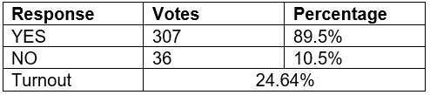
The made Plan, Decision Statement and declaration of result can be viewed at: Over Wallop Neighbourhood Development Plan | Test Valley Borough Council
From 3 May, the Over Wallop Neighbourhood Plan is subject to a six week period where applications can be made to the High Court on the grounds that the plans are not within the appropriate powers and/or a procedural requirement has not been complied with. This six week period of legal challenge ends on 14 June 2024.

Andover and Romsey Retail Capacity, Food and Beverage, and Hotel Study Update – Stakeholder Engagement
The council has appointed consultants Lichfields to undertake this study to inform planning policy on the town centre, retail food/beverage and hotel development for the new Local Plan 2040, and also inform the Andover town centre masterplan and South of Romsey town centre masterplan, and other council policy, as relevant.
As part of this work, the consultants are undertaking stakeholder engagement to gather views of the town centre and views on where people see there may be opportunities for improvements. This will be in the form of a short online survey. An email invitation to participate in this survey will be sent to all members and other key stakeholders for the town centres, in the near future. The survey will be optional and by completing the survey, the information gathered will be held and used by Lichfields for the purpose of the study. There will be an option for this to be held and used anonymously and for Lichfields not to make further contact by email if you prefer.
For further information, please contact David Bibby, Principal Planning Officer (Strategy) dbibby@testvalley.gov.uk or 01264 368105

Test Valley Community Energy Project Update
With funding from the UK Government through the UK Shared Prosperity Fund, the Council commissioned Community Energy South to deliver a community energy programme for the borough. We are now about a year into this two-year project, which will end in March 2025. Community Energy South has prepared the attached newsletter to provide an overview of the project and its key workstreams. This includes an overview of the work on community generation projects, support for community buildings, and energy advice.

Parishes join forces in village hall build

To mark our 50th year milestone, we’re sharing examples of our work with partnerships and communities across Test Valley.
We’re very proud of our grant schemes, that have financed projects run by charitable organisations and parish councils to make significant and long-lasting improvements in their communities.
Monxton and Amport Parishes have joined forces to get a new village hall built, partly funded by Community Asset (£25K), Community Infrastructure (£345K) grants and £100K fund-raised by locals! Underway right now, and with a beautiful oak frame fully installed, the hall will be energy efficient and provide a large, light space for rural communities, as well as residents of both parishes, to use.
Pics show concrete floor going in and oak frame. We look forward to sharing pics of the finished hall in early June.

Fine for Andover woman after cardboard boxes fly-tipped near supermarket
A woman from Andover has been handed a fine after pleading guilty to fly-tipping cardboard boxes.
On May 1 2023, a Test Valley Borough Council (TVBC) officer found a number of cardboard boxes dumped in the Tesco Extra car park on River Way. Information found within the waste led officers to Maria Dias, of Picket Piece, Andover.
Appearing at Basingstoke Magistrates Court on 19 March 2024, Dias pleaded guilty to the fly-tip and was given a fine of £200 and ordered to pay a victim surcharge of £80 and costs of £300.
Head of Environmental Services at TVBC, Paul Wykes, said:
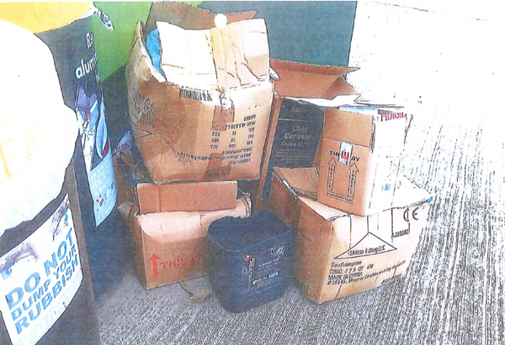
“This result illustrates our zero-tolerance policy on fly-tipping and demonstrates that you will be prosecuted if you are found doing so. Our teams work incredibly hard to try and keep the borough clean and the clearing up for these types of incidents takes up valuable time, money and resources.”

Fly-tip close to Andover nature reserve leads to hefty fine
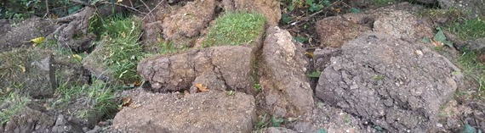

A man from Twickenham has been ordered to pay over £3,000 after fly-tipping garden waste near a nature reserve in Andover.

On 28 May 2023, we received a report of a fly-tip in Burnham Close.
When officers arrived on site they found a large quantity of garden turf on the footpath close to Anton Lakes.
Michael Brett Graham, 52, from Twickenham, had recently dug out the grassed area from a driveway at a property on Burnham Close and admitted to the offence when sent questions under caution.
Appearing at Basingstoke Magistrates Court on 6 March 2024, Graham was given a fine of £1,923 and ordered to pay a victim surcharge of £769 and costs of £500.

Other News

Be a Citizen Scientist and help monitor butterflies in Test Valley

Calling all butterfly enthusiasts. It’s time to prepare for the 2024 butterfly season. Every year, we take part in the United Kingdom Butterfly Monitoring Scheme (UKBMS) in conjunction with Butterfly Conservation.
We would like to hear from you if you’d like to walk a transect, record your sightings and provide valuable information for our conservation work to help us plan how we manage our areas in the borough.

Meadowscape at Romsey Abbey
Teams from Environmental Services and Community and Leisure spread 23 bags of Meadowscape on Tuesday at the north churchyard at Romsey Abbey to enhance the Urban Meadow on site.
A route was also created that will eventually allow visitors to walk through a scenic path through a wildflower meadow.
The meadow will be monitored over the coming weeks with fixed point photography taken weekly to follow its progress.
For further information please contact Charlotte Rimmer, Senior Countryside Officer on ext 8811 or crimmer@testvalley.gov.uk

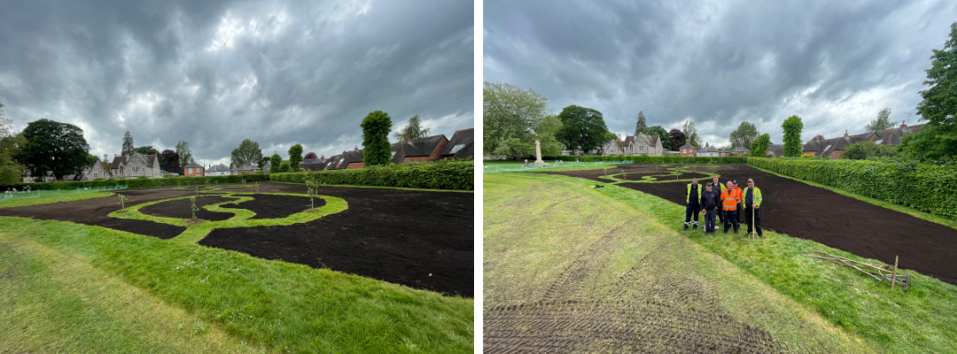

A Defibrillator Near You

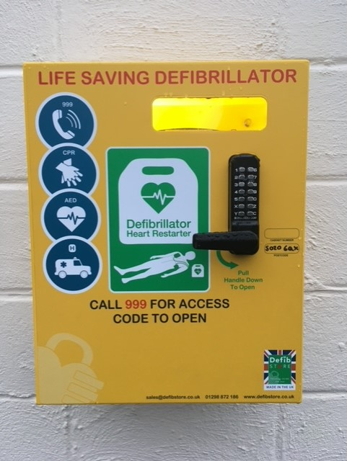
Defibrillators for public use are located at:

Stockbridge Fire Station (available 24 hours)
Longstock Village Hall (available 24 hours)
Leckford Estate Office (restricted hours)
Leckford Farm Shop (restricted hours)
Up Somborne Rookley Farm (24 hours)
King’s Somborne Village Hall
King’s Somborne – The Crown Inn (available 24 hours on front wall of pub)
Over Wallop - the White Hart pub, Pinchbecks Garage and the Army Flying Museum.
Nether Wallop -Village Hall and the Pavilion on the playing fields.
Ashley Farm (available 24 hours)

Instructions for use are given when the device is commandeered but for anyone who would like prior understanding of how to use one, see:
https/www.aeddonate.org.uk/events/

In the event of an emergency, after dialling 999 to report the incident, the phone operative should give the access code for the cabinet, to the person/first aider using the device.

Contact

If there are any issues in this copy that you would like to discuss, or any items of news that you would like to be considered in a future copy please contact any of the Borough councillors.

Councillor
Alison Johnston
01794 500610
cllrajohnston@testvalley.gov.uk

Councillor
Ian Jeffrey
01794 388872
cllrijeffrey@testvalley.gov.uk

Councillor
Stewart MacDonald 07803 594872
cllrsmacdonald@testvalley.gov.uk

