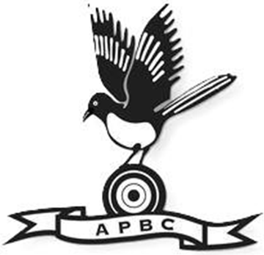

Aldiss Park Bowls - Code of Conduct
Charter
Bowls is a sport that thrives on its traditions of fairness, respect, and camaraderie. It should be played not only in accordance with the Laws of the Sport of Bowls, but also in the spirit of the game and the values of Bowls England: Collaborative, Adaptable, Responsible and Encouraging (CARE).
The responsibility for upholding these values lies with everyone involved - players, team managers, officials, volunteers, coaches and supporters.
This Code of Conduct reflects our Club’s commitment to creating a welcoming, inclusive and enjoyable environment for everyone - on and off the green.
These guidelines were agreed by our Club Committee on 15th February 2026 and are designed to support a thriving community where everyone feels valued and inspired.

Respectful Behaviour
- Treat everyone with courtesy and respect, regardless of differences in opinion, background or ability.
- Use positive, respectful language, avoid offensive language, taunting, bullying, harassment or discrimination.
- Celebrate and congratulate good play and positive behaviours. Demonstrate good sportsmanship at all times, win or lose.
Celebrate Our Differences
- Embrace the diversity of our club community and encourage participation from individuals of all backgrounds, abilities, genders and ages.
- Be mindful that some disabilities may be hidden - always approach others with kindness and understanding.

Maintain a Safe Environment
- Help create a safe and inclusive space for all, ensure you notify club management of any unsafe conditions.
- Ensure adequate supervision of Under 18s, ensure the right number of adults are present based on the children's age, group size, the activity and their specific needs.
- Report safeguardingconcerns promptly to our Club Safeguarding Officer.

Online Conduct
- Treat others online with the same respect you would in person.
- Do not send messages or make/interact with posts that could be perceived by others as harmful, offensive or threatening via any media, such as Email, Text, WhatsApp, Facebook and Instagram.
- Do not post content that could bring you,our Club, County Association or the sport into disrepute.
- Respect members’ privacy - always seek permission before sharing images or personal information.

Our Club, Our Responsibility
- Keep the clubhouse clean, safe and welcoming.
- Report any health and safety concerns to club management.

Appropriate Attire
- Dress suitably for club events and activities. When we look like a team, we feel like a team.
- If unsure about dress code expectations, ask a fellow member - we're here to support each other.
- Be understanding if a teammate or opponent requires flexibility with the dress code, as accessibility or personal circumstances may play a role.

Volunteer Appreciation
- Our volunteers are the heartbeat of our club. From Greenkeepers who care for our playing surface to Umpires who make our games happen to Club Secretaries who keep everything running smoothly, their dedication makes our sport possible.Take time to acknowledge and appreciate their efforts. A simple thank you goes a long way.

Breaches of Conduct
The club takes breaches of this Code seriously. If behaviour falls short of these expectations and a complaint is made, Regulation 9 (R9) will be followed.

Acknowledgment
By being part of our Club, every member, parent or guardian and supporter agrees to uphold these standards. Together, we commit to creating a positive and supportive environment where everyone can enjoy the sport and thrive.

