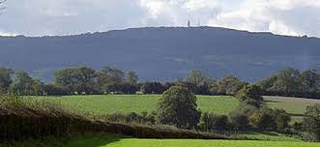

ABDON & HEATH PARISH COUNCIL
Including: Balaam’s Heath, Baucott, Brookhampton, Holdgate & Tugford

www.abdonandheathparish.org.uk

ABDON AND HEATH PARISH COUNCIL Meeting
Wednesday 12th August 2026 at 7.30pm
At Abdon Village Hall
Please reply to Clerk to the Parish Council: Wendy Richards clerk@abdonandheath.gov.uk
In alphabetical order - Cllrs. Peter Hartley, Bill Lewis, Rowland Price, Oliver Uffold, Chris Yarwood
AGENDA
- Open Session: Members of the public are invited to raise any issues prior to the meeting
- Declarations of Interest To receive declarations under consideration on this agenda in accordance with the Localism Act 2011 s32 and The Relevant Authorities (Disclosable Pecuniary Interests) Regulations 2012.
- Apologies (acceptance of absences)
- Minutes to approve and consider matters arising from meeting 13-5-26
- Finance: Balance, cheques requested: Clerks wages: £244.51
- Discuss Brown Clee View Camping and Caravan Site at Marsh Farm, Abdon
- Consultation on Proposed woodland creation project: Nordy View, Abdon, Shropshire - OSGR: SO 588 856
- Highways: please help pinpoint ditching priorities, culverts and potholes.
- Correspondence & reports from members
- AOB:
- Items for consideration for the next meeting(For dissemination of information only)
- Date of next meeting: 11th November 2026

All residents of the villages are invited to attend.
Wendy Richards - Parish Clerk: clerk@abdonandheath.gov.uk Tel: 07813 271 274
2-8-26

