Interests | Present | Cllr A Sharp  Cllr M Ridley  Cllr D Rogan-Mackie  Cllr G Heppell | Cllr S Dalglish  Cllr S Nixon  Cllr K Teasdale  Cllr A Cheverst | Ms Emma Ackroyd - Clerk  2 members of the public
 | 174/24 | 174/24.01 Apologies for absence - Cllr J Hunter (Indisposed), Cllr Hutchinson
 | 175/24 | Public Questions – No questions
 | 176/24 | Declarations of Interest  The Chair reminded members of the Council of their duty to declare an interest at each agenda item, and he informed everyone that that the initials of Councillors declaring an interest will be listed in a column on the Minutes.
 | 177/24 | Minutes of the meeting for approval held on Monday 2nd September 2024  The minutes were approved.  Proposed by: Cllr G Heppell Seconded by: Cllr K Teasdale AGREED
 | 178/24 | Matters arising from the minutes not covered elsewhere in the agenda  Working Men's Club Update:  The site was made safe by the Gas Board six weeks ago, and Northern Power Grid will disconnect electricity on 14th October. Demolition work is set to begin soon..
 | 179/24 | Grounds Report –updates with resolutions arising  - 179/24.01 Orchard Garden:  A quote of £780 was accepted for tree trimming, including necessary conservation paperwork.  Proposed by: Cllr D Rogan-Mackie Seconded by: Cllr G Heppell AGREED  - 179/24.02 Bus Shelter and Seating:  Agreed to continue with ongoing maintenance of public seating and bus shelters, including cleaning plaques and repainting.  - 179/24.03 Public Footpaths Lighting:  A lighting pole near the church hall was reported as not operational. The issue will be followed up with Paul Jones at NCC.
 | 180/24 | Northumberland County Council (NCC)  141/24.01 No Report given  141/24.02 Asset Transfer (Land by the Swimming Pool):  The council is awaiting final confirmation of the transfer of land north of the swimming pool for the play zone and football field. Ensuring the inclusion of the swimming pool car park in the transfer is essential for safeguarding the future of the pool. Cllr A Sharp will continue to press this issue with NCC.
 | 181/24 | Police in Haltwhistle  The police report covered various incidents, including theft, damage to vehicles, drug-related arrests, and shoplifting. The council expressed concern about the incidents, and it was noted that there has been an increase in certain types of crime. Residents were encouraged to report incidents to the police to ensure adequate police presence and response in the town.
 | 182/24 | Neighbourhood Plan  A meeting with Mark Harrison from NCC is scheduled for November to continue progress on the Neighbourhood Plan. Cllr S Dalglish reported that the housing survey and site reviews are ongoing.
 | 183/24 | Borderlands Projects  New projects were discussed:  1. A proposal to create a play park on Park Head Road.  2. Support for the Working Men's Club redevelopment if insurance does not cover all costs.  Existing applications were also reviewed, some of which included the Conservative Club’s plan to incorporate a banking and post office service, and proposals for a community centre and EV project from the Chamber of Trade and improvements made to the Burn Track.
 | 184/24 | Planning Applications  Phase 1 Park Road Street Naming:  The new development was officially named "Featherston Gate" and sought approval for the street names. These were approved.  Proposed by: Cllr G Heppell Seconded by: Cllr S Dalglish AGREED
 | 184/24 | Other Planning Matters  Application 24/02597 – Haltwhistle Tandoori: Planning application for the removal of PVC roof drainage and installation of a cast iron replacement was granted.  Proposed by: Cllr G Heppell Seconded by: Cllr M Ridley GRANTED
 | 185/24 | Remembrance Day  It was agreed that three wreaths would be ordered for the Remembrance Day event. Cllr K Teasdale will liaise with the Co-op funeral directors to arrange the laying of wreaths, and he will also finalize details regarding a piper for the ceremony.
 | 186/24 | Freedom of the Town  A ceremony will be held at 4:30pm before the December council meeting in the library; to present the Freedom of the Town to Lawrence Thompson for his significant contributions to Haltwhistle. A small buffet will be arranged for the event and the public are invited to attend.
 | 187/24 | Office Space  The council toured the available office space at the Haltwhistle railway station on the Newcastle platform, with a rent of £250 per month.  Proposed by: Cllr A Sharp Seconded by: Cllr D Rogan-Mackie AGREED
 | 188/24 | Grant Requests  The grant application from Young and Sweet was reviewed and approved for the amount of £4,000.  Proposed by: Cllr D Rogan-Mackie Seconded by: Cllr G Heppell AGREED
AS | 189/24 | Haltwhistle Swimming & Leisure Centre  The resignation of John Clark was noted, and the council reviewed the accounts of the centre. The next Tranche of funding was approved.  Proposed by: Cllr D Rogan-Mackie Seconded by: Cllr K Teasdale AGREED

 | 190/24 | Reports on Financial Matters  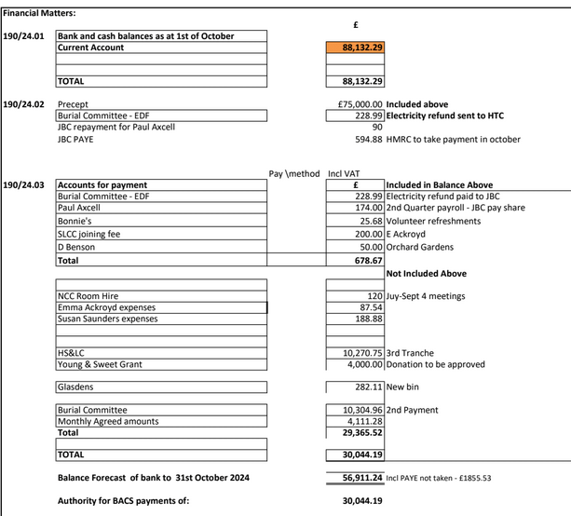.  168/24.04 Bank Reconciliation/Inc & Expenditure as at 1st of October 2024. Noted.  Proposed by: Cllr S Dalglish Seconded by: Cllr G Heppell AGREED
 | 190/24 | 190/24.05 Internal auditor (appoint)  An internal auditor was appointed for the financial year.  Proposed by: Cllr M Ridley Seconded by: Cllr K Teasdale AGREED  190/24.06 Notice of conclusion of audit 23/24  Notice of the External Audit was posted to the public on the noticeboard and Halthwhistle Town Council website. The council reviewed the audit report.  190/24.07 Update bank mandate  Updates to the bank mandate should be complete, clerk to follow up with bank to confirm.  190/24.08 Cloud storage and email  The council approved the introduction of cloud storage and email services.  Proposed by: Cllr G Heppell Seconded by: Cllr M Ridley AGREED
 | 191/24 | Haltwhistle Partnership  The partnership’s AGM is scheduled for 6th November at the ticket office. The community fund will soon be open for applications, and volunteers at the bookshop will be involved in deciding the distribution of funds.
 | 192/24 | Haltwhistle & District Joint Burial Committee  169/24.01 Withdrawal of Melkridge Parish Council – The withdrawal of Melkridge Parish Council was discussed. Payment of outstanding fees has been received.  169/24.02 Land Registration for Haltwhistle & Greenhead Cemeteries. – progress is being made with the land registration for Haltwhistle and Greenhead Cemeteries.
 | 193/24 | Correspondence received since last Council meeting.  NCC has offered £20,000 toward toilet repairs, leaving HTC to find £50,000. The council expressed disappointment with this funding offer and will draft a response to NCC. The council also discussed the maintenance of a memorial bench, which will be supported if the family buys the bench.
 | 194/24 | AOB  - Wetpour Remedial Works: Suggestions were raised to fix the sunken wetpour area in the park, with proposals such as inserting a perforated pipe. The council discussed contacting Abacus for a quote on rectifying the issue.  - Turf: Delay turf for playing field until spring  - Sycamore Gap Event: A community seeding event at Sycamore Gap is being planned.
 | 195/24 | Resolution to Exclude Press and Public  To consider a resolution to exclude the public and accredited representatives of newspapers from the following item relevant to a subject which affects the Council’s area.  Resolution  “That in view of the confidential nature of the business about to be transacted it is advisable in the public interest that the public be temporarily excluded and they are instructed to withdraw.”  This resolution is moved under the Public Bodies (Admission to Meetings) Act 1960 (as extended by s.100 of the Local Government Act 1972), the public and accredited representatives of newspapers be excluded from the meeting for the following items of business on the grounds that it involves the likely disclosure of exempt information as defined in Part 1 of Schedule 12A of the Local Government Act 1972 by virtue of the paragraph specified against the item.  Proposed by: Cllr K Teasdale Seconded by: Cllr A Sharp AGREED  Clerk’s contract: Signed and approved  Application for new councillor: Agreed for appointment to take place next town meeting
 | 196/24 | Dates and times of next meetings  Grounds Maintenance Meeting – Monday 28th October 2024 – 10am Clerk’s Office  Town Council Meeting –Monday 4th November 2024, at 6:30pm in Haltwhistle Library.  The meeting closed at 9pm.

