PETROCKSTOWE PARISH COUNCIL
Parish Clerk: Fiona Lowe, Rose Farm, Petrockstowe, Okehampton EX20 3HQ
Phone: 01837 811749 E-mail: petroc.clerk@hotmail.com

Dear Councillors

You are duly summoned to attend a short Parish Council meeting after the Petrockstowe Annual Parish meeting on Tuesday 19th April 2016, at Baxter Hall, Petrockstowe, to discuss the following business.

AGENDA
- Matters arising from minutes of 15/03/2016
- North Devon Records Office – Update
- Play Area – Update
- War Memorial
- CPRE Devon ‘Our Outdoor’ Competition 2016
- Financial Matters Payments to be approved

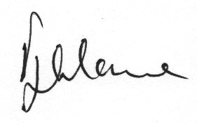

Fiona Lowe
Parish Clerk
13/04/2016

