WHAT’S ON
In The Village?
Issue 238 August 2024

Steve and Viv ran July’s Village Café most successfully. This month it’s the turn of Lucy and Richard Slade and Lucy Howe. All are welcome!

Our village community faces two challenges. The Village Hall is investing £14,000 in solar panels and EV charging to cut/fund its long-term running costs and to become ‘Zero Emissions’. Early donations and a Low Carbon Dorset grant have raised £7,600, but the grant requires work to be complete before 2025. £5,000-£7,000 remains to be found: this is our village’s top priority. Our Church’s challenge is of a larger order: the Quinquennial Phase 1 repairs are complete; quotes are due for Phase 2. Phases 1 and 2 together are estimated to cost about £19,500. In addition, Phase 1 work on the chancel roof, i.e. over the church’s whole east end, has revealed that the roof may have less than five years’ life left. The PCC will apply for most of the up-to-£100,000 overall project cost to outside charities; but they will want to see our village prove its commitment by having raised an appreciable sum itself.

The Fete proceeds were just over £8,000, over twice our previous record! Thanks to this unexpected bonus, the Fete Management Committee has decided that £6,500 of this sum will go towards the church repairs, and the remainder to the Village Hall.

Artsreach have two events for us to look forward to this month. For ticket details, see below.

- On 16th August, Three Inch Fools present ‘The Comedy of Errors’, Shakespeare’s wildest comedy in the open air at Higher Orchard, courtesy of the Potter family.
- On 21st August, run off to the circus with Kevin Burke and learn new ‘Circus Skills’: juggling with clubs, rings, diabolo, plate spinning, stilts, poi, rolla bolla, and more!

CONTACTS / ORGANISERS:
Website: www.sandfordorcasvillagehall.com; Email: info@sovhall.plus.com
Sandford Orcas Village Hall Committee:
Claire Arnold (Fete); Cindy Brown (Secretary); George Lossius (Treasurer, 100 Club);
Rowlie McBeath (QTPC, Artsreach*); Robert Patterson (Billiards & Snooker; PCC);
Richard Pollard (Maintenance, Friends of SOVH); Richard Slade (Chairman).
.* Children’s events are run by Susan Yeoman and Helen Donnelly.

Village (and Outside) Organisers:
FOSOVH Friends of Sandford Orcas Village Hall I.e. anyone who wants to help, on an ad hoc basis
FPO Footpaths Officer Steve Donnelly (01963 220446)
Mitre The Mitre Inn: Steve Hooper (01963 220 271). steve@mitreinn.co.uk
HW Home Watch Allen Page (01963 220 271).
PCC Sandford Orcas PCC: Secretary: Nickie Page (07766 666552‬).‬‬‬‬‬‬‬‬‬‬‬‬
- Dorset Police: Sherborne Rural: PC 2777 Laura McKeeman & PCSO 6269 Mark Jones
Safer Neighbourhood Team Phone: 101, sherborneruralsnt@dorset.pnn.police.uk
QTB Queen Thorne Benefice Rector: Reverend David Bond (01935 850 201)
QTPC Queen Thorne Parish Council Parish Councillors: Jan Lowe (01963 220 490), Rowlie McBeath
(01963 220 208), Paul Phillipson (07974 348545),
Secretary: Rose Edwards (01963 220 491).
www.queenthorneparishcouncil.gov.uk
VH Village Hall: Chairman: Richard Slade (01963 220 740)
Village Hall Bookings: Cindy Brown, sandfordorcasvillagehallsec@gmail.com
Village Events Every Week:
The Mitre Inn Opening Hours: Contact: Steve Hooper (01963 220 271) steve@mitreinn.co.uk)
- Mondays: 6.30 p.m. - 10.30 p.m.
- Tuesdays / Wednesdays: 12.00 p.m. - 3.00 p.m. (Food 12.00 p.m. - 2.00 p.m.) and 6.30 p.m. - 10.30 p.m. (Food 7 p.m. - 9 p.m.)
- Thursdays / Fridays: 5.30 p.m.-6.30 p.m.: HAPPY HOUR! Sandford Orcadians 50p off!
- Thursdays / Fridays / Saturdays: 12.00 p.m. - 3.00 p.m. (Food 12.00 p.m. - 2.00 p.m.) and 5.30 p.m. - 10.30 p.m. (Food 7.00 p.m. - 9.00 p.m.).
- Sundays: 12.00 p.m. - 3.00 p.m. (Food 12.00 p.m. - 2.00 p.m.)
The Story Pig Pop-Up Shop, at Lavender Keepers, in Great Pit Lane:
NEW OPENING HOURS! Thursdays to Sundays 10 a.m. to 2.30 p.m.
Friday and Saturday Pizza Nights: 5.00 p.m. to 8 p.m.
- Open for glorious free range, pork products - bacon rolls, pulled pork, and pork and other products, including Charlotte’s wonderful baked goods! Please pre-order your pizzas on 07724 885 353: the dough is made fresh each day.
- Billiards & Snooker Club: Contact Robert Patterson (01963 220 455) for details.
- Table Tennis Club: Contact Richard Pollard (01963 220 893) for details.
- Bellringing: Contact John Ferdinando (01963 220 666) to learn how to ring church bells.

Saturday, 3rd August 2024. Time: 2.00 p.m. - 8.00 p.m. Mitre Inn Mitre
Antiques Roadshow 2024!
Once again the Mitre Inn is holding an Antiques Roadshow hosted by TV’s Gordon Brockman from www.truevalues.co.uk. Bring your antiques along to be valued … Please contact Steve Hooper on 01963 220 271 or steve@mitreinn.co.uk for details.

Saturday, 10th August 2024. Time: 10.30 a.m. – 12.00 a.m. Village Hall SOVH
Village Café
The Village Café is a great way to catch up with local news. Proceeds go to the village hall. All helpers welcome - please contact Maggie Pollard. (maggiepollarde@gmail.com).

Saturday - Sunday, 10th - 11th August 2024. Time: 10.00 a.m. - 4.00 p.m. Glenholme Herbs
Open Garden Weekend
Come to see Glenholme Herbs’ beautiful gardens! Teas, coffees and cakes and children’s nature trail. Raising funds for the National Gardens Scheme charities. Adults £4, children free.

Friday, 16th August 2024. Time: 7.00 p.m. Higher Orchard Artsreach
Three Inch Fools present ‘The Comedy of Errors’ Doors open at 6.00 p.m.

The Three Inch Fools are back with Shakespeare's shortest (and wildest) comedy! The clock is ticking, as the Fools rush to untangle one almighty mess in this farcical tale of long-lost twins, hysterical misunderstandings, and endless mishaps. With musical instruments in hand, expect a joyous take on this Shakespearean rib-tickler. Tickets: £16 adults, £5 under 18s and £40 families (max 2 adults) from www.artsreach.co.uk, or Rowlie McBeath, 01963 220 208.

Wednesday, 21st August 2024. Time: 2.00 p.m. - 4.00 p.m. Village Hall Artsreach
Kevin Burke presents ‘Circus Skills’

Learn new Circus Skills this Summer! Run off to the circus this summer and learn new skills that will impress your friends and family! Join Kevin this summer and learn a variety of circus skills including juggling with clubs, rings, balls and scarves, diabolo, plate spinning, stilts, poi and rolla bolla! Suitable for ages 5+. Tickets £6 on www.artsreach.co.uk.
Wear loose, comfortable clothing and soft shoes. (Tracksuit bottoms and trainers are ideal).

Friday, 23rd August 2024. Time: 9.00 p.m. - 11.00 p.m. Mitre Inn Mitre
Live Music: Peter Burns – Rock & Soul!

Published by Sandford Orcas Village Hall Committee. Distributed free to all actual and honorary villagers.
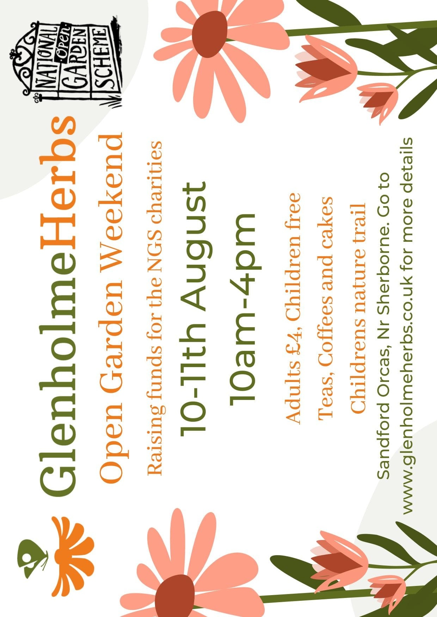


Sandford Orcas Village Community (Version 24).
Here are local suppliers who can provide home delivery or collections for basic food and health requirements. Please support, particularly, our most local businesses.

Name & Contact Info | What’s Available – To Buy or To Order | Delivery Options
The Mitre Inn, Sandford Orcas  01963 220 271, steve@mitreinn.co.uk | The menu changes weekly, with locally-sourced produce. Opening hours will be on www.mitreinn.co.uk. | The pub is open for meals.
Jeff* and Somaya Davies  07918 745826 & 07918 743071  * The Mitre Inn’s chef, no less! | Delicious cakes and bakes: Cakes, Chocolate Logs, Mince Pies, Sausage Rolls, Desserts, Cupcakes and Celebration Cakes. | Contact Jeff and Somaya directly, or through The Mitre Inn (see above).
Glenholme Herbs  Sandford Orcas, 01963 220 302  alison-redman@hotmail.com | Herbs, vegetables and vegetable plants. For the full range, see www.glenholmeherbs.co.uk | Free delivery within Sandford Orcas, or collect. Seasonal plants to order.
The Story Pig  Sandford Orcas, 07802 443 905  jameshull777@gmail.com | Tamworth pork, sausages, bacon, chutney, saffron rolls, apple buns. Also meat boxes. | Now offering pizzas – see above - along with glorious free range, rare breed Tamworth pork products - bacon rolls, pulled pork, and pork and other products. Please pre-order your pizzas on 07724 885 353: the dough is made fresh each day.
Rosanne Eskell  Higher Sandford House,  Sandford Orcas, 01963 220 275  r.eskell@hotmail.com | Sandford Orcas’ very own ‘Benchy View’ white wine, grown in Rosanne’s own vineyard. Rated “delicious” by our ex- wine merchant Rector! | Free delivery in Sandford Orcas, discuss delivery elsewhere with Rosanne when ordering.
Kim Creswell, Dip.Herb.Med.,MNIMH  By The Ford, Moorway Lane,  Sandford Orcas, 07765 654 771  www.kimcreswell.co.uk  kim@kimcreswell.co.uk  www.goldberryherbs.co.uk  kim@goldberryherbs.co.uk | Fully qualified and insured medical herbalist, trained in diagnosis, treatment and medicine making, using organically grown medicinal herbs.  Woven willow sculptures and baskets.  Willow weaving courses. | Professional, confidential and able to prescribe alongside conventional health care. Also grower of willow, maker of sculptures, baskets and other rural crafts. Workshops held and private bookings available.
Fiona Potter, Higher Orchard,  Sandford Orcas.  01963 220 773, 07708 842 553  fionapotter@live.co.uk | Bramblewood grass fed Dexter Beef. Joints, steaks, stewing steak, mince, sausages and burgers. Also Pure Apple Juice from their own trees. | Current beef stocks have expired for now – you’ve bought it all! Fiona’s apple juice remains available, and is on sale at The Story Pig.
Monique Hustinx.  07949-595632  monique.hustinx@hotmail.com | Sandford Orcas-reared, lamb. Half a Lamb: £80, Quarter of a Lamb: £40. Butchered to your requirements. | Contact Monique for delivery details.  www.ciderappletrees.co.uk
Market Town Garden  52, Cheap Street, Sherborne  07967 659638  sherbornemarketfruitandveg@aol.com | Fresh fruit and vegetables. | Contact them, or visit their shop, to discuss box sizes and delivery details.
J&M Parsons  Cheap Street, Sherborne  01935 812 071  info@parsonsbutchers.co.uk | Traditional butcher and milk, cheese, eggs. | Free delivery with orders over £10.
Olives Et Al  Sturminster Newton  01283 474 300  viki@olivesetal.co.uk | Fresh fruit, vegetables, freshly-made bread, milk, eggs, pasta, rice, biscuits, chocolate and all your Olives et Al favourites. | Free delivery to village through Viki (East Field Cottage). Viki also collects shopping & medical prescriptions.

Useful Facebook groups: Queen Thorne Parish News and Views; Sherborne Viral Kindness

