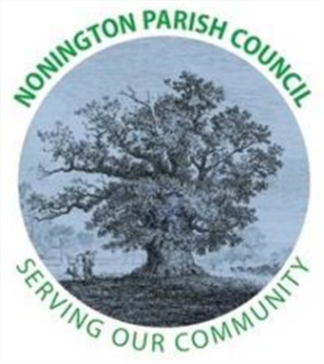

NONINGTON PARISH COUNCIL
Email: noningtonparishclerk@outlook.com Website: www.noningtonpc.org.uk

TO: ALL MEMBERS OF NONINGTON PARISH COUNCIL
Councillors are hereby summoned to attend an Ordinary Meeting of the Council to be held on
Wednesday 3rd September 2025 at 7.00pm in Nonington Village Hall

A G E N D A

- Chairman’s Welcome and Apologies for absence

- Declarations of Interest

- Confirmation of the Minutes of the Meeting held 2nd July 2025

- Review of Previous Action Points

- Public Forum

- Finance

Balance as of 28th August 2025
Current Account: £10,045.39 (opening) £9063.40 (28/08/2025)
Savings Account: £18,431.96

Payments 01/08/25 28/08/2025 (£981.99)
Hugo Fox £11.99 (website)
Envisage £296.40 (Grass/Hedge Maintenance)
Envisage £596.40 (Grass/Hedge Maintenance)
HMRC £77.20 (Clerks deductions Pay – Aug 2025)
Pending Payments (£2284.48)
Clerks Pay £318.64 (February 2025)
Clerks Pay £318.64 (March 2025)
Clerks Pay £318.64 (April 2025)
Clerks Pay £318.64 (May 2025)
Clerks Pay £318.64 (June 2025)
Clerks Pay £318.64 (July 2025)
Clerks Pay £318.64 (August 2025)
Clerks Travel £54.00 (April – July 2025)

- Planning
  - Tree stumps site visit building site

- Highways and Footpaths
  - CON/19/00381/D – Trinity Court, Easole Street, Nonington

- Playground, Field and Pond

- Items for discussion not on the Agenda

- Date of the next meeting: Wednesday 1st October 2025

