MINUTES OF THE MEEETING OF CHUTE PARISH COUNCIL
HELD ON THURSDAY, 3RD JULY 2025
AT CHUTE VILLAGE HALL

69/25 OPEN FORUM
6 members of the public were present.

Huw Lovesey asked if the parish notice board on the bus shelter in Upper Chute was going to be reinstated. He also advised that the signpost at the bottom of Forest Lane is looking worse for wear and could do with a coat of paint to extend its life. Huw also asked if the request to reinstate the white lines at the Upper Chute green and Tibbs Meadow junction had been made to WCC Highways.

Several parishioners are increasingly concerned about anti-social behaviour and lawlessness in Upper Chute. Cllr Parr explained that the Parish Council can only facilitate contact between the police and Sanctuary Housing but has no remit or jurisdiction to engage in the discussion beyond this. The police were invited to attend the meeting and Sanctuary Housing have been made aware of the situation.

PCSO Ruby Kaur and PC Juliette Cox attended the meeting and listened to residents talking about incidents of anti-social behaviour in Upper Chute. Their advice was to collate a dossier of incidents to include the date, time and preferably some photographic or video evidence of each incident. It was advised by PC Cox that footage from doorbell cameras can be used as effective evidence in court. If the observed activity is breaking the law or somebody is at risk, dial 999. If the matter is unpleasant but nobody is at risk, report it by dialling 101. PCSO Ruby Kaur advised that she would hand-deliver an ASB letter to all Sanctuary Housing properties and those in the immediate vicinity. These can be returned anonymously to Ruby in a pre-paid envelope. After Ruby has received the ASB letters back she will review them with the housing and ASB officer of Wiltshire Council. If they get enough evidence, then Ruby will push housing to issue a warning letter to the offending residents. If anti-social behaviour continues then please report via 101/999 and then, if the police get enough evidence, they we can issue a CPW (Community Protection Warning).

70/25 PRESENT
Cllr Parr (Vice-Chairman), Cllr Hopton, Cllr Rudland and Cllr Taylor. The Clerk was in attendance.
71/25 ELECTION OF VICE-CHAIRMAN
Cllr Parr was re-elected to the position of Vice-Chairman by all councillors present at the meeting.

72/25 APOLOGIES
There were apologies from Cllr Wall (Chairman), Cllr Alderson, Cllr Harker and Cllr Chris Williams (WCC)

73/25 DECLARATIONS OF INTEREST
None.

74/25 MINUTES OF THE LAST MEETING
The minutes of the last meeting held on 5th June 2025 were proposed by Cllr Taylor and seconded by Cllr Rudland. The minutes were then signed by the Vice-Chairman as a true record.

75/25 PLANNING
PL/2025/04935 Prospect Villa, Upper Chute – Tree works in a conservation area - Support
PL/2025/04936 Parsonage Farm, Upper Chute – Tree works in a conservation area – Support

76/25 COUNTY COUNCILLOR / WILTSHIRE POLICE REPORTS
Cllr Williams send in his report prior to the meeting and this is attached.

77/25 PARISH REPORTS
Highways (TH)
Cllr Harker’s will be asked to address Huw Lovesey’s comments about the sign at the end of Forest Lane and to confirm if the request to reinstate the white lines in Upper Chute has been acknowledged by WCC.

Footpaths/Rights of Way (AR/MA)
Cllr Rudland said the application to divert Chut18, which is linked to the planning application for the new garage at the Cross Keys site, has not yet been determined.
King George Playing Field (CW/TH)
Cllr Wall had advised Cllr Parr ahead of the meeting that tree works are the only item outstanding.

Village Hall (CW)
Cllr Wall was not at the meeting to provide an update.

Allotments (MT)
Plots 8&9 have been let to Vicky Morey in Chute Cadley. Thank you to Linda Shepherd who has kindly filled up the water butt at the allotment site.
78/25 FINANCE
The bank reconciliation and the corresponding bank statement for June was circulated to all councillors prior to the meeting. Parish Council funds were £8,622.65 with £5,820.60 in the current account and £2,802.05 in the deposit account and these figures reconciled to the bank statements. The remaining 50% of the precept will be paid in September. The Chairman signed the bank reconciliation as a true record.

The record of payments made and received since the last meeting is as follows:

Payments Made:
05/06/2025 John Murray – Internal Audit Fee £ 190.00
27/06/2025 Clerks Salary – June £ 260.00
27/06/2025 HMRC – PAYE £ 65.00
Payments Received:
09/06/2025 Vicky Morey re. allotments 8/9 £20.00
Payments for approval via online banking:
27/07/2025 Clerks Salary – July £ 260.00
27/07/2025 HMRC – PAYE £ 65.00

The above payments were proposed by Cllr Taylor and seconded by Cllr Rudland.
79/25 PARISH IMPROVEMENT PROGRAMME
The bus shelter has been repaired free of charge by RMT Fencing for which we are grateful. The notice board will be reinstated once the bus shelter has been painted.

80/25 CORRESPONDENCE AND ADMINISTRATION
Anti-social behaviour issues in Upper Chute were discussed at length in the Open Forum.
The Land Registry record address for the allotment site is in the process of being updated from Cockards Farmhouse to Chute Village Hall, following a recent discussion between Cllr Wall and Johnny Sykes.
Cllr Wall has ordered from Hugo Fox a .gov.uk provision for councillors e-mails free of charge as they are our website providers and the matter is being progressed.

Due to the limited number of people who have responded to an article in The Chute Chronicle about their preference for bus routes it is unlikely that one will be reinstated as those who did respond did not want to go to the same destination. One wanted Marlborough/Hungerford and the other Andover. It is highly likely that the provision of a bus service for the Chutes is financially unviable.

The meeting closed at 8.31 pm.

The next meeting of Chute Parish Council will take place on
Thursday, 4th September 2025 at 7.30pm in the Village Hall

Wiltshire Councillor Chris Williams Report - June 2025
A very different Wiltshire Council meeting took place on 20 May with no political party gaining a majority after the recent election. Cllr Laura Mayes was elected as Chairman of the Council for the forthcoming year with Cllr Ruth Hopkinson as Vice-Chairman.
There is now a liberal democratic leader, Cllr Ian Thorn, with the cabinet made up of liberal democrats and an independent.
Annual updates from Committees were then reported on highlighting the activity and key issues dealt with or covered at various council committees throughout the council year and there was a report on a new Overview and Scrutiny Committee structure, with the proposal of a Finance and Procurement Select Committee. This would be instead of a finance task group.
Directly after the full council meeting, the area boards met to select the chair and vice chair for the coming year. Cllr Dave Lumsden (Tidworth North & Ludgershall South) was elected AB Chair, myself as Vice Chair and Cllr Keith Allen (Tidworth North & West) as LHFIG Chairman.
At the time of writing this report, the LHFIG meeting will take place on 4th June, the agenda has been published and circulated and the outcome and any proposals from this meeting will form part of the Tidworth Area Board agenda which will meet on Monday 23 June, 7pm in the Tedworth Hall, Tidworth Civic Centre.
LHFIG meeting update: agenda item Chute PC 15-24-13, Request for additional streetlight. The group agreed to proceed, and Rhiann has provided Chute PC with a standard installation cost and will follow up with Streetlighting team to determine suitability.
I have contacted Jason Salter who is Head of Service, Passenger Transport Unit regarding extending the Wiltshire Connect Bus request service to include the Chutes. Jason has passed it onto Paul Sanders who is the Demand Responsive Transport Manager, who will be able to provide a more complete response. I will provide further updates as soon as I receive further information.

Christopher Williams
Wiltshire Councillor for Ludgershall North & Rural
Tel: 07712159562
Email: christopher.williams@wiltshire.gov.uk




EL12 Ludgershall and Rural Police Report – June 2025

- Inspector1359 Gavin BREWSTER
- Sergeant 2687 Caroline RALPH
- Police Constable 2054 Jody KINGE
- Police Community Support Officer 6373 Rupinder KAUR

Pro-Active Work

- Primary School, Netheravon- Youths and former pupils have gained access to the school by climbing over the fence and played football, however the Council has been made aware as there is no place to play football in the local area as this may be a solution. Patrols being conducted.

- Castle street, Ludgershall - Unknown persons has stolen a CCTV camera which was being used to monitor HGV using a weight restricted road. Value to £390. Enquiries are still ongoing. Patrol being conducted.

- Marlborough Raod, Everleigh- Unknown persons has smashed a rear window on a vehicle, pulled up the parcel shelf and stolen a mobile camping charge worth £180. Damage to the rear window valued at £300-600.Patrols being conducted

- POP Plan, High Street, Ludgershall - Case for POP plan regarding exceeding maximum weight restriction (RC8258). HGVs have been driving straight through the 7.5t weight limit coming so close to the properties that they have caused the houses to shake. POP Plan on going.

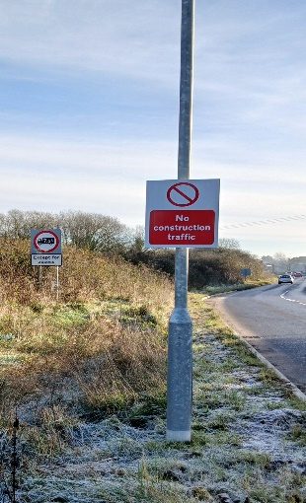

- Recreation Ground, Ludgershall - Unknown youths acted disorderly in public, causing distress to residents. Patrol being conducted.

- The Knapp Close, Collingbourne Ducis - Unknown persons(s) have gained entry to a work van and stolen a backpack blower. £500 TVO. Enquiries are still ongoing. Patrol being conducted.

- Tibbs Meadow, Upper Chute-Unknown persons kicked in the wooden sides of a bus shelter. The cost of repairs is £2000+. Enquiries are still ongoing. Patrols being conducted.

- Salisbury plain- We’ve received reports of motorcyclists and 4x4 vehicles using the byways and bridleways in Ludgershall, Upper Chute and Salisbury Plain, patrols being conducted in area.

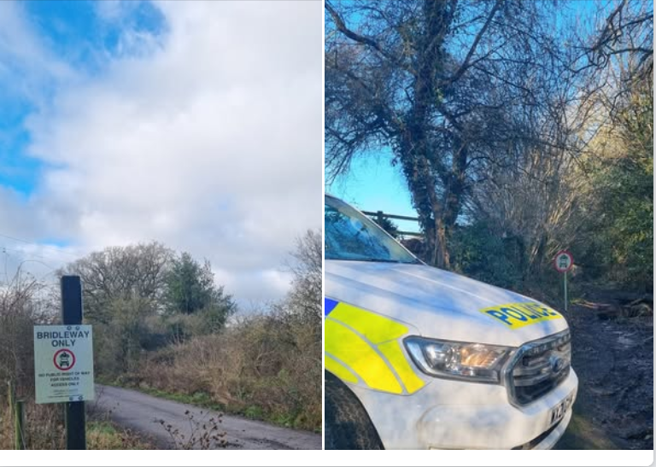

- During Neighbourhood Action Week and County lines Intensification week local neighbourhood officers have completed activities as follows:
  - Local officer has attended the coffee morning in Netheravon and provided them the cold caller stickers and further information.
  - Local officer attended the Collingbourne Ducis school to deliver the school talk to year R and year1 children about ‘people who keeps us safe’.
  - Local officer attended the Netheravon primary school to deliver the school talk to year 6 children about ‘Criminal responsibility’.
  - Drug awareness leaflets have been dropped to local post offices, Air B&B and the town council.
  - Cuckooed address been checked for county line intensification week.

Community Engagement
- Neighbourhood officer came along with the search team and have attended the Ludgershall freedom Prade, engaged with the community and gathered the intel.
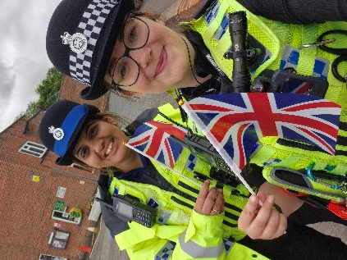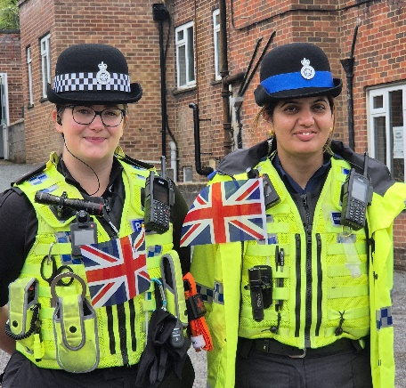
- Local officer has attended various locations to speak with the Indian community and to reassure them as for the recent Air India plane crash.
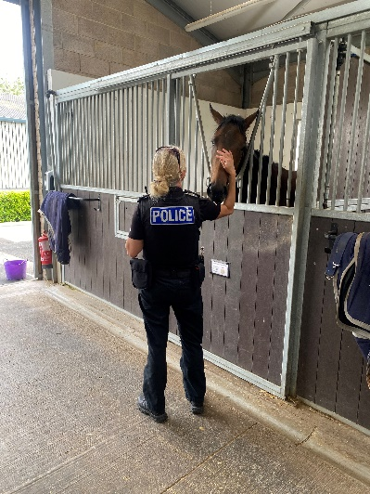
- Local officers conducted the foot patrol of Millenium Park in Netheravon due to receive the reports of drug activities in the area.
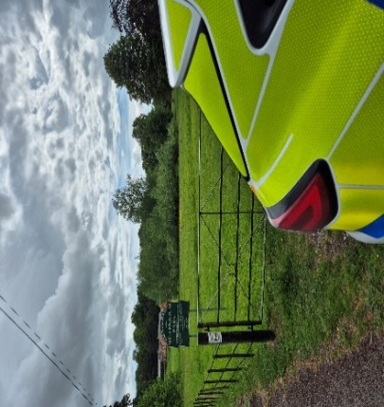

- Local officer has attended the Royal visit in Larkhill to help Military and met with the King Charles III.
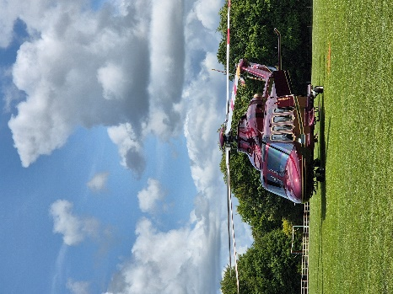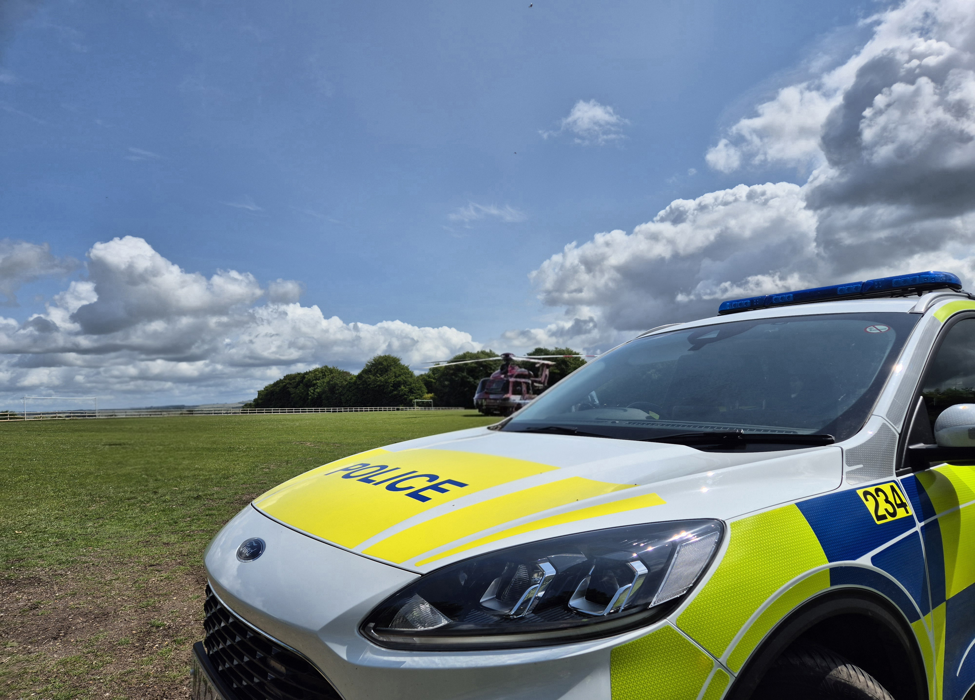

- Local officer has conducted the marked vehicle patrol around the Chute, Ludgershall Collingbourne, Everleigh, Netheravon and Salisbury plain to focus on ASB dirt bikes.

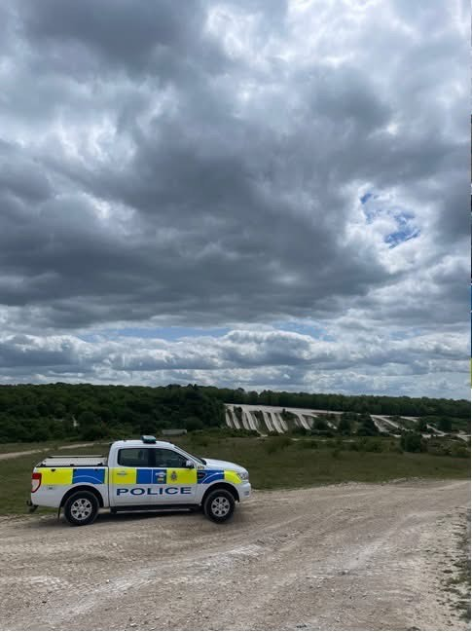

Speed Enforcement
- Collingbourne Ducis- Speed Enforcement caught 2 vehicles speeding on 6 May 2025 in Collingbourne Ducis near the Everleigh Road.
This stretch of road has a clearly displayed speed limit of 30mph. The faster vehicle was captured travelling at 41mph. On the day in question, it was bright, and roads were dry.
Depending on previous convictions and history, both drivers will be offered a speed awareness course.
Proceedings will now be undertaken to ensure the most appropriate outcome for the offenders takes place.
Proceedings will now be undertaken to ensure the most appropriate outcome for the offenders takes place.

- Ludgershall: Speed Enforcement caught 13 vehicles speeding on 5 June 2025 in Ludgershall on the Tidworth Road.
This stretch of road has a clearly displayed speed limit of 30mph. The fastest vehicle was captured travelling at 41mph. On the day in question, it was raining, and roads were very wet.
Depending on previous convictions and history, 13 drivers will be offered a speed awareness course.
Proceedings will now be undertaken to ensure the most appropriate outcome for the offenders takes place.

Ludgershall- Speed Enforcement caught 4 vehicles speeding on in torrential rain 5 June 2025 in Ludgershall on the Andover Road.
This stretch of road has a clearly displayed speed limit of 30mph. The fastest vehicle was captured travelling at 42mph. On the day in question, it was raining hard, and roads were extremely wet. Visibility was reduced both by the rain and by the spray from passing vehicles.
Depending on previous convictions and history all 4 drivers will be offered a speed awareness course.
Proceedings will now be undertaken to ensure the most appropriate outcome for the offenders takes place.

Ludgershall- Speed Enforcement caught 9 vehicles speeding on 27 June 2025 in Ludgershall, 1 on the Andover Road and 8 on the Tidworth Road.
Both stretches of road have clearly displayed speed limits of 30mph. The fastest vehicle was captured travelling at 44mph on Tidworth Road. On the day in question, it was bright, and roads were dry. Traffic was comparatively light on both roads.
Depending on previous convictions and history: -
8 drivers will be offered a speed awareness course
1 driver will receive a Fixed Penalty Notice and 3 points.
Proceedings will now be undertaken to ensure the most appropriate outcome for the offenders takes place.

- Collingbourne Kingstone- Speed Enforcement caught 6 vehicles speeding on 5 June 2025 in Collingbourne Kingston at the southern end of the village.
This stretch of road has a clearly displayed speed limit of 30mph. The fastest vehicle was captured travelling at 41mph. On the day in question, it was raining steadily, and roads were wet. It was also very quiet, traffic-wise, for the area.
Depending on previous convictions and history, all 6 drivers will be offered a speed awareness course.
Proceedings will now be undertaken to ensure the most appropriate outcome for the offenders takes place.

Priority Patrols
- Ongoing reassurance patrols around Upper Chute and Chute area for following the report of ASB and criminal damage.
- Regular reassurance foot patrols of Ludgershall for following the reports of ASB and thefts and breakings.
- Regular reassurance patrol of Collingbourne Ducis for following the report of Dogs are on off leads.
- Ongoing reassurance patrol of Wood Park, Ludgershall, Upper Chute and Salisbury for following the report of ASB in the area.
- Ongoing reassurance patrol of Salisbury Plain for following the reports of ASB.
- Regular reassurance patrol of Netheravon for following the report of criminal damage and theft of oil.
- Regular reassurance patrol of Everleigh for following the report of vehicle been breaking into.
- Regular marked vehicle patrols targeting Rural Crime, Poaching, Fuel theft, Hare Coursing in Enford farm, COLLINGBOURNE DUCIS Farms, COLLINGBOURNE KINGSTON farms, Everleigh farms, Netheravon and Haxton farm, Enford farm, Gammon Farm.

Numerous other activities have been carried out, which cannot be disclosed for operational reasons



Reporting Incidents or Intelligence

At Wiltshire Police, we have a number of ways you can report crime or incidents

- Via our online reporting hub https://www.wiltshire.police.uk/ro/report/
- Via 101 for non-emergencies and the drink drive hotline.
- Via 999 for crimes in progress and immediate threats or danger
- Via the Amesbury email inbox AmesburyAreaCPT@wiltshire.police.uk
- Directly to your Neighbourhood Policing Team via email

amesburyareanpt@wiltshire.police.uk

You can also view a crime and incident map for your area; this will show you crimes and incidents that have been reported https://www.police.uk/pu/your-area/wiltshire-police/amesbury/

