“Special Days” part 1
On the weekend of 20/21 June 2015, in Beaumont Parish Hall, visitors enjoyed an exhibition of 100 years of Wedding dresses and Christening robes, together with displays of associated memorabilia. The event, which had taken over a year to plan and bring about, involved many local families as well as those from further afield, and was supported by a wide range of local businesses.
The opportunity for some of the helpers to dress up appropriately; either as wedding guests or waitresses in the "Reception" marquee was taken up and greatly added to the overall effectiveness of the occasion.
A total of £1800 was raised, which was divided equally between "Hospice at Home" and St. Mary's Church, Beaumont.
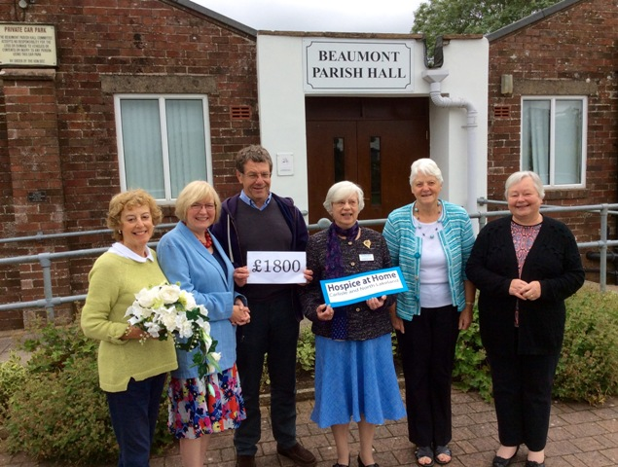
From left to right: Eve Johnson, Ann and David Thomlinson, Josephine Hope (representing Hospice at Home), Margaret McKenna and Linda Beattie.

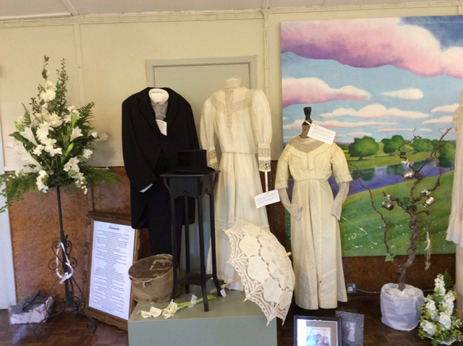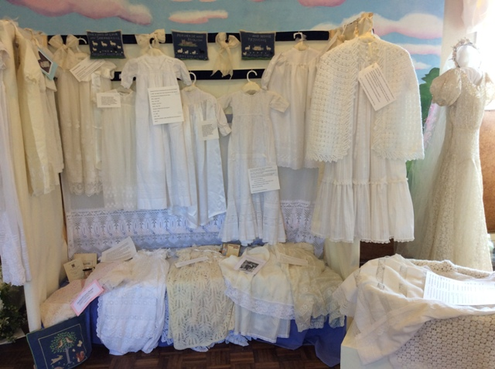

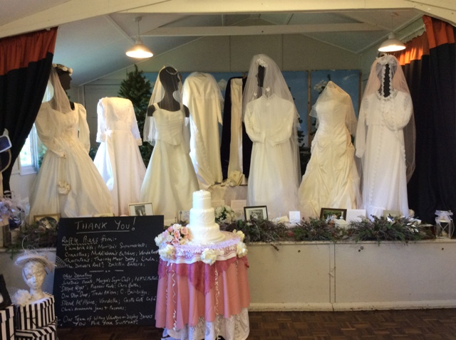

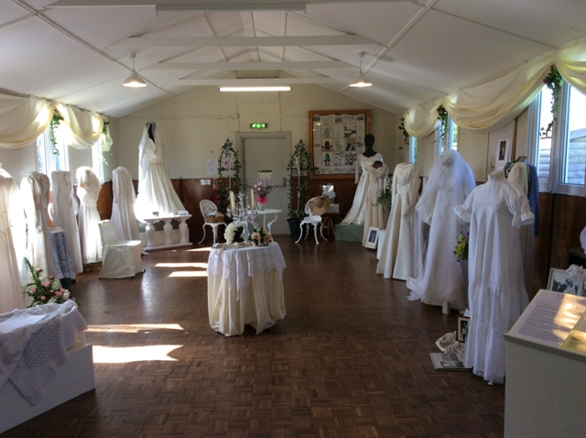

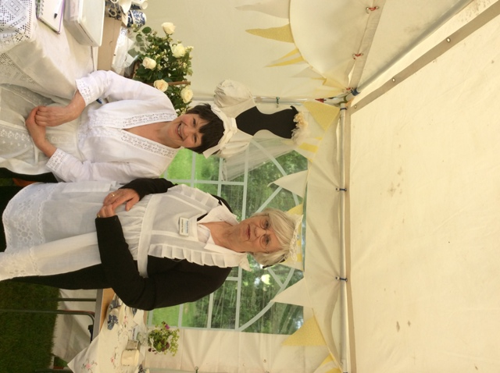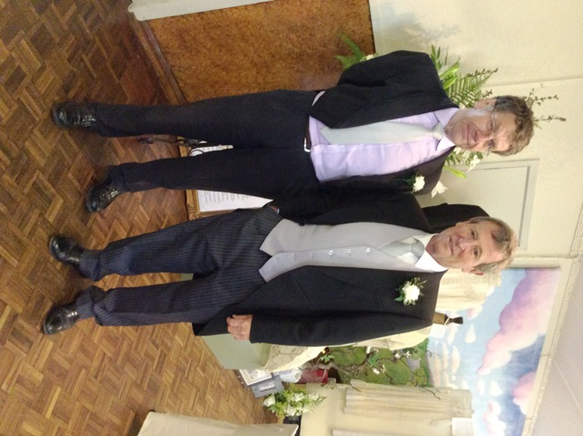
Judy Gopsill and Josephine Hope David Tomlinson and Jim Johnson

