Who built East House?

Sydling, like many Dorset villages, has its manor house (or Court House), vicarage, farmhouses and cottages. But right in the middle is an imposing Georgian house, which stands out as completely different, and slightly incongruous. Various stories as to its origins have been around over the years. It is often said to have been built by a wealthy Bristol merchant, or sea captain, for his mistress. So what is the true story?

It was built in 1787, by a Sydling man, whose family had lived in the village for hundreds of years, and had become wealthy through farming and brewing. But its origins can be traced back much further.

In Medieval times, all of Sydling belonged to Milton Abbey, except for one plot, called “The Free Suite”. This was held in 1423 by a man called Thomas Playis, seemingly quite a wealthy man. There was a medieval mansion house here. 100 year later, in 1557, it was owned by John Bowyer, another wealthy man, from Spetisbury. He may never have lived in Sydling, as he gave 100 years lease of half of the mansion house to a Sydling man, Edmund Hardy.
At the end of this 100 years, in 1667, his descendant, Edmund Bowyer had run up considerable debts, and he agreed to sell this half of the mansion House to Nicholas Hardy. The house was physically divided into two. He describes it in great detail (attached at the end of the story). The other half was eventually sold to the Kiddles, who built what is now Greystones.

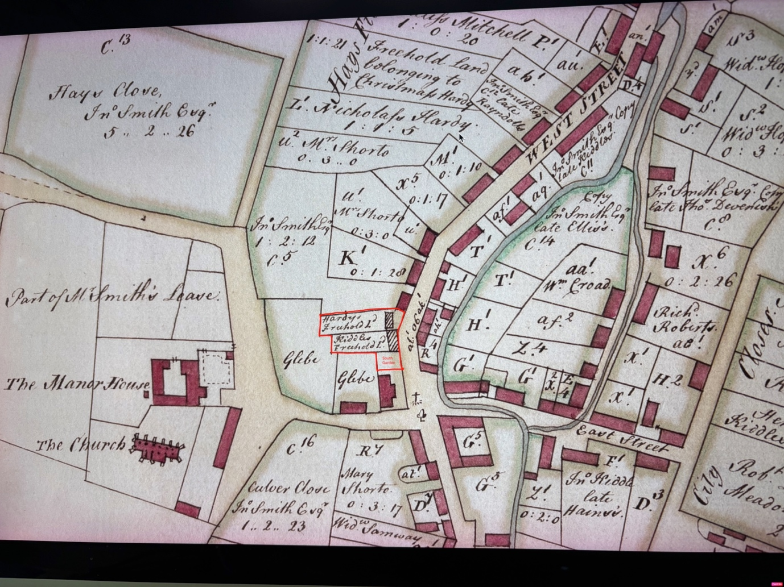
This map shows the two halves of the mansion house and its plot in the 18th Century

In 1778, Christmas Hardy was the owner of “the premises known by the name of Hardy’s part of the Free Suite”.
The premises were described as:
the Hall, the Great Parlour, the hall chamber, the parlour chamber, the staircase leading from the hall to the hall chamber, the gatehouse, the gatehouse chamber, all which premises are now one entire dwelling house known by the name of The Sun; the stable, the south pigs’ pound, that part of the garden bounded to the south by the church path.

Christmas Hardy, also had financial problems. He was living in Milton Abbas, and borrowed £100, using the house as security. A year later, he had made no repayments, the interest was building up, and he took out a bigger loan of £230 from a Matthew Devenish. Once again, he could not repay the loan, and Matthew’s brother William stepped in, and in 1785 he paid Matthew and bought the freehold from Mr Hardy for £230.

The Devenish family
There had been Devenishes in Sydling since records began (14th Century). In the 16-17th Century some were agricultural labourers still. But one branch of the family had become wealthy, farmers and brewers, establishing and running the Devenish Brewery in Weymouth.
Matthew lived in Sydling, and William lived at Huish Farm. He built East House. A plaque on East House reads “D W E 1787”, which may stand for Devenish, William and Eleanor 1787. But we believe that he built the magnificent Georgian structure on the footprint of the medieval manor house.
In his will of 1800 he bequeaths the house to his wife Eleanor and their daughter Anne.
He describes it as “the house in which we lived, which I bought from Christmas Hardy”
Which implies that some of the original house still exists, and that he did not demolish it and build from scratch.
Is the lower floor of East House the great hall and parlour of The Sun? Certainly the lower floor looks much older than the rest of the house.
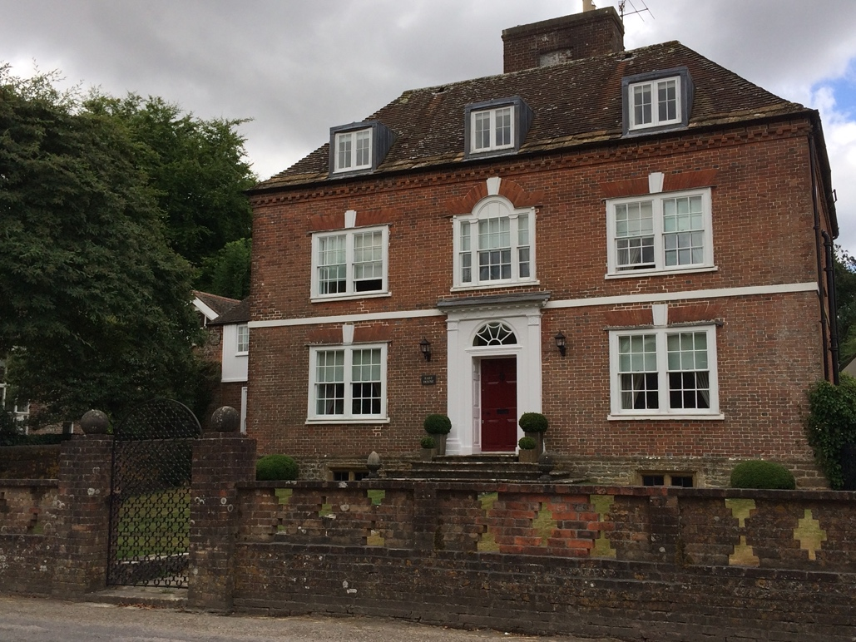
So there it is. The story of a Sydling family who did well and built a magnificent house for their family, which stands proudly to this day. We don’t know when the name changed from The Sun to East House. It’s tempting to think it was when the new house was built, with its large windows facing east to take in the morning sun and the views of the hills. But the name only appears in records from the 20th century. So, who knows?

The story of the house and its occupants from the 18th century to the present day is for another time.

Anne Brown
June 2026

And for those who are interested, here is a copy of the document of 1667, describing the mansion house, with thanks to Dorset History Centre
Transcription D/CPR11,768

This indenture made the seventh day of June in the nineteenth year of the reign of our sovereign lord Charles the second by the grace of God king of England Scotland France and Ireland defender of the faith etc anno domini 1667 between Edmund Bowyer of Spetisbury in the county of Dorset Esquire of the one part, and Nicholas Hardie of Sidling in the said county of Dorset Yeoman of the other part. WHEREAS the said Edmund Bowyer and the said Nicholas Hardie are now jointly seized of certain freehold lands situate lying and being in Sideling aforesaid, late in the tenure of Richard Christmas gent deceased And commonly knowne by the name of the Free Suite. And whereas for the more equal quiet and peaceable holding and enjoying of the said free suite between them they the said Edmund Bowyer and the said Nicholas Hardie have agreed to part and divide the said Free Suite with all the houses, outhouses edifices, gardens meadows pastures and arable lands thereto belonging with all other the appurtenances WITNESSETH now these presents that it is covenanted, granted, concluded and agreed by and between the said parties, and for them, their heirs or assigns, that a partition of the premises shall be had and made between them in manner and form following. That is to say the said Edmund Bowyer for him and his heirs and assigns is contented and well pleased to accept and take for his divided part of the whole this part and parcell of the premises following, vis the buttery, the little parlor, the larder, the kitchen, the Brewhouse, the buttery chamber, the brewhouse chamber called the pidgeon house, the oven house, the furse house with the ground thereof, the garden called the best garden and that part of the pigs pound next the house of office called the north piggstie, that part of the other garden which lyeth on the south side of a path called Church path leading from the dwelling house to the church. The pasture for one ox, one cow and one horsebeast, twenty five ewes and one Barridg’ to depasture from time to time on the pastures belonging to the premises, one close of meadow called Long Close, bounded with the land of Thomas ……….on the north part, and the common fields of Sidling aforesaid on the south part. One acre of arable land lying in the fields called Markescrosse field called eight acres in Chalcomb bounded on the east with the land of John Shortoe, one other acre lying in the same fields at a place called ..indon’s hedge bounded on the west with the land of Richard Hellier. Two acres of arable land lying in the southfields of Sidling aforesaid known by the name of Shortlands, the one bounded with the land of James Gillingham on the northside and the land of Richard Hellier on the southside, the other bounded with the river on the east side. The moiety or half in deale of one acre of arable land in the northfields of Sidling aforesaid bounded with the land of Thomas …… on the north, and the land of Johane Webber widow on the south. That is to say that half ……. Of the said acre lying next unto the land of the said Johane Webber. And the said Nicholas Hardie for him, his heirs and assigns by those presents doth covenant grant and agree to and with the said Edmund Bowyer, his heirs and assigns that … the said Edmund Bowyer, his heirs and assigns shall and may for ever hereafter have hold possess and enjoy severally and dividedly the said Buttery, little parlor and all those other houses chambers gardens, pastures, meadows and arable lands then after and hereabout particularly mentioned and expressed to be the divided part of the said Edmund Bowyer, his heirs and assigns. And doth for him, the said Nicholas Hardie his heirs and assigns remise, release and quit clayme unto the said Edmund Bowyer his heirs and assigns All and every of his and their estate right and title to that premisses above mentioned agreed upon for the several and divided part of this said Edmund Bowyer so that neither the said Nicholas Hardie nor any of his heirs or assigns at any time hereafter shall or may have or clayme any estate right or title to that said divided part for and unto the said Edmund Bowyer but shall thereafter be forever hereafter debarred and excluded by these presents. And the said Nicholas Hardie for himself his heirs and assigns is likewise contented and well pleased to accept and take for his and their several and divided part, this part and parcell of the said Free Suite and premises hereafter following. Viz the hall, the greate parlor, the hall chamber, the parlour chamber, the staire case leading from the hall to the hall chamber, the gatehouse, the gatehouse chamber, the stable, the south pigg pounds, that part of the garden bounded on the south by the church path, the pasture of one ox, one ….. one ramme and twenty five ewes to depasture from time to time on the pastures of the premises, one close of meadows lying above Hayes containing by estimation one acre and a half, and ……… by the name of Christmas Close, one acre of arable land in the said southfield called Longlands bounded on the south by the land of John Reynolds on he west and the land of James Gillingham on the east and the moiety that halfendeale of the said acre lying next the land of the said Thomas ………And the said Edmund Bowyer for him, his heirs and assigns doth by those presents covenant grant and agree to and with the said Nicholas Hardie his heirs and assigns that the said Nicholas Hardie, his heirs and assigns shall and may forever hereafter have hold possess and enjoy severally and dividedly the said hall, great parlor and all other houses, chamber, gardens pastures meadow and arable lands then after and last hereabove mentioned and expressed to be the divided part of and for the said Nicholas Hardie, his heirs and assigns and doth for him the said Edmund Bowyer his heirs and assigns remise ….. quit clayme unto the said Nicholas Hardie his heirs and assigns all and every of his and their estate, right and title to that premisses above mentioned agreed on for the several and divided part of of the said Nicholas Hardie. So that neither the said Edmund Bowyer nor any of his heirs or assigns at any time hereafter shall or may have or clayme any estate right or title unto that said divided part for and unto the said Nicholas Hardie but shall thereafter be forever debarred and excluded by these presents. And it is also covenanted and agreed by and between the said parties that the partition between the upper rooms of the house and the lower shall be erected and made by the said Edmund Bowyer. And the west end and part of the fences of the court from the stile in the said Churchpath so far as unto the oven house shall be likewise from time to time repaired by the said Edmund Bowyer, his heirs and assigns. And that the court or yard adjoining to the mansionhouse shall be and remain to and for the use of both parties, their heirs and assigns in common and to be fenced by the said Nicholas Hardie his heirs and assigns from time to time, when and as often as need shall, and that the church path ……..and ingress, egress and regress through the gatehouse shall be in common to and for both parties their heirs and assigns. And also the house of office which shall be from time to time repaire at the equal charges of each party their heirs and assigns. And lastly it is covenanted and agreed by and between the said parties that the seats in the church of Sidling aforesaid belonging to the said Free Suite and premises shall be and remain in common by and for the use of both parties and between them equally to be repaired until the said parties shall have opportunity to likewise part and divide the said seates by lott or otherwise which division and partition for the avoidance of differences which may otherwise in time to come arise and be between the said parties, their heirs or assigns they the said parties do declare the will do or cause to be made and done as soon as with convenience they can and their other occasions may permit a meeting of both parties for the effecting thereof. IN WITNESS whereof the parties to these presents each to other interchangeably have put to their hands and sealed, the day and year first above written

