Sydling Doves and Peacocks

Sydling St Nicholas has many lovely listed buildings, grand houses, farmhouses and cottages. We can also boast an 18th century dovecote, in the grounds of the Court House.
Historic England describes it as dating from 1773, and having brick walls, a pyramidal roof and clay tiles, with stone slab eaves, and steps to a door in the north wall.

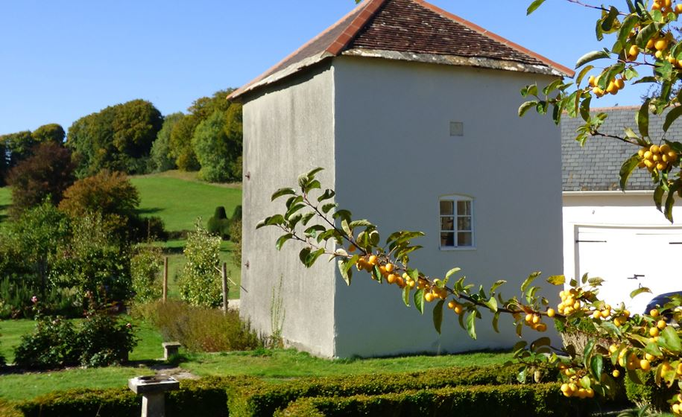
Dovecote, seen from St Nicholas churchyard

But this was not the first dovecote in the village.

In 1315, the reeve of Sydling, in his annual accounts for the Abbot of Milton Abbey, (then known as Middleton Abbey) describes a flock of 155 doves kept in Sydling. Most of them were sent to the Abbey, presumably destined for the monks’ table, and the rest were fed to the villeins of Sydling, who received a food allowance or “livery” as part of their payment for work at harvest time.

In the 1331 accounts, the reeve gives details of the building of a new dovecote. Below is his description, an interesting account of medieval construction methods, materials and wages. And the cost of sending a boy on a long errand.

Cost of a new Dovehouse
The same accounts in wages to John the Mason for making the wall around the dovecote for 1 week 20d. In payment to Robert, his mate 18d for the same. In payment to 2 boys, the servants of the same 9d. In laying the foundations 12d. For collecting stone for the wall 4d. For carrying earth to the wall 3s 4d. In carrying water 3s. In making the wall of earth and for making inside windows 13s 4d. In covering the windows with stone 6d. For collecting rods and making wattles 2s. In payment for a roofer and his helper on the same for board (food) 21d. In payment of 1 carpenter to do the carpentry of the same dovecote 10s. In buying door handles for the same 5d. In purchase of 8 young doves to stock the dovecote 4d. In payment for 1 boy to bring 12 doves from Osmington 1d
Total 40s 10d

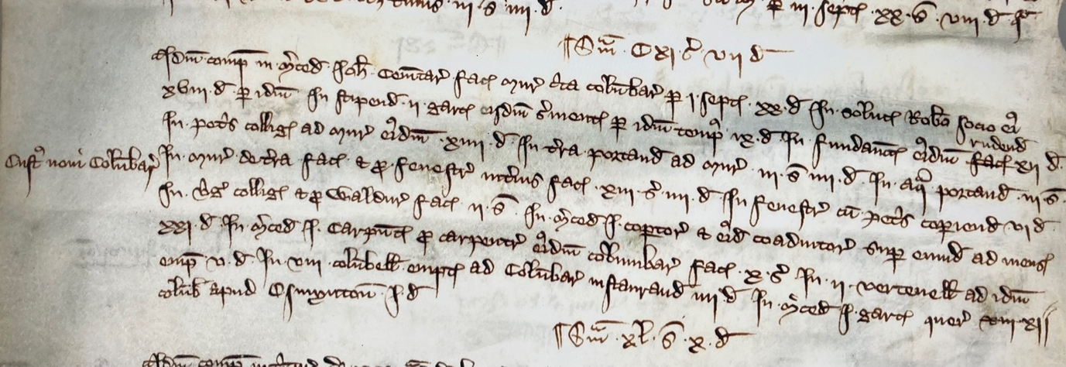

It was a long walk to Osmington, and a harder journey back carrying a dozen doves.
We don’t know exactly where the early dovecote was sited, but probably in the grounds of the Court House, and possibly in the same place as the existing building.

The monks obviously appreciated beautiful birds, as it seems, from the same account of 1331, that they kept and bred peacocks in Sydling, and sent some of the birds and their feathers to the abbey:

Peacocks
The same answers for 6 remaining from last year and for 2 born
Total 8
Of which 4 sent to Middleton for tally, and there remain 4 peacocks, 3 female and 1 male
Tails and feathers
The same answers for 2 peacock tails received from issue and for 24 feathers received from other peacocks. Of which 2 tails and 24 feathers sent to Middleton

Peacocks strolling in Milton Abbey grounds must have impressed visitors, they were certainly a demonstration of wealth and status. And a whole roast peacock would have been a showstopper for a Christmas feast. Especially with the feathers and tails on display. Perhaps the life of a Benedictine monk was not all prayer and hardship!

Anne Brown
August 2025

