The Parish Council of Little Harrowden
Clerk  Nikki Daft MILCM  45 Park Road  Irthlingborough  Northants  NN9 5PW |  | Telephone 07525 909528 email:  clerk@littleharrowdenparishcouncil.gov.uk

Dear Councillor 8th March 2018

You are hereby summoned to attend the meeting of the Little Harrowden Parish Council to be held in the Committee Room Village Hall, Main Road, Little Harrowden on Wednesday 14th March 2018 at 7.30p.m.

Yours faithfully
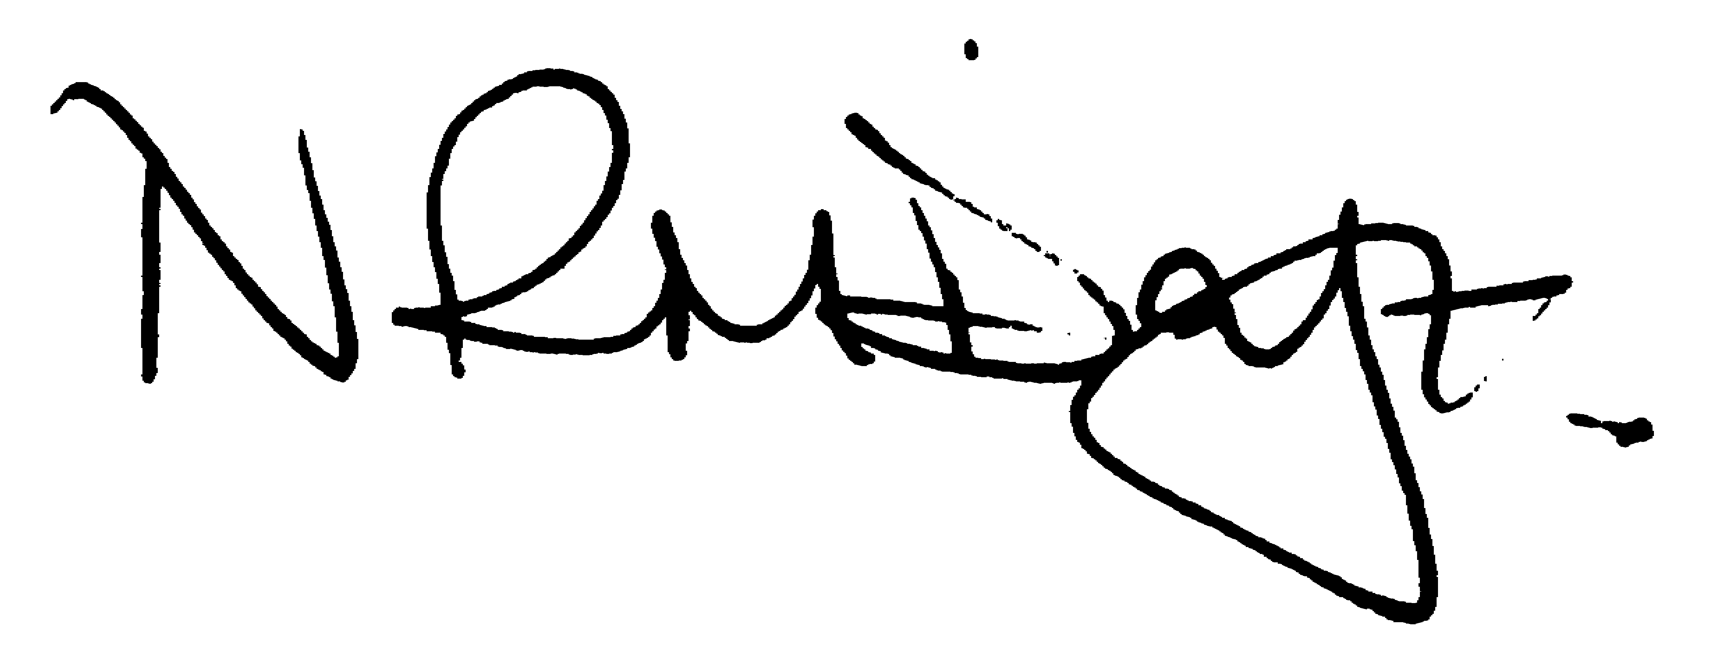

Nikki Daft - Parish Clerk

AGENDA

APOLOGIES AND ACCEPTANCE OF APOLOGIES

78/17 DECLARATION OF INTEREST

“To receive disclosures of and new DPI’s applicable to the agenda items below, personal and prejudicial interests from Councillors on matters to be considered at the meeting.
The disclosure must include the nature of the interest. If you become aware, during the course of a meeting, of an interest that has not been disclosed under this item you must immediately disclose it. You may remain in the meeting and take part fully in discussion and voting unless the interest is prejudicial.

A personal interest is prejudicial if a member of the public with knowledge of the relevant facts would reasonably regard it as so significant that it is likely to prejudice your judgement of the public interest and it relates to a financial or regulatory matter.”

79/17 PUBLIC PARTICIPATION, POLICE AND BCW/NCC COUNCILLOR REPORTS

Public participation may continue for 15 minutes where the public can make comment and ask questions which the Council may add as an agenda item at a further meeting, after which the public must not take part at any other time during the meeting. Should any member of the public wish to record the meeting please notify the chair. Police report will be given after the public session

80/17 MINUTES

To approve the minutes of the meeting held on 14th February 2018

81/17 FINANCIAL/POLICIES

- To approve payments for March 2018
- To receive information regarding the current financial statement
- To agree the authorisation of the BACS payments
- To receive information regarding the GDRP legislation that comes into force in May 2018 and to discuss who will be able to take over the role

82/17 HIGHWAYS

- To receive a report on highways issues
- To receive an update on the damage to the grass verge by Openreach
- To discuss if the pc need to purchase further Wheelie bin stickers

83/17 REPORTS

- Belgrove Park - to receive information regarding the upkeep and maintenance.
- To discuss the adding of a further dog bin near to the new gates
- Police Liaison and Safety Representative – to decide it any items are to be added to the next agenda
from the police and safety report/JAG meeting. VAS data.and policy information.

84/17 PLANNING

To discuss any planning issues:
WP/18/00115/FUL - Proposed part first floor, part two storey front extension and conversion of the garage to habitable room. Two storey side extension and two storey rear extension and the raising of the existing roof to create two additional rooms in the new roof (second floor). - 12 Orlingbury Road, Great Harrowden,

85/17 COMMUNITY ISSUES

- To receive an update regarding the articles submitted to the village magazine
- To receive an update on the Speed Watch programme
- To receive an update on events planned to commemorate World War 1

86/17 CORRESPONDENCE

To consider information received from incoming correspondence and to decide if an agenda item is required for the next meeting.

- EON price increase

