The Parish Council of Little Harrowden
Clerk  Nikki Daft MILCM  45 Park Road  Irthlingborough  Northants  NN9 5PW |  | Telephone 01933 384180 email:  clerk@littleharrowdenparishcouncil.gov.uk

Dear Councillor 7th June 2017

You are hereby summoned to attend the meeting of the Little Harrowden Parish Council to be held in the Committee Room Village Hall, Main Road, Little Harrowden on Wednesday 14th June 2017 at 7.30p.m.

Yours faithfully
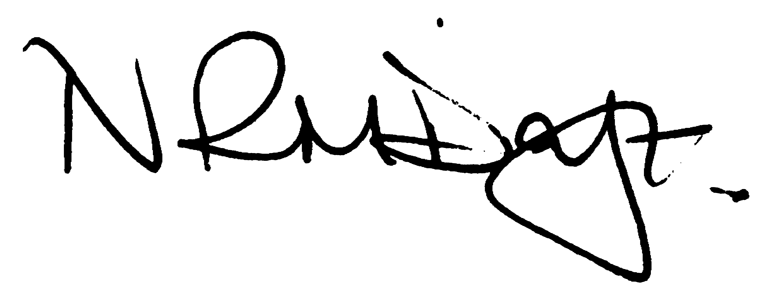

Nikki Daft - Parish Clerk

AGENDA

APOLOGIES AND ACCEPTANCE OF APOLOGIES

14/17 DECLARATION OF INTEREST

“To receive disclosures of and new DPI’s applicable to the agenda items below, personal and prejudicial interests from Councillors on matters to be considered at the meeting.
The disclosure must include the nature of the interest. If you become aware, during the course of a meeting, of an interest that has not been disclosed under this item you must immediately disclose it. You may remain in the meeting and take part fully in discussion and voting unless the interest is prejudicial.

A personal interest is prejudicial if a member of the public with knowledge of the relevant facts would reasonably regard it as so significant that it is likely to prejudice your judgement of the public interest and it relates to a financial or regulatory matter.”

15/17 PUBLIC PARTICIPATION, WBC/NCC COUNCILLOR REPORTS

Public participation may continue for 15 minutes where the public can make comment and ask questions which the Council may add as an agenda item at a further meeting, after which the public must not take part at any other time during the meeting. Should any member of the public wish to record the meeting please notify the chair. Police report will be given after the public session

16/17 MINUTES

To approve the minutes of the meeting held on 10th May 2017

17/17 FINANCIAL/POLICIES

- To approve payments for June 2017
- To receive information regarding the current financial statement
- To agree the procedure for BACS payments for the new bank account
- To agree the Financial Risk Assessment

18/17 HIGHWAYS

- To receive a report on highways issues
- To determine who owns and is responsible for maintenance for land opposite the properties at Hilltop.

19/17 REPORTS

- Belgrove Park - to receive information regarding the upkeep and maintenance. To discuss the problem with bottles etc being dumped in the park area near to residents fencing.
- Village Hall representative – to agree a village hall council representative
- Police Liaison and Safety Representative – to decide it any items are to be added to the next agenda
from the police and safety report/JAG meeting. VAS data.

20/17 PLANNING

To discuss any planning issues

21/17 COMMUNITY ISSUES

- To discuss the responses for the leaflet drop and to decide the next course of action.
- To discuss the lowering of the Union Flag and to determine how long/why the flag should be lowered.

22/17 CORRESPONDENCE

To consider information received from incoming correspondence and to decide if an agenda item is required for the next meeting.

- Civic Service invite for the Chair
- Seafarers – flag flying
- Query cutting trees at Hilltop

