Agenda item 7
To consider recommendations from the NDP Steering Group.
- The scoring matrix for the LAGS.
(NDP SG minute no. 154.1)
see minutes as back up paper attached.
- To confirm no sites will be chosen for building on as part of the NDP
(NDP SG minutes no. 155.4)
see minutes, info from consultants Feria Urbanism, info from TVBC planning officer Sarah Hughes.
Consider Questionnaire feedback from residents.
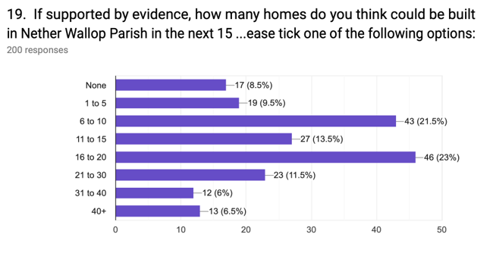
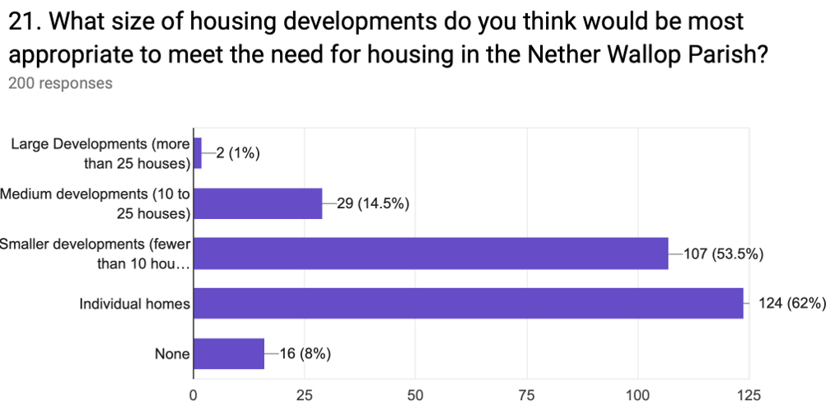
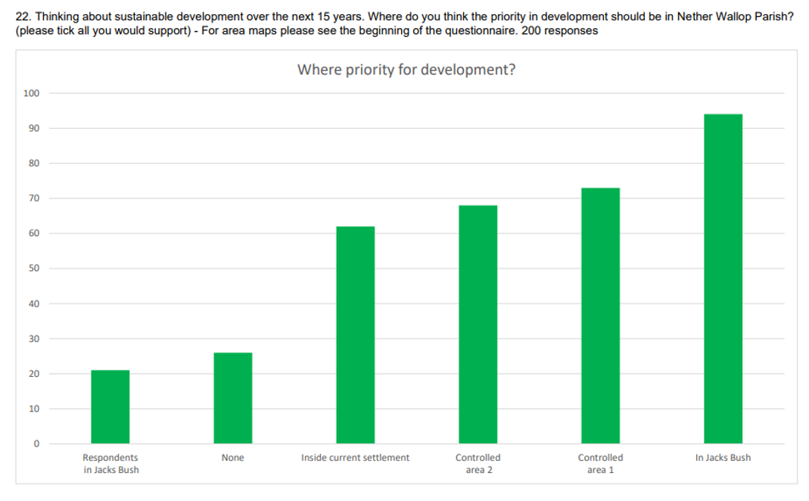
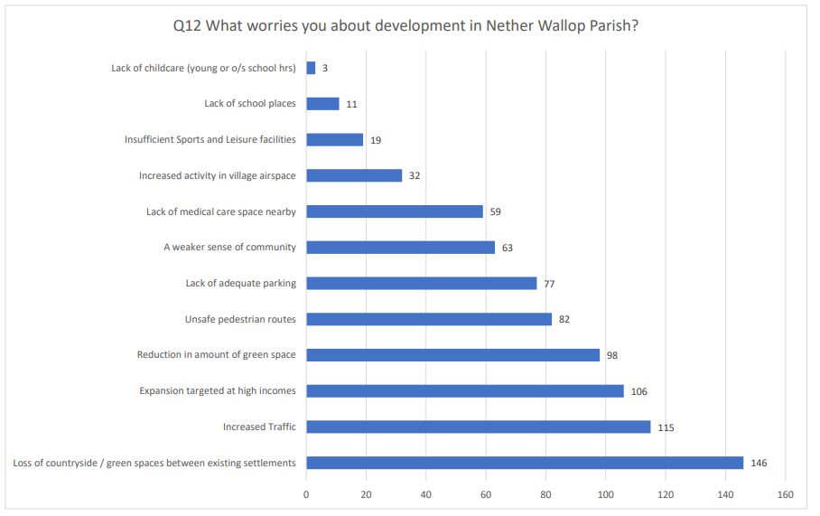
COUNCILLORS TO DISCUSS AND DECIDE WHETHER THE STEERING GROUP’S RECOMMENDATIONS ARE ACCEPTED.

