MEMBERS OF THE COUNCIL YOU ARE HEREBY SUMMONED
TO ATTEND A MEETING OF BISHOP'S CASTLE TOWN COUNCIL
WHICH WILL BE HELD IN Via Zoom
ON TUESDAY 8th JULY 2019 AT 7.30 PM

Signed: 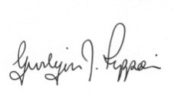^{FSLCC, Cert HE Ceg} Date: 30th June 2019
TOWN CLERK

A G E N D A
FIRE PROCEDURE

APOLOGIES
To note apologies
DECLARATIONS OF INTEREST
a) To declare any disclosable pecuniary interests.
b) To declare any personal interests.
ICO APPEAL
Update on the appeal by David Jones in relation to the ICO’s decision and direction as to actions required.

