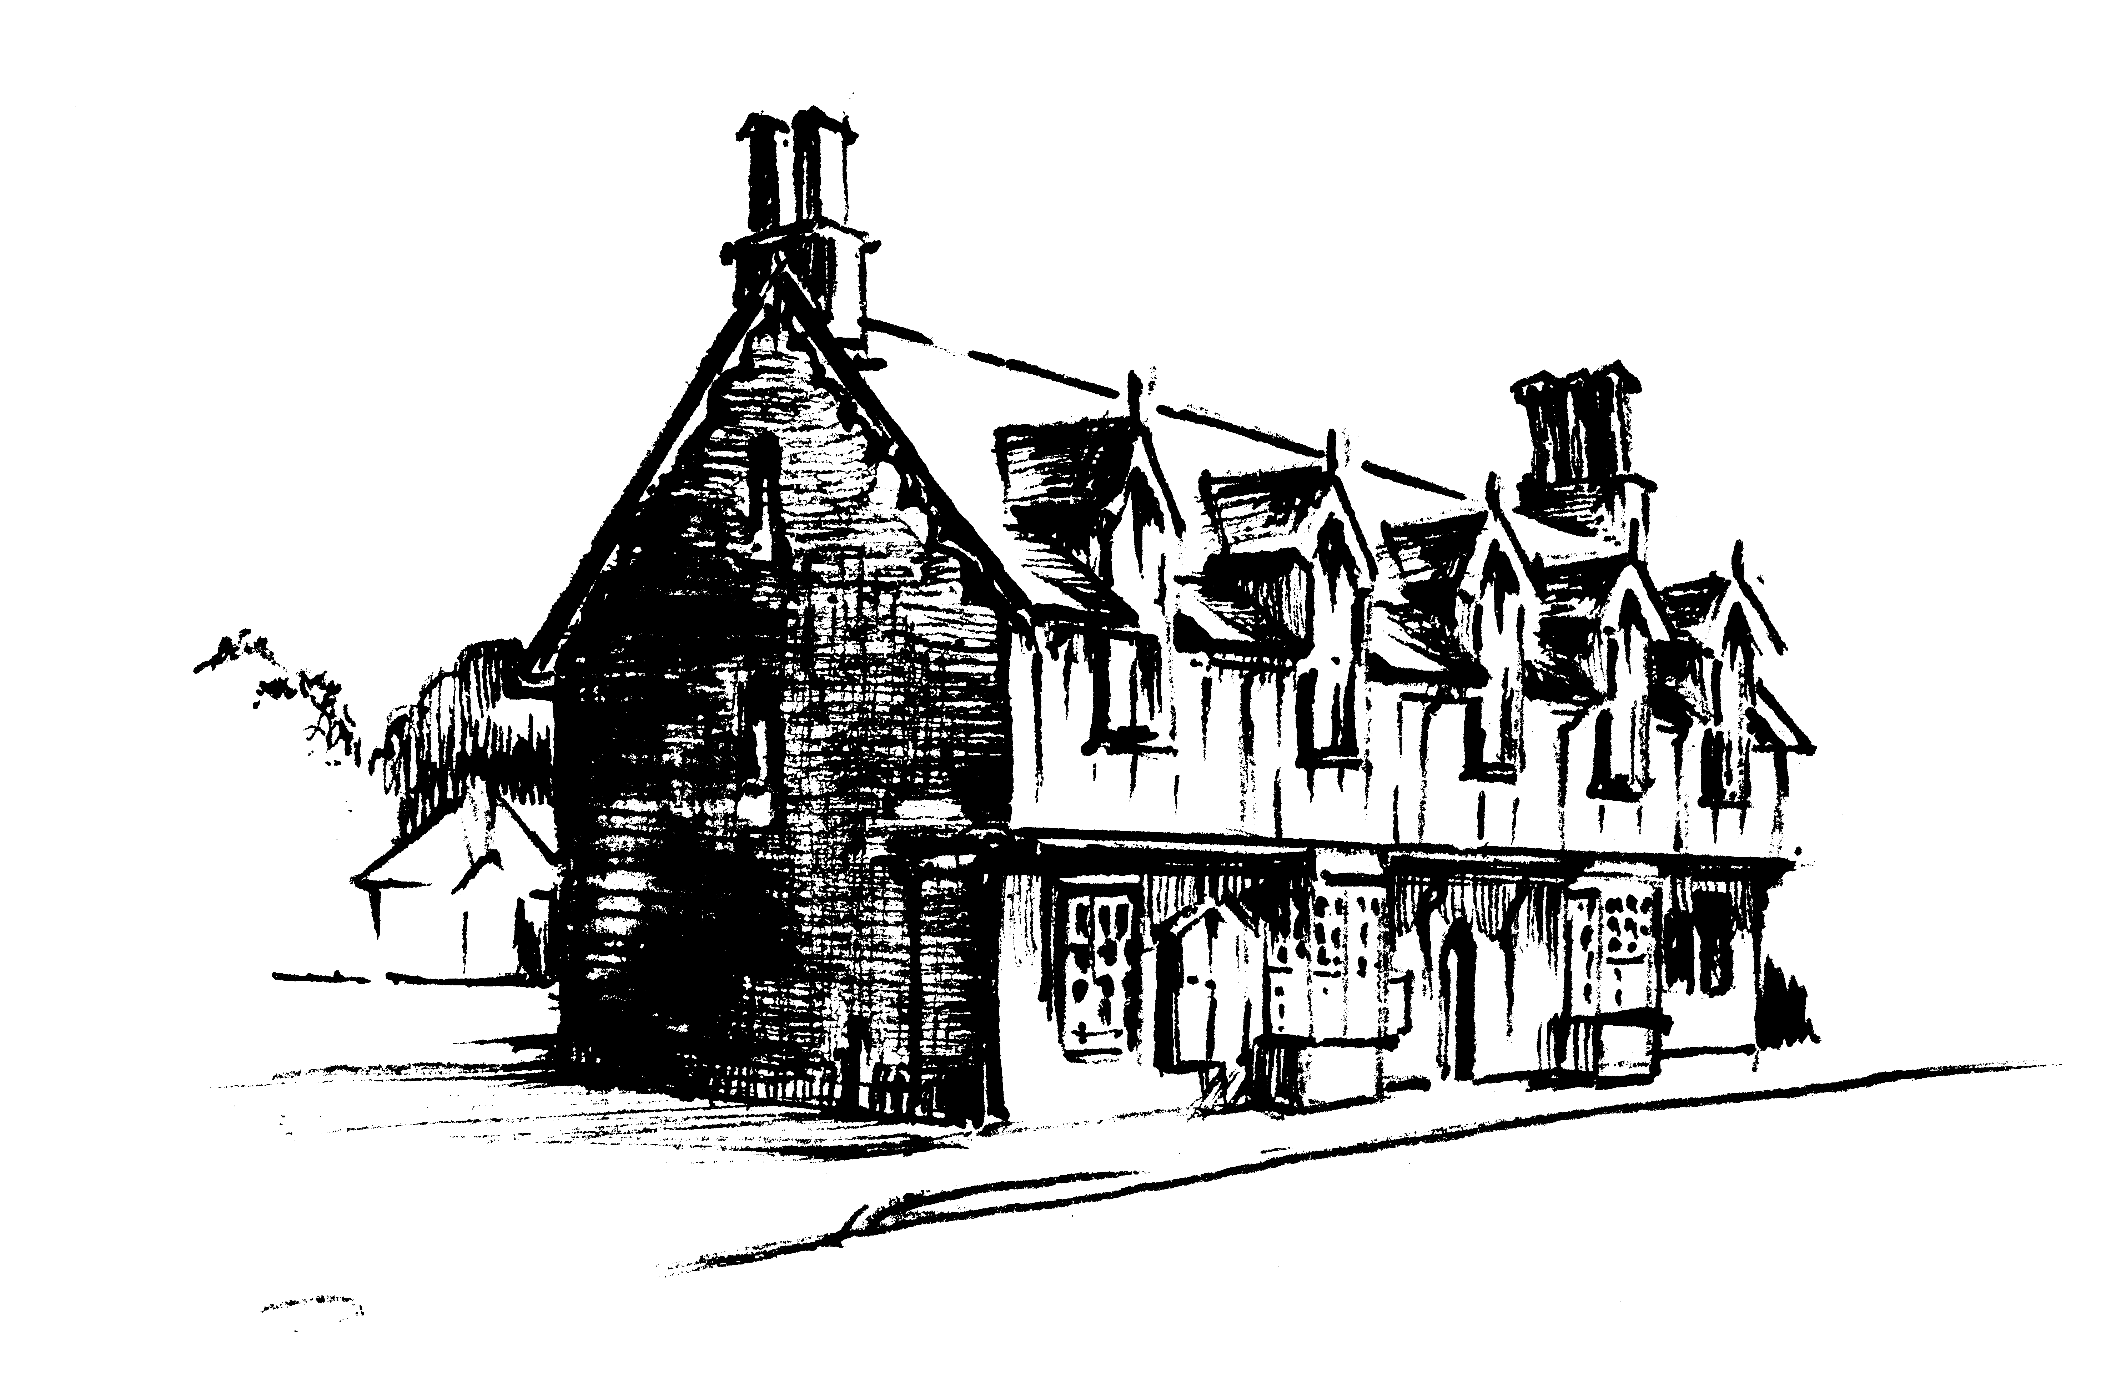
Ivinghoe Town Hall
+
Beacon Villages
Community Library
(Charity No. 300287)

Town Hall Management Committee Meeting
to be held on Monday 1st December 2025 at 6pm
in Beacon Villages Community

AGENDA

- Welcome
- Apologies for absence
- Minutes of last meeting – 6th October 2025
- Matters arising
- Chairperson’s Report
- Treasurer’s Report
- Booking Secretary’s Report
- BVCL report
11. Any other business
12. Date of next meeting

