


Briefing Note – changes to layout plan
Land off Ridout Way, Cross Houses

January 2026

Briefing Note

This briefing note is intended to be a short note highlighting the changes shown on the updated site plans that takes into account the feedback received form the parish council and local community following feed back at the previous parish council meeting and comments on the application online. The Design and Access Statement has also been updated and includes the majority of changes on page 14 of the statement, there is a Transport Statement that has been submitted.

The changes proposed include:
- Single storey bungalows along the site entrance as you enter from Ridout Road – each bungalow is marked with a yellow star below and some of the houses have been orientated to be sideways on and cross sections have been produced to ground levels across the site,
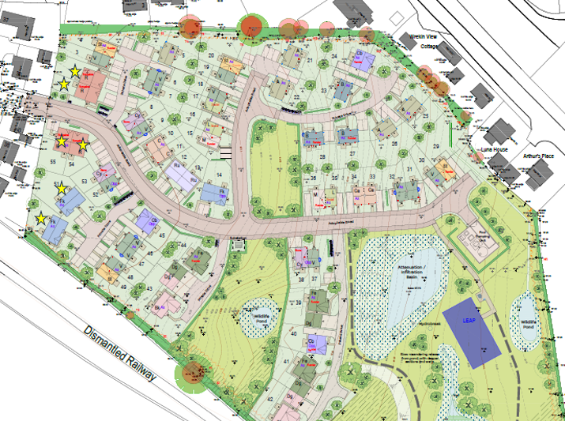
- Increased parking for 4bed dwellings and additional side by side parking to the front of most houses, with extra parking within the turning heads in several places to alleviate on street parking pressures,
- The LEAP (play area has been located in the eastern side of the site as per the request of local residents at the meeting (purple rectangle),
- The redline boundary has been altered to meet ownership requirements as you enter the site and we apologise for any oversight on the original application (shown by a green circle below),
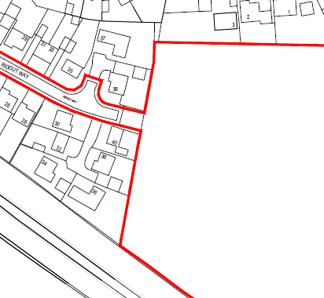
- Noise from the proposed pumping station – details have been requested form the pumping station manufacturer and confirmed as follows:
These pump stations utilise submersible pumps, which only operate when the pump units are partially or fully submerged in water. Most pump units generate 70-80dB of noise within 1m from the unit itself. Most pump units are position 4+ meters underground with a concrete slab and steel access cover to enclose the well. Noise level above the ground, directly above the pumps is estimated to be no more than 40-50dB. Type 3 adoptable pump stations require a 15m unhabitable radius from the pump station. Which means, if this station is in a residential area, then there is going to very little chance of noise disturbance whilst in operation.
Pump stations designed to adoptable standards have to meet a rigorous set of design criteria and standards, which have been curated over many years to ensure that they are not a nuisance to surrounding residents.
- With regard to access into the site – access is only available from Ridout Road because Fletcher Homes own the site. The site is currently farmed by a neighbouring landowner, which allows them to access the site from a track to the southeast (circled green), however this is third party land and NOT under the control of the applicant, so access via this route is not possible,
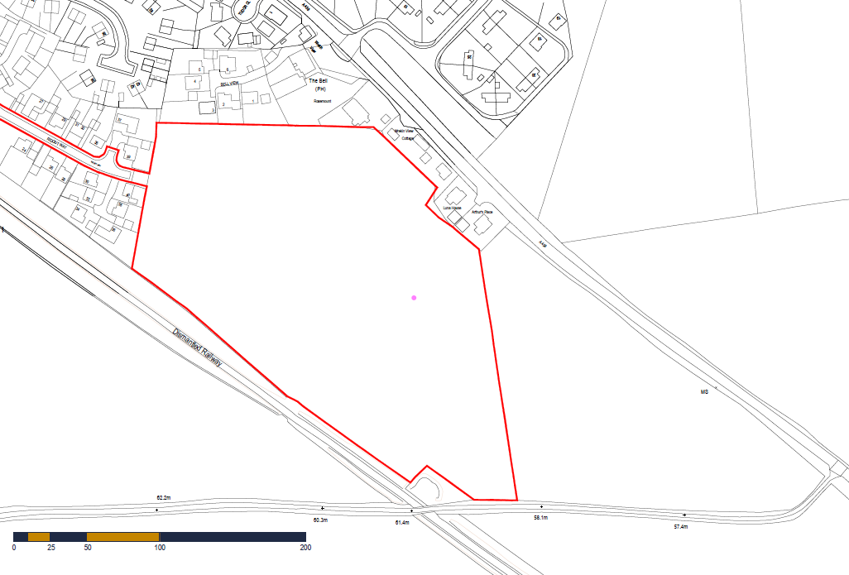
- Concerns regarding the bin lorries mounting the kerb are an existing situation and already happening, the council’s highways officer concerns this is already happening and will not result in additional refuse movements to serve the proposed site.
- Transport Statement confirms that vehicle swept paths have been assessed for the internal site layout and access route via existing residential estate roads. The assessments demonstrate that the existing and proposed road networks are suitable to accommodate emergency access. Measures to minimise potential vehicle conflict along the access route will be set out within a Construction Traffic Management Plan, to be secured as a conditional matter under any subsequent planning approval.
- Traffic generation - the proposed development is forecast to generate in the region of 29 – 31 combined arrivals and departures in the network peak hours, with a total of 135 arrivals and 136 departures per day. This represents an additional traffic movement every 2-minutes on average across network peak hours. Given that the wider development is served by a four-arm roundabout junction, it is considered that this level of additional movements can be accommodated without detriment to the operational safety and capacity of the adjoining highway network.

