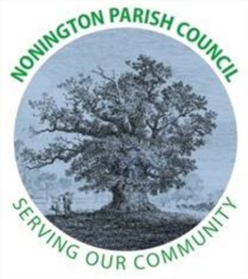

NONINGTON PARISH COUNCIL
Email: noningtonparishclerk@outlook.com Website: www.noningtonpc.org.uk

TO: ALL MEMBERS OF NONINGTON PARISH COUNCIL
Councillors are hereby summoned to attend an Ordinary Meeting of the Council to be held on
Wednesday 5th February 2025 at 7.00pm in Nonington Village Hall

A G E N D A

- Chairman’s Welcome and Apologies for absence

- Declarations of Interest

- Confirmation of the Minutes of the Ordinary Meeting held 22nd January 2024

- Public Forum

- Finance
- Payments and Receipts: Bank Balance as of 2nd February 2024: £647.04 (Current Account) and £18,210.12 (Savings Account) = Total £18,857.16
Payments
Hugo Fox – Monthly Website Costs (Jan 24) - £11.99
Unity Trust Bank – Service Charge - £6.00
Stephanie Woods – Clerk Salary (Jan 24) - £380.14
HMRC – Clerk PAYE - £293.60
Stephanie Woods – Final Salary - £71.15

- Planning

- Highways and Footpaths

- Playground, Field and Pond

- Items for discussion not on the agenda

- Date of the next meeting: Wednesday 5th March 2025

