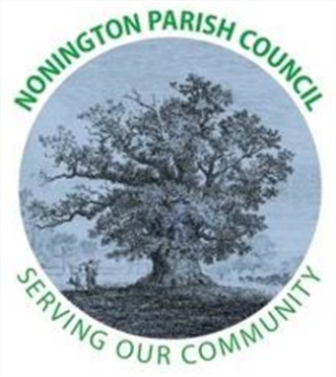

NONINGTON PARISH COUNCIL
Parish Clerk: Stephanie Woods
Email: noningtonparishclerk@outlook.com Website: www.noningtonpc.org.uk

TO: ALL MEMBERS OF NONINGTON PARISH COUNCIL
Councillors are hereby summoned to attend an Ordinary Meeting of the Council to be held on
Wednesday 22nd January 2025 at 7.00pm in Nonington Village Hall

A G E N D A

- Chairman’s Welcome and Apologies for absence

- Declarations of Interest

- Confirmation of the Minutes of the Ordinary Meeting held 4th December 2024

- Public Forum

- Finance
- Payments and Receipts: Bank Balance as of 29th November 2024: £1,668.37 (Current Account) and £18,210.12 (Savings Account) = Total £19,878.49
Credits
Unity Trust Bank – Credit Interest - £121.37
Payments
Hugo Fox – Monthly Website Costs (Dec 24) - £11.99
Unity Trust Bank – Service Charge - £6.00
Stephanie Woods – Clerk Salary (Dec 24) - £380.14
Nonington Village Hall – Hall Hire (Oct – Dec) - £51.00
Stephanie Woods – Reimbursement Annual 123 Domain Registration - £15.59

- Planning

- Highways and Footpaths

- Playground, Field and Pond

- Grants 2024/25

- Items for discussion not on the agenda

- Date of the next meeting: To be confirmed

