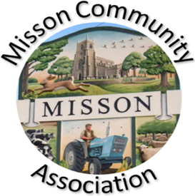
MISSON COMMUNITY ASSOCIATION

AGENDA

MEETING ON WEDNESDAY 21st October 2026 AT 7.15 PM

- Apologies for absence

- Declarations of any new committee member interests outside MCA.

- Minutes of 16th September 2026.

- Non-agenda matters arising from minutes 16th September 2026.

- Treasurer’s report

- Building maintenance
- Replacement taps in toilets
- Fire extinguisher testing
- Boiler breakdown
- Boiler room clear out
- Cleaning update
- Work outside the building
- Recent Events and bookings
- Talk on Vermuyden
- Misson Beat Surgery
- Live and Local – Appraisal
- Private party 10th October
- Play group
- Chair Exercise Class
- Future Events
- Friday 23rd October – Church Harvest Quiz and Supper
- Saturday 31st October – Church TableTop Sale
- Saturday 31st October – Children’s Halloween Party
- Friday 13th November – Marcella’s Minute to Minute
- Sunday 22nd November – Christmas Fayre
- Wednesday 9th December – Over 65s Christmas Lunch, White Horse
- Sunday 13th December – Children’s Christmas Party

- Correspondence/Contact/Communication (Facebook, Posters, NL etc.)

- Any other business
- MCA Constitution and Management Agreement.
- MCA website
- Inspire Heating App

- Date and time of next meeting – Wednesday 18th November at 7.15pm

