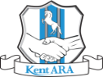KENT ACTIVE
THE NEWSLETTER OF KENT ACTIVE RETIREMENT ASSOCIATION
Volume: Seven May 2021 No. 83

“Do not think of retirement as someone closing a door on a bright and crowded street.
Think of it as someone opening the door to a beckoning and uncluttered world.”
John Hardiman (Founder of the Association)
Yes, To The Test!
Better Safe, than Sorry!
A suggestion on how to make your meetings safer…

Please tell your members about the Covid-19 Test Kits, and perhaps suggest that they use them, so they can show their negative test result ‘White Stick’ if asked, before joining any event you might be planning in the near future, especially if it is indoors.

Always observe the evolving government unlocking guidance at
https://www.gov.uk/coronavirus

Get your Free Lateral Flow Covid-19 Test Kits NOW!

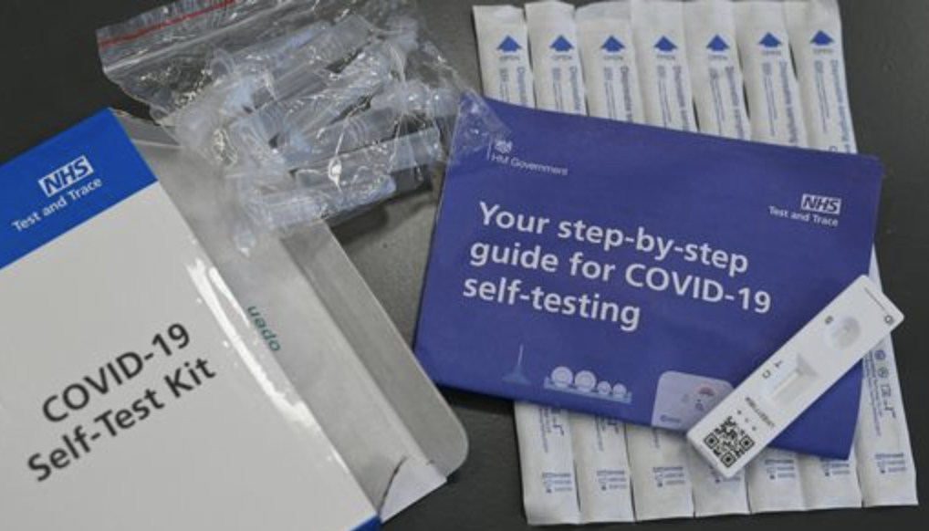

- Collect from your local Covid Testing Centre
- Collect from your Local Chemist / Pharmacy
or
- Order your Coronavirus (COVID-19) rapid lateral flow tests at
https://www.gov.uk/order-coronavirus-rapid-lateral-flow-tests

or
Find Where To Your Get Rapid Lateral Flow Tests at
https://maps.test-and-trace.nhs.uk/
and enter your postcode to find your nearest supply.

They are FREE!

Protect yourself, and everyone else!

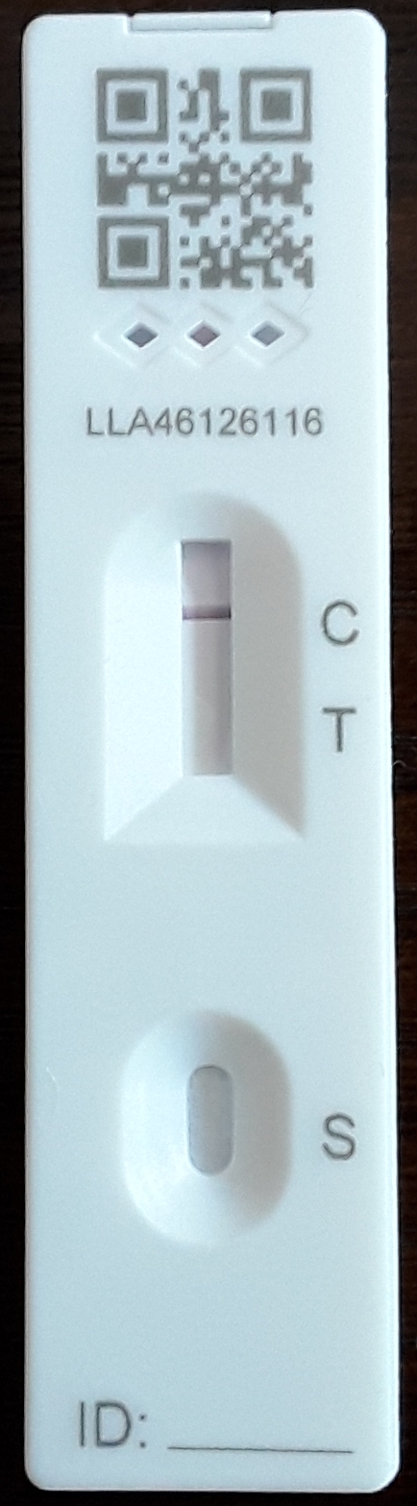
Actual Size

This is my Negative Test result.
Note the single horizontal line at the letter ‘C’,
which confirms a negative test result for Covid-19.

A Negative Test Result shows you care, and is the best passport you could take with you before entering any meeting.

This is what various test results should look like.
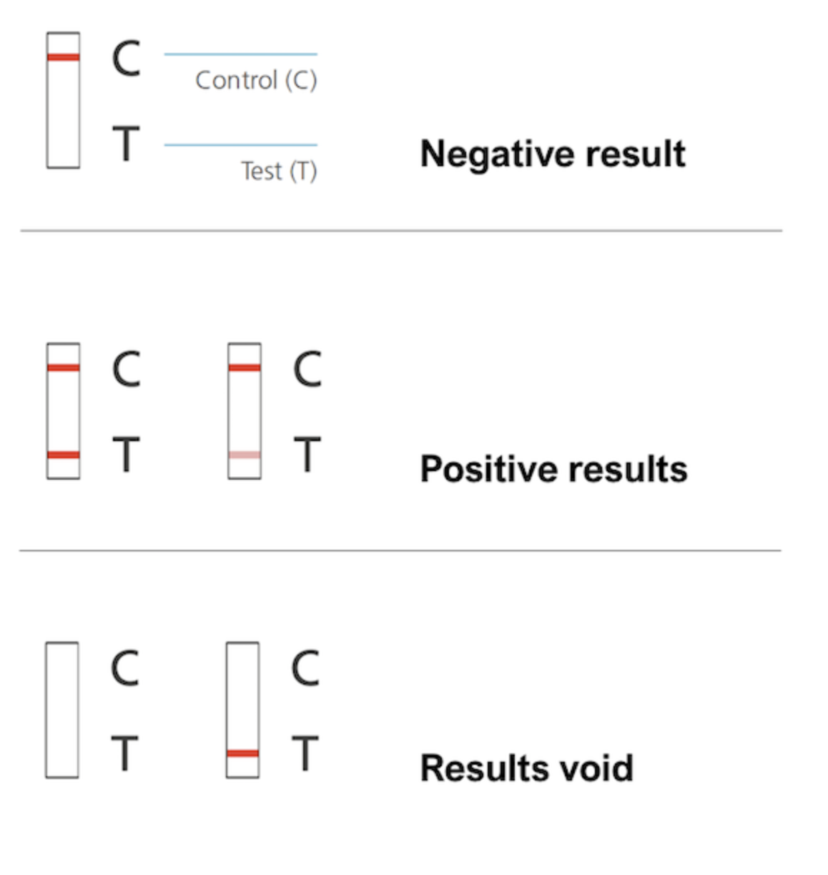

Watch the Video
https://www.youtube.com/watch?v=ebxhEOLfTN0

Understanding Lateral Flow Antigen Testing
for people without Symptoms
https://www.gov.uk/guidance/understanding-lateral-flow-antigen-testing-for-people-without-symptoms

For more information on Covid-19 Rapid Tests, and Test Kits,
https://www.nhs.uk/conditions/coronavirus-covid-19/testing/regular-rapid-coronavirus-tests-if-you-do-not-have-symptoms/

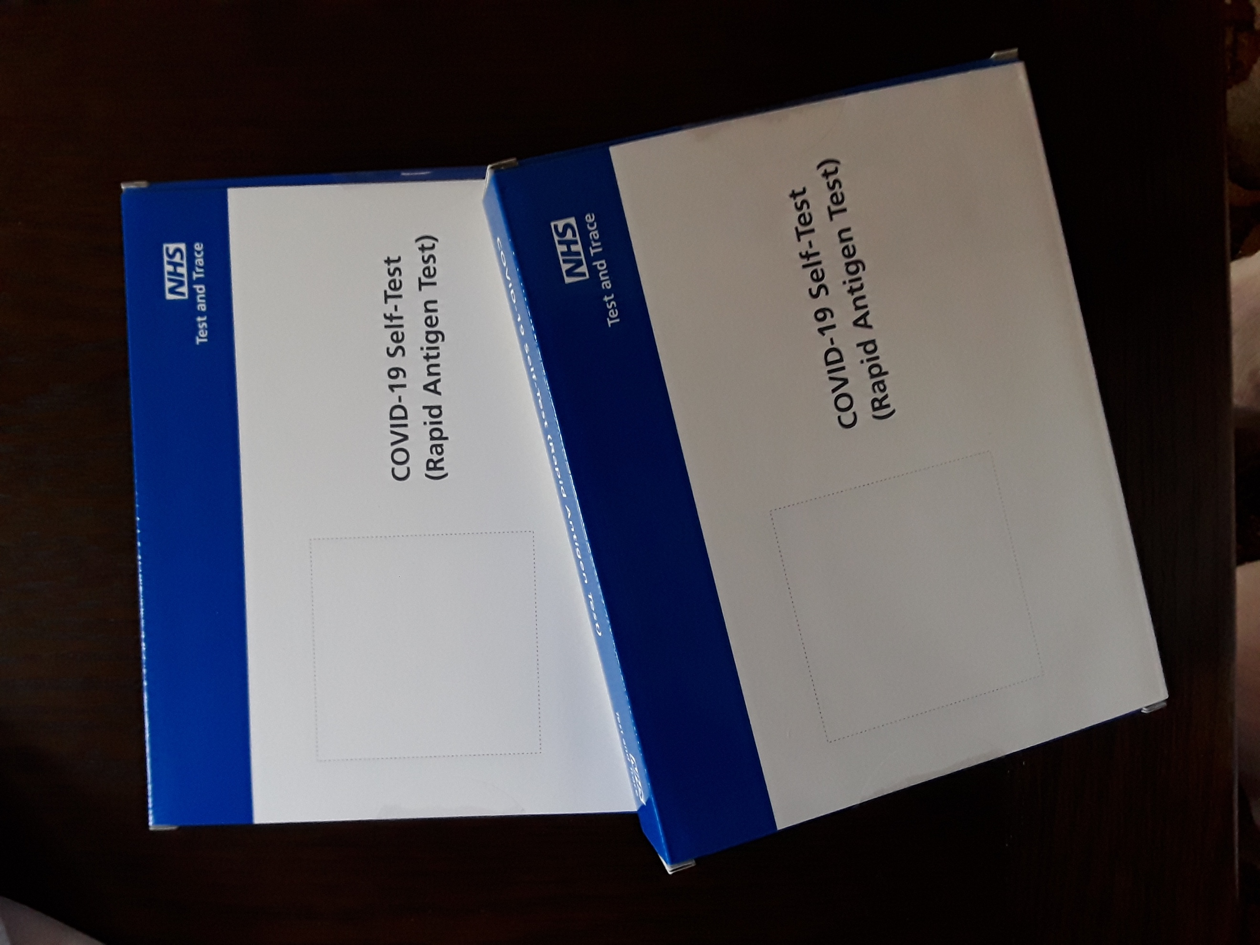
You get two Covid-19 Test Kits, with 7 individual Tests in each box.

Feel free to call me if you have any questions.
Love, Joan Rhodes
KentARA Chairlady 01732 844 953 rhodjo@aol.com

KENT ACT!
THE ALTERNATIVE NEWSLETTER OF RIOTIOUS KENTARA SENIORS
Volume: Seven June 2021 No. 83
Circulation: All Who Can Carry a Pitchfork, And Can’t Read.

“When I Said I Wanted My Second Jab, I Didn’t Mean Cut My Head Off, And Put It On a Pike.”
Wat Tyler. (Former Chairman of KentARA c.1381)



Photograph’s by Graham Pover. Graham can be contacted at gpoverphotography@btinternet.com

Letters to the Editor.
Dear Mr Wishy Washy,
Has anyone considered that it would be a zoonotic folly to use ‘Sniffer’ dogs to detect a respiratory virus in humans?
Yours Truly,
June Pooch
RoversdenARA

Dear June,
You make a worryingly good point. Perhaps you should send your letter to a newspaper with a wider reach than the ‘Kent Active’ newsletter, or perhaps email someone in the NHS science community.
Yours helpfully,
Wishy Washy
Newsletter Editor Kent Active togthedog@btinternet.com

May Day at Viking Bay

The KentARA Long Ship, ‘Oares Away’ commenced boarding from 6.30am, at Gravesend Pier, and departed at 7.45am, after loading vittles of 100 gallons of lager, 20 kilos of bacon, 12 dozen eggs, and 36 crusty brown loaves, 1000 tea bags, and a cow for milk.

Unexpectedly crewed by the passengers, who were not all together pleased when presented with the oars for rowing by the rather fearsome looking Skipper, ‘Olaf’ (who obviously had lockdown locks, under his horned helmet, and a beard to match), the KentARA ‘crew’ decided it might be better to cheerfully volunteer, rather than end up over the side, on what was meant to be a jolly day out.

After much moaning and groaning, the boat, stopped at Sun Pier, Chatham, to pick up a contingent from Area 11, who discovering a large sail on board, opened it, had the oars pulled in, and then happily set sail up the Medway estuary; where under the direction of Magnus of RoffARA, there was a mutiny, after the Skipper Olaf made a very dodgy decision - at low tide, to take a short cut up ‘The Swale’, to reach Whitstable. Captain Olaf, (now renamed ‘Skipper Your Having a Laugh’), was put off, and marooned on Sheppey, and the boat was turned around, avoiding being stranded on the mud.

A hearty breakfast was then had by all, and a vote of thanks was made to Æstrid of Strood for cracking the eggs, and beating off the gulls.

After a passing bout of sea sickness around Botany Bay, a pod of dolphins was spotted at the prow of the boat, but on closer inspection they were considered as possible sharks, at which point all the oars went back into the water, and the boat reached speeds of up to 40 knots, causing a wake the like of which had not been seen for decades.

On speedily arriving at Viking Bay, Broadstairs, around midday, it was with the utmost dismay of all on board, when they found that there was not enough room on the beach to fit a chip between the deck chairs.

The local RNLI then ‘moved on’ the KentARA Longship as a hazard to swimmers, and the local Coast Guard escorted the boat out to sea, and told them to go the ‘long way’ around, to get back to Gravesend.

The last reported sighting of the KentARA Long Ship, ‘Oares Away’ was somewhere off Spithead, Portsmouth.

