Information on the Pound, Kirkandrews on Eden
Information gained from residents in the Drover’s Rest on Thursday 26th March 2015

The Pound in Kirkandrews is the enclosed area of land in the centre of the village that some local residents refer to as the Pinfold.

Although the area is currently grassed with a few small trees and shrubs, surrounded by a low wall, in living memory residents of the village recall that the area was secure, having railings above the front wall with secure gates with a hand pump and trough for the animals to drink from. The pump and trough were situated inside the gate on the Beaumont road opposite Eden Farm. There were no trees in the enclosure.

The Pound was used as a temporary holding pen for animals to be kept safe overnight by drovers moving animals between the Solway marshes and Carlisle or on the way to the animal markets in Carlisle They would pay a small fee to hold their animals in the pound overnight and then stay at the Drover’s Rest in Monkhill.

The Pound was also used to hold stray animals found in the village until the owner of the animals could be found and then the animals released upon payment of a small fine.

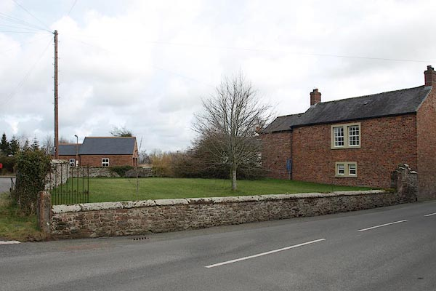

The Pound from Burgh road (2014)

General information about folds.

Managing farm animals through the farming year is a far from simple job. From the very earliest days when animals were first domesticated, there needed to be places where animals could be kept for protection from wolves and thieves, or to make sure they did not damage growing crops in fields.
It seems likely that these enclosures were used to corral sheep or cattle whenever necessary. From the Norman period, the feudal system of managing farmland communally meant that strict controls were placed on where and when animals could graze. The village pound or pinfold was created as a place where straying animals could be locked up until their owners paid a fine for their release.

The village pound survived the end of the medieval system of communal farming and shared grazing since animals still tended to stray if their owners failed to keep up their field boundaries. The pound was a handy place to keep animals while their owner was located even if fines were no longer imposed. Most of these little stone walled enclosures fell out of use after the implementation of the Enclosure Acts in the early 19th century. Little open grazing survived after this and land had to be securely walled or hedged.

