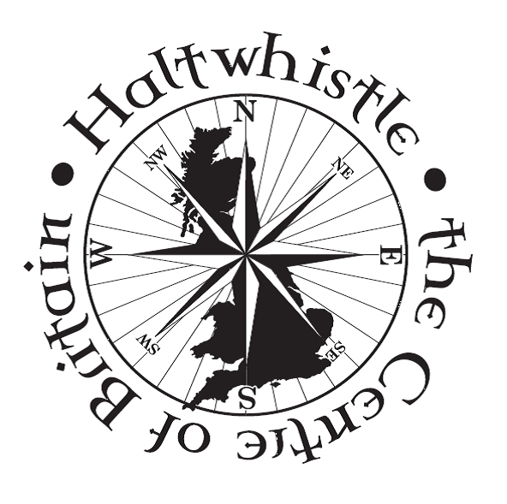
Haltwhistle Annual Town Meeting

TUESDAY
19th Of May 2026 From 6:30pm
First Floor At Haltwhistle Library
AGENDA
- Minutes Of The Annual Town Meeting Held On
Tuesday 6th Of May 2025

- Matters Arising From The Last Town Meeting On
Tuesday 6th Of May 2025

- Annual Report For 2025-2026
- Matters Raised By Parishioners
This Is An Opportunity To Ask Questions Of Councillors And To Make Your Views Known About The Directions Of Services In Haltwhistle

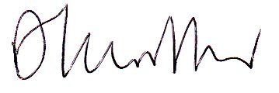
Signed:
Councillor Alan Sharp, Chair Haltwhistle Town Council

Town Clerk: Emma Ackroyd
Tanglewood Cottage, Pennine Road, CA8 7AB
Tel: 07818915171
Email: clerk@haltwhistletowncouncil.org

