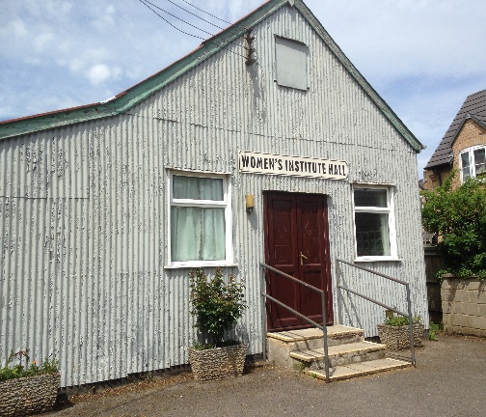.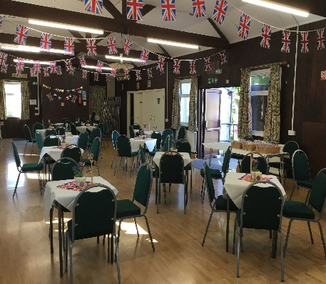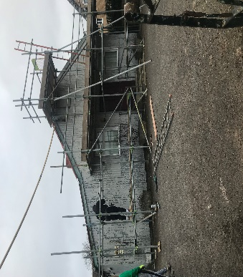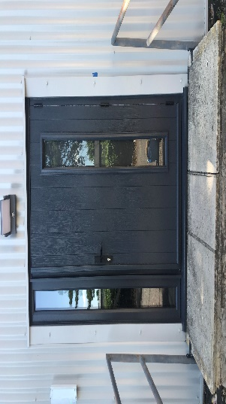Carterton Women’s Institute Hall. Charity No.227773.

An amazing story of Hard Work and Determination over the Generations by members of Carterton Women’s Institute
Carterton, in West Oxfordshire, grew from farm land to a collection of small holdings when Mr. William Carter bought the land and divided it into plots to sell to people wanting to escape big cities for a new life at the beginning of the 1900s. Early settlers included Soldiers returning from Conflicts. The Charity St. Dunstan’s sponsored injured and partly slighted soldiers to take up rural occupations in the countryside to help them recover from their injuries and live fulfilling lives.
In 1922 three ladies, Mrs. Annie Clarke, Mrs. Jessie Offley Shore, and Mrs. Gladys Hammett living in the rapidly growing village decided to form a Women’s Institute. At their initial meeting sixty ladies attended, being the majority of ladies in the village. It soon became apparent that a meeting place was needed for this expanding community.
A plot of land in the centre of the hamlet near the crossroads was purchased for the sum of £25.00. By 1925 a tin corrugated hall had been built on the site thanks to Mr. Ernest Christmas Clarke, and his wife Mrs. Annie Clarke who mortgaged their home to fund the building of the WI Hall. It took many years of fund raising by the Women’s Institute members to pay back the loan. A passage in our Archives in 1928 states “members still working to pay off the debt”. By 1932 members had managed to raise enough funds to pay back the loan.
These three ladies became the first Trustees of the Hall.
It was the wish of the three ladies that the hall be administered by four Trustees, the members of Carterton Women’s Committee and members. These wishes were written into the original convenance dated 3rd November 1925. They are still in place today.
The hall today is a much-loved community asset full of memories of village life over the decades. Nowadays, in addition to WI meetings, the WI run a weekly Coffee Shop for the community and monthly Craft Group. The hall is hired out daily by many local organisations.
When the hall was originally opened it was lit by Tilly lamps, heated by Tortoise Stoves and had no running water.
No insulation in the ceiling or walls, over the years plumbing, toilets and a kitchen have been added with electricity and oil central heating, but still no insulation.
Our hall offers a cosy, safe and friendly environment. During a recent survey we found that the WI Hall is very much appreciated by the local community.
The extensive refurbishment of the hall requires dedicated fundraising activities and is a huge undertaking by our members.
Due to continued fund-raising events organised by our members refurbishment was able to start in early 2023. We receive no funding from either the Oxfordshire or National Federation of Women’s Institutes.
To date we have a new roof, new external walls with insulation, new central heating boiler. New secure front door and safe steps, new external lighting, and entrance bell above the disabled entrance ramp, which completes Phase one of the refurbishment plan. Hopefully, Phase Two will be started in the Autumn of 2024 when internal walls and the ceiling will be insulated, new toilets built, including disabled facilities. New storage. An internet connection allowing a new booking system.
Without the indomitable determination of these three ladies our hall would never have happened. With the same determination today the Ladies of Carterton WI are determined to bring the Hall up to today’s standards so that it can be loved and used by everybody in the Carterton Community for many years to come. EG.

