Grinshill Parish Council
Sub Committee Meeting Agenda
Venue – The Old Vicarage
6th April 2017- 13.00hrs – 14.30hrs

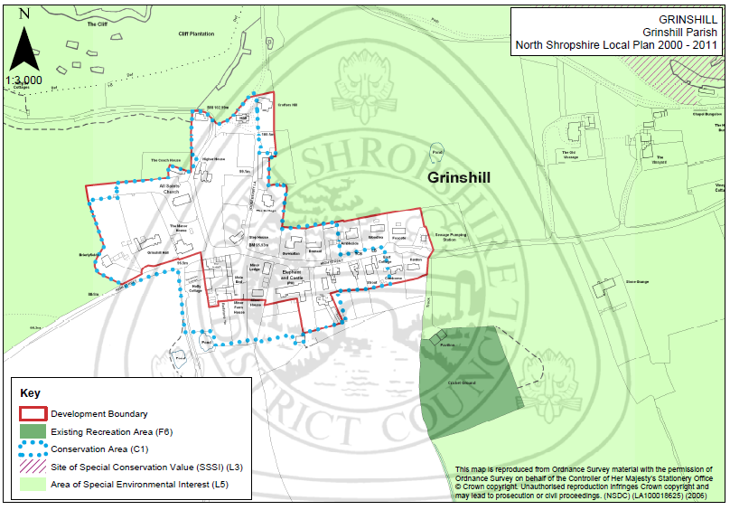

Duration | Subject | Lead | Objective
2 minutes | Chairman Welcome and Introductions | Paul Jones | Meeting introduction and welcome any new attendees.
2 minutes | Apologies and reasons for absence and approval of meeting minutes. Agree minute taker for today. | Paul Jones | Note any apologies for absence and sign off minutes of previous meeting.
2 minutes | Agenda Share | Paul Jones | Quick run through meeting agenda to provide some focus.
2 minutes | Action Points | Paul Jones | Update actions as required.
40 minutes | Public drop in session | Mike Roocroft | Discuss analysed feedback and specific comments and ideas.
20 minutes | Next Steps Plan | All | Decide our next steps following feedback from the community together with a timetable for action including communications.
20 minutes | Partial Review of the Local Plan | All | Discuss and agree next steps towards Cluster arrangements and a timetable of actions required for plan handover.
2 minutes | Agenda Items for next meeting | All | Agenda items and date of next meeting.

Action | Person Responsible | Update  (Red,Amber,Green)
Submit Parish Council Input to Consultation on Issues and Strategic Options | Paul Jones
Handover Drop in Session materials to PC Clerk | Mike Roocroft
Analyse and categorise feedback from Drop in Session for 6th April meeting. | Mike Roocroft
Ask Sue Thomas for her views concerning Adrian Cooper briefing. | Tom Wycherley
Submit article for local newsletter for Drop in Session initial feedback and next steps. | Paul Jones

