Accessibility Statement for Bowes Parish Council Website
This website is run by Bowes Parish Council
We want as many people as possible to be able to use this website. AbilityNet has advice on making your device easier to use if you have a disability.
Accessibility
We aim to meet the accessibility standards defined by the Public Sector Bodies (Websites and Mobile Applications) (No. 2) Accessibility Regulations 2018 and the WCAG 2.2 AA guidelines.
How accessible this website is
The Council pay Hugo Fox to administer the website. On 17 March 2026, their managing director informed the Council that “your Hugo Fox website is already fully compliant with WCAG 2.2 AA accessibility requirements, GDPR regulations and Assertion 10. We continuously monitor standards and requirements to ensure your site always remains secure, accessible, and in compliance with current regulations.”
Users with visual difficulties should click the icon in the top right-hand corner of the home page (person in a blue circle) and switch accessibility features on before accessing content:
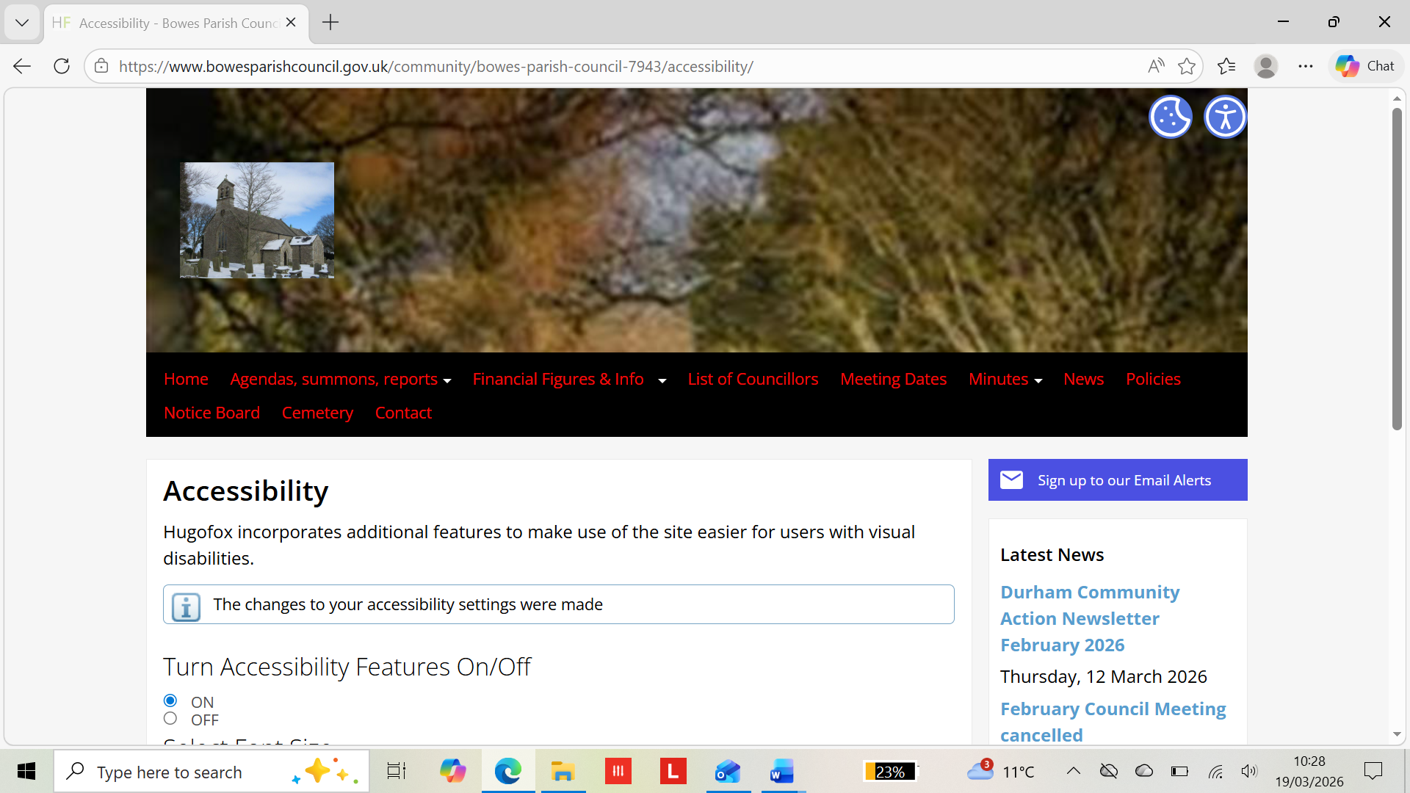
If you need information on this website in a different format (e.g. large print, audio, or braille) please request using the contact form on this website or email clerk@bowesparishcouncil.gov.uk
We will consider your request and respond within 15 working days.
Regulation 6 of the Accessibility Regulations (2018) does not require the Council to comply with requirements that impose a disproportionate burden on it. Bowes Parish Council consider that for a council with fewer than 500 residents and a single part-time employee it would be disproportionate to test the website for compliance. Instead, the Council relies on the assurance given by Hugo Fox above. However, if any non-compliance is brought to our attention, we will update this statement to outline the exceptions.
Enforcement procedure
The Equality and Human Rights Commission (EHRC) is responsible for enforcing the accessibility regulations. If you are not happy with how we respond, please contact the Equality Advisory and Support Service (EASS).

This Statement was published on 19 March 2026 and will be formally approved at the next council meeting.

