Public footpaths within our parish boundary

How do you get around within the village? You almost need your own means of transport to leave the village. We are fortunate enough to have Hugin’s Green and Pegwell Nature Reserve, both of which are generally accessible. There are a few footpaths through the village. Do you know where they are and do you use them? The parish council have just received a report from Maura Pell, Ramblers Footpath Officer about our local public rights of way.

Ramblers Local Footpath Officer - introduction

Like many others in the village I love walking and over the 20+ years I have lived here I became increasingly concerned that so many paths were in disrepair or being closed off altogether. Ten years or so ago I joined the Ramblers as they were the one charity who seemed to be addressing this issue.

I volunteered to become a Ramblers footpath Officer which effectively means the dog and I have been walking as many paths as possible North and East of Wingham to report problems on the paths; and there are many of them! Recently I have been given particular responsibility for checking paths in Minster, Monkton Cliffsend and Manston.

I believe the paths are so important because they are part of our heritage, if we lose them we won't get them back. They are essential to many for not just physical but mental health. Green Tourism is particularly important for our villages and they are a resource we are just so lucky to have.

If you would like to find out about our paths get hold of an ordnance Survey Map Explorer 150 Canterbury & Isle of Thanet of if you go to the following KCC website its free. It shows all the footpaths in Kent, all of which have a number and there is a tool for reporting any problems.

Who is responsible for what?

KCC are responsible for maintenance of footpaths but, since the council is claiming to be starved of vital resources, they have become greatly dependent on volunteers.

Faults or concerns can be reported to KCC using the following tool -
https://webapps.kent.gov.uk/countrysideaccesscams/standardmap.aspx

Obviously KCC will not come out to every reported fault but if a whole lot of people report the same fault, it pushes up the priority to get it cleared.

The Ramblers form a big part of this volunteer service. Local contact details are -

LFO Maura for Minster, Monkton, Cliffsend, Manston who can be contacted on maurapell@btinternet.com
CAWS https://www.kent.gov.uk/leisure-and-community/volunteering/countryside-volunteering/countryside-access-wardens

TDC really only get involved where a footpath or right of way becomes involved as part of the planning application process.

Parish Councils, probably the larger ones, may have a person or group responsible for monitoring the state of footpaths within their parishes. They may offer some kind of assistance and coordinate groups of volunteers.

The following is a personal assessment of the footpaths of Cliffsend parish.

Public Rights of Way, Cliffsend Parish
(current situation September 2020)

There are 4 Public Rights of Way in Cliffsend Parish and the Parish is crossed by 2 major walking routes. They PROWs are deep purple and the Walking routes are shown in Yellow on the map below.

TR32 - Between the Eastern boundary of the old Lavender Farm and Canterbury Road West.
TR11 - Path across Marjorie Chapman Meadow
TR33 - Path from back of Hugin’s Viking ship, down steps through the old hover port to the seafront.
TR15 - Beginning of Cliff Path to Ramsgate

The English Coastal Path (follows coast line) which is also known in this area as the Contra Trail, a path from Pegwell to Ramsgate.

The St Augustine Camino, https://britishpilgrimage.org/portfolio/augustine-camino/ is a pilgrim route from Canterbury to St Augustine’s shrine in Ramsgate.

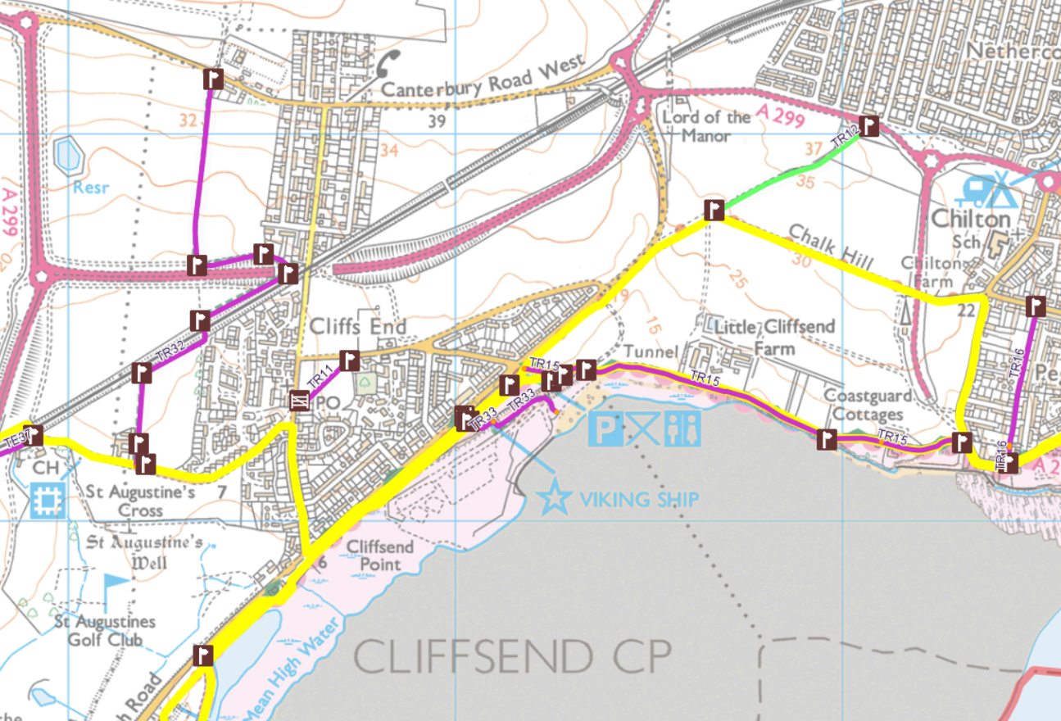

TR11 (path across Marjorie Chapman Meadow) and TR15 (Cliff Walk) are in excellent order. The views particularly in winter across the marsh from Marjorie Chapman Meadow are beautiful and in a sheltered corner you’ll find a some picnic tables, suitable for a stop. TR15 has some of the finest views in the country, looking out across Pegwell Bay, this is where English History began, the Romans, the Anglo Saxons, the Christians and the Vikings all landed here. The busiest shipping lanes in the world are readily observed and there are often amazing views right across to France. The Viking Bay café is terrific and I have used it for many years. It is a bit of a shame that due to Covid the public toilets are closed.

TR33 (the path that goes down steps from behind the Viking Ship to the old Hover port) is in good order but not perhaps as attractive as it could be. My main concern is that the new sewage line Works HQ is in the Hover Port and multiple lorries are roaring up and down the old road with no thought that there is a public right of way across their path. I spoke to the guys at the site office who were very pleasant but they had no idea there is a PROW; in fact they had wondered why they had seen so many people in the Hover Port. It is dangerous as there is no signage and general ignorance all round. Southern Water are due to complete their major repairs by the end of 2020 and, presumably, will vacate the site.

TR32 (path from lavender farm to Canterbury Road). This is a real PROBLEM PATH and should be kept under careful observation as it forms part of the new Cliffsend Parkway Station Development. However, the Railway station is not the problem, all the plans I have seen show the footpath is included in the planning applications.

My concerns are much more pragmatic. The first part of the path from the Lavender Farm to the Railway line is constantly ploughed up and under crops and despite repeated notifications over many years nothing has been done to rectify this. I will endeavour to discuss with the landowner the need to recognise and preserve the right of access. The finger post adjacent to the railway line has been taken down and buried in a tree. I have reported this on the KCC website.
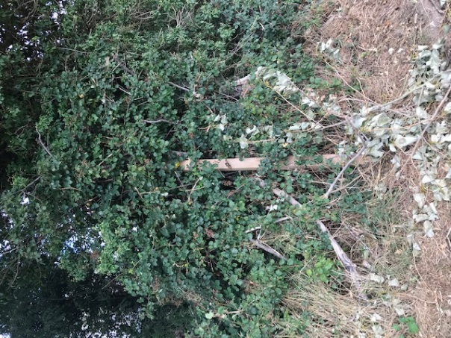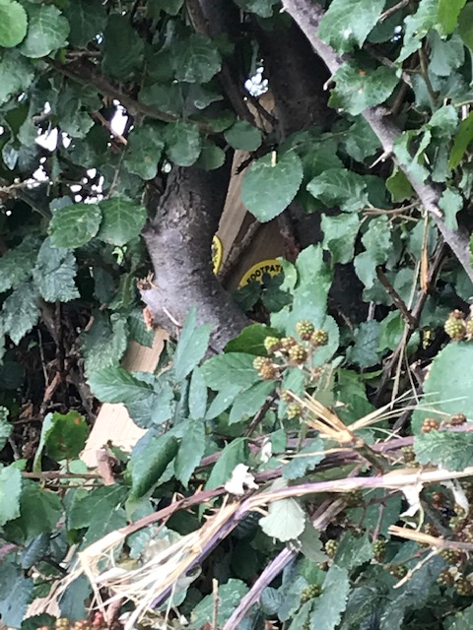
The path adjacent to and south of the railway line is OK but again often ploughed up.

The tunnel under the railway line is very beautiful with some wonderful Victorian Brickwork, I hope this will be retained when the new station is built. The latest plans for Parkway indicate using this under track passgeway instead of steps and bridge over the tracks between platforms.
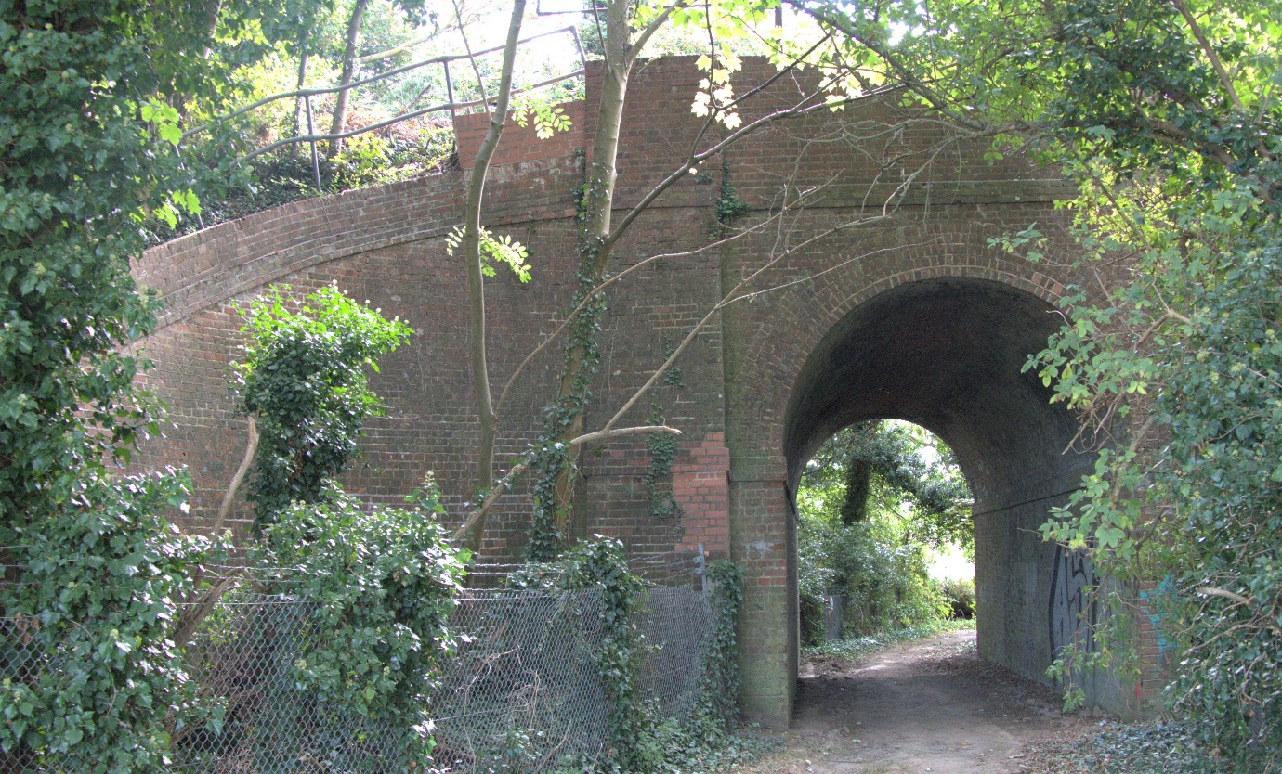

On exiting the tunnel, one should be able to turn right and walk East, adjacent to and North of the railway line. The path is overgrown, with deep rutted asparagus beds right up and onto the path so walking in winter is particularly difficult. The vegetation can be seen behind the way marker, the notice is the planning application for the new station. Reported KCC Website.

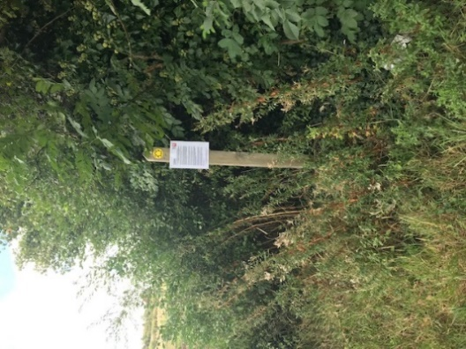

The path “u turns” over the new underpass and is concrete so is fine and the way signs are in place but once the path turns “North” up the hill toward Canterbury Road it is ploughed up. This path has not been marked for a couple of years. Just before the path exits onto Canterbury road it runs adjacent to a house fence. Progress is impeded by what appear to be deposits of garden waste. As said at the start of this section, this a clearly a problem path.

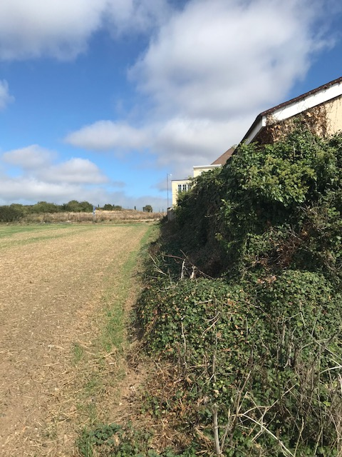

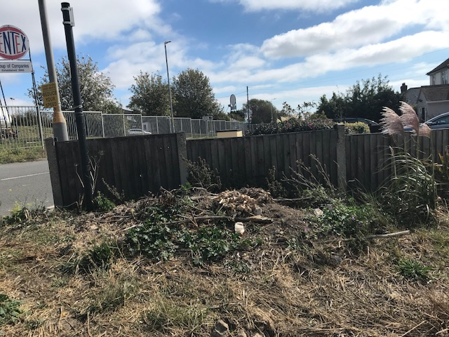

The major walking routes are both fine but through Cliffsend they are mostly on existing roads and cycle paths. One of the routes including Foads Lane and Cottington Road are noticeably lacking in pavements.

My hope is the Parish Council might get behind some of the problems, particularly with regard to TE32 as KCC seem to have such limited resources and these wonderful paths do need looking after.

* * * *

