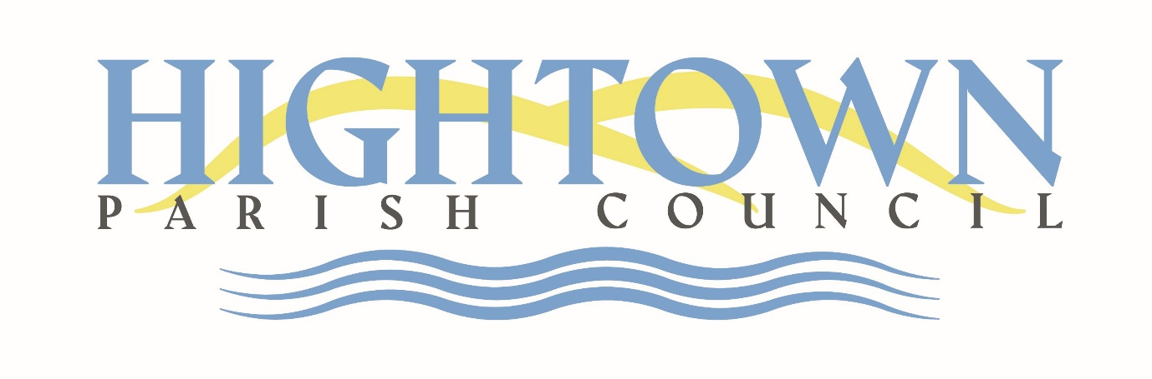

Scheme of Delegation
for Hightown Parish Council

Reviewed March 2026
This Scheme of Delegation authorises the Parish Clerk to act with delegated authority in the specific circumstances detailed below:

- The day to day administration of services.
- Day to day supervision and control of all contractors and staff employed by the Council.
- Approval of urgent expenditure up to £1000 regardless of budgetary provision.
- Approval of routine expenditure up to £500 provided the same is within the budgetary provision.
- Delegated actions of the Parish Clerk shall be in accordance with Standing Orders, Financial Regulations, this Scheme of Delegation and with resolutions made by the Council from time to time.

