PETROCKSTOWE PARISH COUNCIL
Parish Clerk: Fiona Lowe, Rose Farm, Petrockstowe, Okehampton EX20 3HQ
Phone: 01837 811749 E-mail: petroc.clerk@hotmail.com

Dear Councillors
You are duly summoned to attend the Petrockstowe Parish Council Meeting to be held at 7.30pm on Tuesday 17th January 2017, in the Baxter Hall, Petrockstowe, to discuss the following business.

AGENDA

- Apologies of Absence. To receive any apologies

- Declarations of interest

- Public Session

- Minutes. To consider the approval of the minutes of the Parish Council Meeting of 15th November 2016, having been previously supplied.

- Planning. Planning applications since 15th November 2016.

- Councillors Reports for information.
- Recreation Ground – Cllr Kelsey
- Play Area – Clerk for Cllr Jeffs
- Baxter Hall – Cllrs Busby / Harris
- County / District – Cllrs Boyd / Wiseman
- Police Report – PSCO Baxter

- Matters arising from previous minutes.
- Rec Ground
- Skate Ramp - update Clerk
- The Square, Land Registry – update Clerk
- Rebinding of historical document - update Cllr Kelsey
- Maintenance review of assets – update Cllr Fisher
- Play Park repairs to wall – Cllr Fisher

- Current Business
- Highway Maintenance – Community Enhancement Fund application
- Date of May meeting
- Annual Parish Meeting arrangements

- Financial Items
- Financial Report
- Precept agreement
- Cheques
- Clerks expenses

- Confirm date of next meeting.

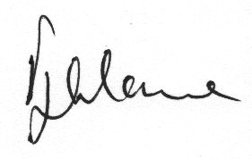

Fiona Lowe
Parish Clerk
11/01/2017

