Old Place Names of Sydling

As you head out for a walk up the hills or around the village, to clear your head after the indulgences of the festive season, spare a thought for the people who went before you and trod these same paths, over the centuries. In many ways the valley would still look familiar to them, but the names they gave to different parts of it have changed over time.
It might make your walk more interesting to ponder on some of the names of familiar places, present and past.

.
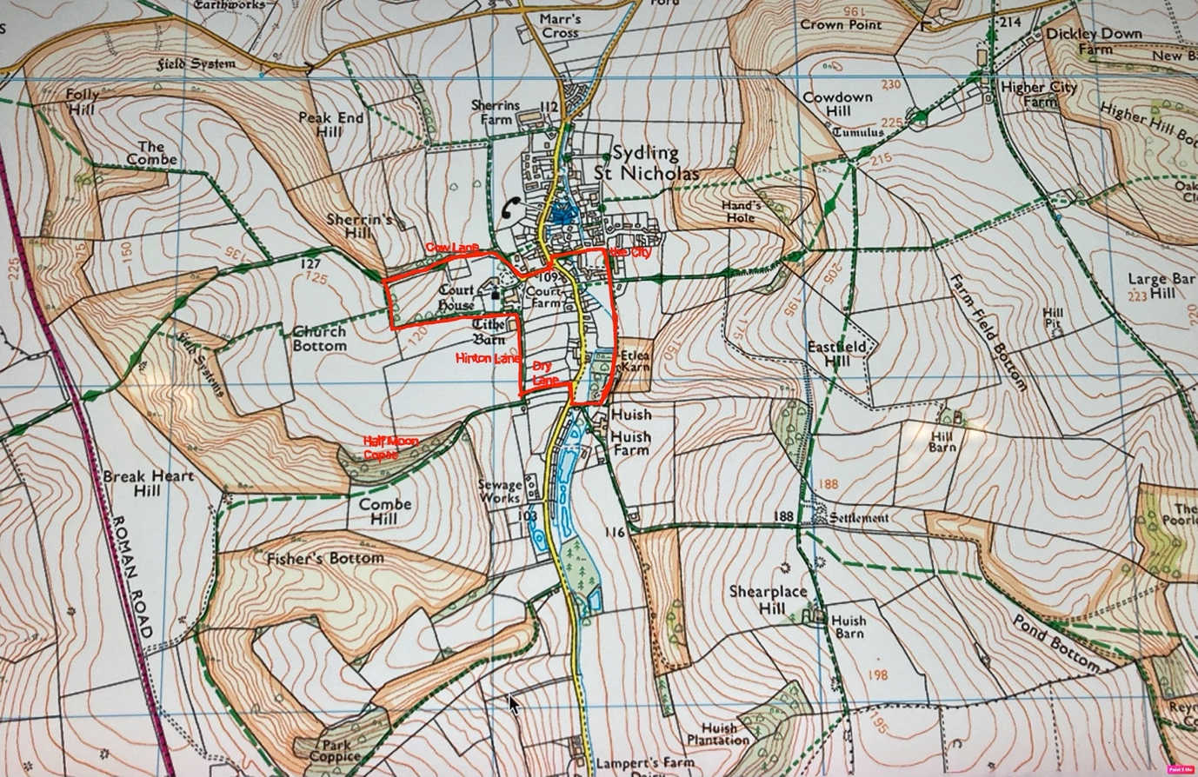

So, let’s take a walk, from the cross tree, up Church Lane, and the lane known as Court Ashes. This lane was called Cow Lane, from at least the 1500s to the 1800s. It runs below Sherrins Hill, named after the Sherren (or Sherrin) family, who lived in Sydling in the 18th Century, and farmed this land in the 19th century. A sherrin is of course the Dorset name for a hare, so it is known also as Hare’s Hill. For hundreds of years before this, the hill was known as Northfield Hill.
If you were to fork right, and head up towards Stag’s Folly, you would be in the Combe, which has had this name since at least the 14th century. The Combe was common grazing, where the villagers were allowed to pasture a certain number of animals, according to each of their individual agreements. The part we now call Church Bottom was also part of the Combe, occasionally referred to as Court Combe and the hill to the south is called Combe Hill.
Carry on round the church and back to the tithe barn, then turn right along Hinton Lane. In medieval times this was known as Hyndon Lane and the area around it Hyndon furlong. The origins of the name are lost in the mists of time. Dry Lane has been known as Dry Lane for at least 200 years, and is shown on the first enclosure maps. Before this, from at least as early as the 14th century, it was known as Water Vallowe. Perhaps this was Water Valley in a Dorset accent? Spelling in medieval times was variable and usually phonetic.
The lovely wood on Combe Hill, which we know as Half Moon Copse, presumably because of its shape, appears on 19th century maps with the less romantic name of Turnip Hill Plantation. To the south, the next wood is Park Coppice, which is an ancient woodland, thought to be within the boundary of a medieval deer park.

And now a mystery for you. If you walk down Dry Lane and turn back down the road to Huish, you may decide to return to the village through the sawmills. On the map above, this area is called Etlea Karn, the name by which it was known in the mid 20th Century. Can anyone suggest where this name came from? In the 19th century, there was a watermill here, and the cottage known as Pitts Cottage (now Little Egret), and the area was referred to as Pitts.

Coming back to the village you go along the green, past the site of “the poor houses known as The City”, on this 18th century map. Their site is remembered in the name of City Cottage. Then turn left down East Street.

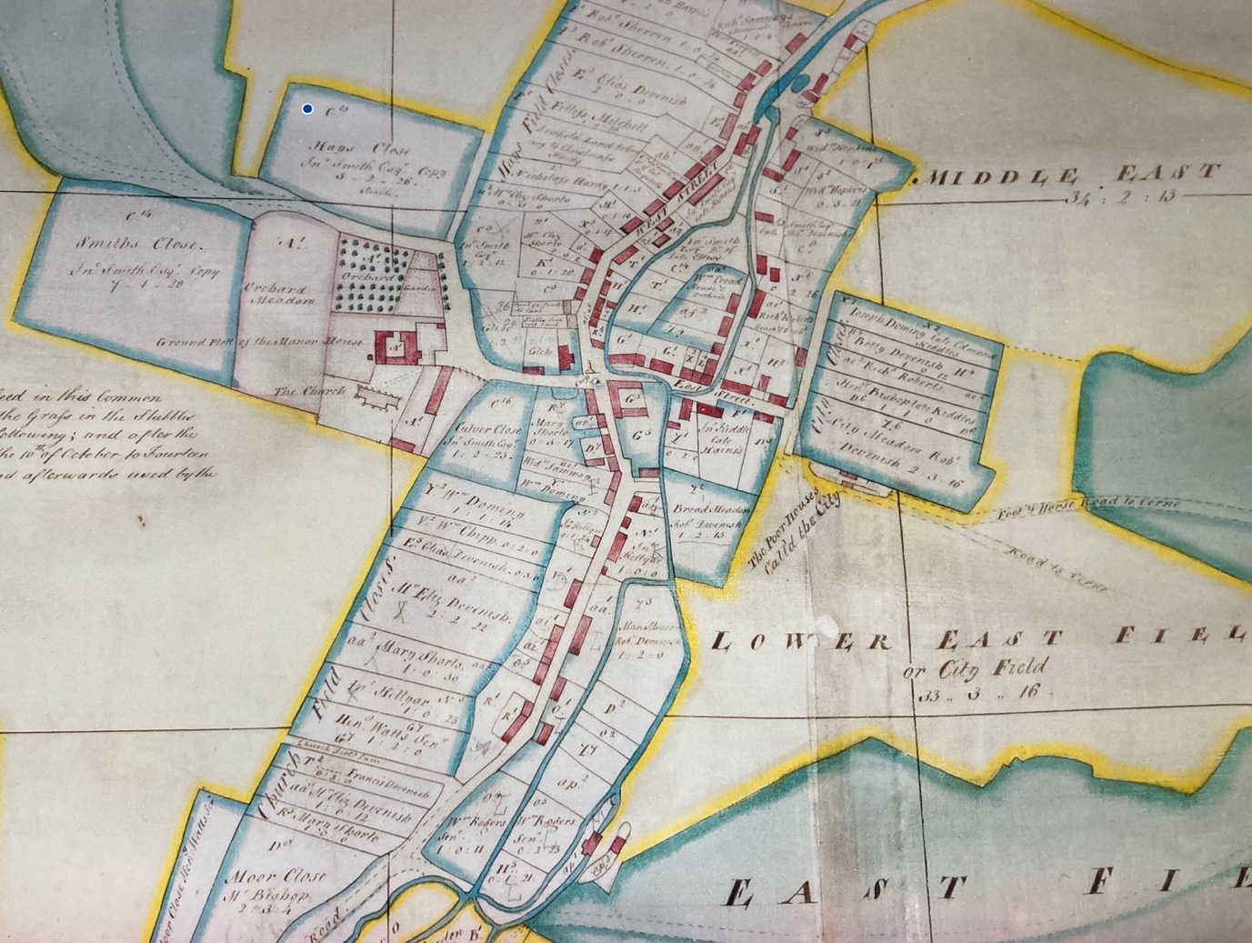

In medieval times, the village of BrodeSydling was spoken of in two parts, Westover and Estover. Westover was the part on the west of the river, with cottages along West Street, which was renamed Sydling High Street in the early 20th century. Estover was on the east side of the river with houses mainly along East Street and Back Street, which is now called Waterside.

The wider landscape

In medieval times, the word “field” was used to describe a large area of land (what we now think of as fields were “closes”, enclosed grazing). The map above shows City Field, and City closes, on the edge of the village (where Three Acres is now). Below is more of the same map, showing that much the land east of the village was known as East Field, with lower, middle and upper East Field, and East Field Hill. To the west is Church Field, and all the small fields behind what is now Lamperts Farm, are called Church Field Closes. To the south lie the Moor, Little Field, and beyond that (not shown) is SouthField. The name of this lives on in Southfield Down Nature reserve, near Magiston, and SouthField Barn, on the hill above Park Coppice.

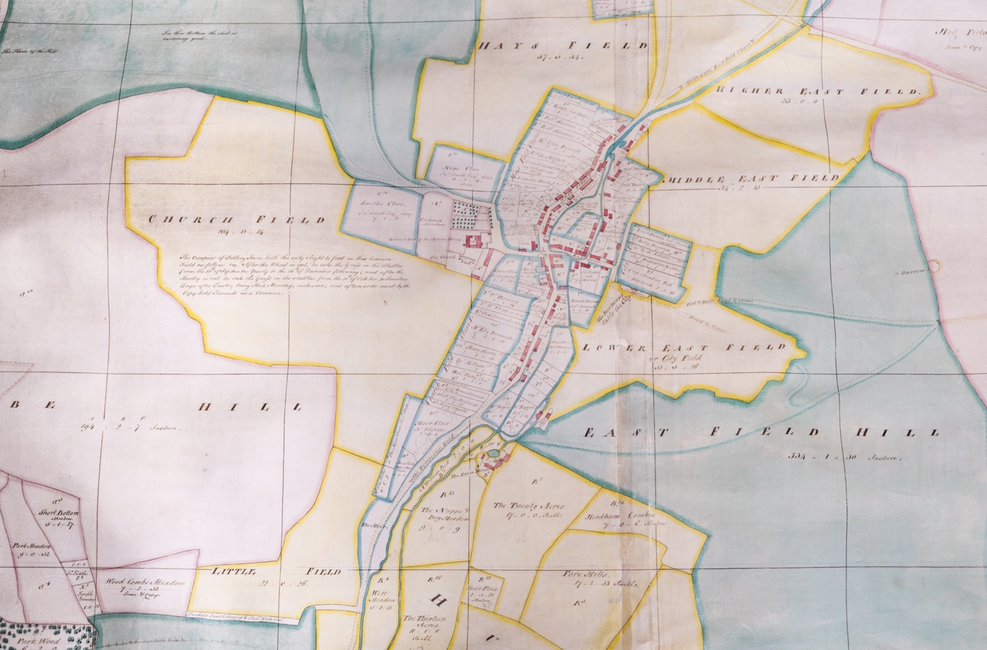

Maybe in the New Year we can take a trip up Eastfield Hill and look at some of the old names on that side of the valley?
Meanwhile, have a very merry Christmas and a happy and healthy New Year.
Best wishes from all at the History Society.
Anne Brown
December 2025

