2023
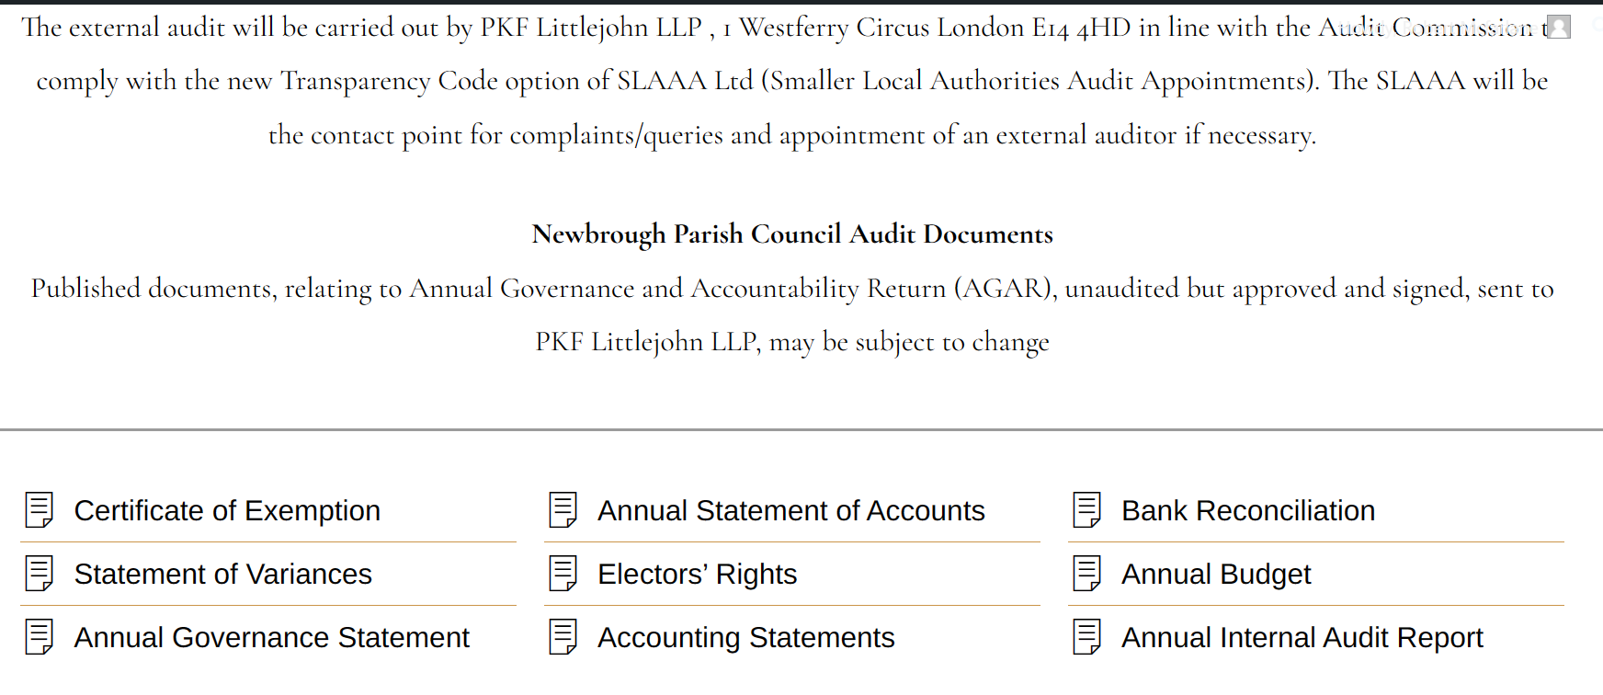
External Auditor is
Smaller Authorities Audit Appointments Limited (SAAA) have appointed Mazars as external auditors for 2022/23, for a five-year contract.

Mazars LLP is the UK firm of Mazars, an integrated international advisory and accountancy organisation. Mazars LLP is a limited liability partnership registered in England and Wales with registered number OC308299 and with its registered office at 30 Old Bailey, London, EC4M 7AU.

Thank you for your co-operation.
Robert Wyllie
Smaller Authorities External Audit Team

Mazars LLP
0191 3836348
local.councils@mazars.co.uk

Please return the AGAR and the supporting documentation listed in our guidance by e-mail by the deadline of 30 June 2023 at the latest. Please can you also acknowledge receipt of this e-mail by 15 April 2023.
Mazars LLP is the UK firm of Mazars, an integrated international advisory and accountancy organisation. Mazars LLP is a limited liability partnership registered in England and Wales with registered number OC308299 and with its registered office at 30 Old Bailey, London, EC4M 7AU.

Mazars LLP
The Corner Bank Chambers
26 Mosley Street
Newcastle upon Tyne NE1 1DF

