Agenda item FC222: Risk Assessment, Farnsfield Parish Council
Organisation: Farnsfield Parish Council | Date Assessed: August/September 2025 | Assessed by: Cllrs Sally Savage, Joyce Shakeshaft, Lesley Healy. Judith Alcock Clerk/RFO. MoP – Linda  Cracknell
Location/Task/ Activity: Governance | Review Date: Next formal review August 2026. | Reference Number:.

Activity/ Task | Hazard/Risk | Persons at risk | Controls in place | Severity (1-5) | Likelihood (1-5) | Risk/ Priority | Additional controls required
PRECEPT | Insufficient Precept demand  Delayed payment of Precept by District Council  To ensure that the annual precept results from an adequate budget forecast, which is evidenced to the Council  Lack of knowledge of budgetary | Chair Clerk/RFO Councillors | All Cllrs to complete an introduction to finance online training. Chair, Chair of F&G and Clerk/RFO complete additional training (budget and precept) as required.  - BPP meeting held in November to discuss indicative costs for the following year that require costing ahead of preparation of a draft budget  Clerk/RFO ensures all necessary information received from the district council regarding submission of the precept demand before the Budget presentation to the Full council in November  - Clerk/RFO completes budget update to the end of the previous month before the working party meets  - Draft budget, precept demand and rationale to be presented at the full Council meeting in November  - Clerk/RFO submits precept demand to the District Council  before the end of January and | 2 | 3 | 6M | Existing Procedures require some actions

Activity/ Task | Hazard/Risk | Persons at risk | Controls in place | Severity (1-5) | Likelihood (1-5) | Risk/ Priority | Additional controls required
 | process and council regulations |  | records the receipt of the precept in the cashbook and notifies the councillors  f. Involve all councillors in the budgetary process and encourage training as necessary
Financial Records | Incomplete or inaccurate records  Financial irregularities | Cllrs Chair  Clerk/RFO | Control systems and accounting records detailed in the Council’s Financial Regulations  Selected Cllrs, Chair and Clerk/RFO complete additional training where necessary Budget monitoring reports and commentary on significant variance shared with councillors monthly  Bank reconciliations completed monthly by the Clerk/RFO for approval by a nominated named Councillor  Annual internal and external audits conducted, findings reported to the Cllrs and recommendations implemented following resolution by the Full  council | 3 | 4 | 12H | Existing Procedures need to be applied consistently  A number of recommendations require action during 2025/26  Council internal audit of financial monitoring to be developed and implemented
Banking | Inadequate checks Mistakes  BACS online payments made without Council approval  To ensure that the banking facilities of | Cllrs Chair  Clerk/RFO Banking Signatories Internal Auditor F&G Committee | The Council’s Financial Regulations govern the banking arrangements and authorisation of payments  Online banking ensures a Cllr verifies / authorises payments processed by Clerk/RFO  All payments included in full council meeting agendas for approval and receipts noted | 3 | 2 | 6M | Looking at a further instant access savings account so money can be transferred quickly in to the current account if necessary, without having to wait for a minimum of 1 calendar month on the current 3 reserve accounts before the money is transferred.

Activity/ Task | Hazard/Risk | Persons at risk | Controls in place | Severity (1-5) | Likelihood (1-5) | Risk/ Priority | Additional controls required
 | the council are secure and offer value for money  Loss though theft or dishonesty  Misuse of Credit Card  Illegal payments or spending  Bank charges unnecessarily incurred  Clerk/RFO taken ill or leaves without a replacement  Internal controls not in place or not operated. |  | Clerk/RFO checks bank statements against cash book monthly and internal audit undertaken by two nominated Cllrs every 6 months  No petty cash is held by the council  Use of the Clerk/RFO’s and 1 other authorised holder’s credit cards is restricted as per the Councils Financial Regulations Balances on Credit card payments are made at the end of each month, recorded in the cashbook and include in full council meeting agendas  Regular checks by Clerk/RFO and internal auditor  To keep number of accounts to a minimum but ensure that any large credit balances are deposited in an interest bearing account to comply with the FSCS Scheme limits  Changing accounts may also incur some risks
Financial Reporting | Insufficient information  Ensure payments made from council funds and the use of assets represent value for money, are adequately managed and comply generally | Cllrs Clerk/RFO Auditors | Clerk/RFO reports payments and receipts to Cllrs at each full council meeting  Additional financial information  e.g. budget updates and variances to reported by the Clerk/RFO to Cllrs at full council meetings  Annual internal and external audits conducted, findings  reported to the Cllrs and recommendations implemented | 1 | 2 | 2M | Existing Procedures adequate  Consider having dedicated sessions to share financial information with residents at least annually during the period of public rights.

Activity/ Task | Hazard/Risk | Persons at risk | Controls in place | Severity (1-5) | Likelihood (1-5) | Risk/ Priority | Additional controls required
 | with the wishes of the residents  Maximise rental income  Ensure year end accounts are prepared on the correct accounting basis, on time and supported by an adequate audit trail |  | following resolution by the Full council  Financial documents, including AGAR, end of year bank reconciliations and cashbook, explanation of variances, end of year accounts, public rights together with budget and precept are published on the council’s website  Ensure that effective lines of communication take place with residents through website etc Charge appropriate rates.  Review lettings potential of facilities on longer terms
Grants awarded to Council | Not receiving grants applied for | Clerk/RFO Cllrs | The annual budget excludes any grants not yet awarded to ensure no future initiatives commence until confirmation has been received that the grant will be awarded  Clerk/RFO and F&G committee ensures all grant applications meet the specified criteria and that all grant payments are made to the council, according to the  terms of the grant, at the correct times | 1 | 1 | 1L | Existing Procedures adequate
Grants Paid by the council | Unauthorised payment of grants | Clerk/RFO Cllrs | Clerk/RFO and the F&G committee determines the maximum amount of money that can be spent under Section 137 each year to ensure it does not exceed the statutory limit set by the Government per electorate | 1 | 5 | 5L | Existing Procedures adequate  Revised grant application process to be approved by full council and published  Establish process for section 137 grants.

Activity/ Task | Hazard/Risk | Persons at risk | Controls in place | Severity (1-5) | Likelihood (1-5) | Risk/ Priority | Additional controls required
S137 budget cost centre to be included in the draft budget resolution to be presented to the full council
Clerk/RFO notifies qualifying organisations and distributes application forms and guidance notes (approved by the full council) to organisations
Any applications made to be included in the next full council
agenda and payments recorded in the cashbook
Rents receivable | Payment of rents to the council | Clerk/RFO Cllrs | The parish council collects a peppercorn rent from the allotment association annually and rental income from the library quarterly | 1 | 1 | 1L | Existing procedures adequate
Best Value accountability | Charges to the council are too high | Clerk/RFO Cllrs | The council’s Financial Regulations set out the requirements and procedures for both regular revenue payments and capital items.  Clerk/RFO usually obtains 3 or more quotations or estimates from appropriate suppliers as per Financial Regulations.  Estimates/quotes are included in agendas for full council approval | 1 | 1 | 1L | Existing Procedures adequate
Salaries and Associated costs | Salary paid incorrectly  Incorrect or unpaid tax deductions | Clerk/RFO Cllrs NALC | Salaries determined by NALC recommended rates each year and be proposed by Staffing Committee in October of each year.  Payroll, payslip and HMRC payments generated monthly | 1 | 1 | 1L | Existing Procedures adequate

Activity/ Task | Hazard/Risk | Persons at risk | Controls in place | Severity (1-5) | Likelihood (1-5) | Risk/ Priority | Additional controls required
 |  |  | Payment made by BACS before the end of the month as per banking controls above
Employee Health and Safety | Staff and public not adequately protected from harm | Staff, Cllrs and Public | All employees to be provided with adequate direction and any safety equipment needed to undertake their roles. Health and safety  training to be provided and updated as required. | 5 | 1 | 5L | Existing procedures adequate
VAT | VAT on payments remains unclaimed | Clerk/RFO Cllrs | Clerk/RFO submits VAT returns quarterly (if the amount of VT paid exceeds £100 that quarter) VAT is recorded separately in the cashbook and VAT refunds reconciled to VAT payments Receipts for VAT refunds are reported to the full council  meeting | 1 | 1 | 1L | Existing Procedures adequate
Insurance | Inadequate cover Costs are too high Compliance | Cllrs Chair  Clerk/RFO VC Users | Usually 3 year annual cover in place, which is reviewed annually. Updated Asset register shared with insurers ahead of renewal Employers and public liability included in the cover  Quotes obtained before renewal of 3 year renewal and presented to the full council for resolution Clerk/RFO and F&E committee checks insurance cover of all contractors to ensure adequate  public liability insurance | 2 | 3 | 3M | Currently one year proposed due to late submission of insurance quote from current provider  Proposal for ongoing insurance cover to be presented to Full Council in January or February 2026 for approval.

Activity/ Task | Hazard/Risk | Persons at risk |  | Controls in place | Severity (1-5) | Likelihood (1-5) | Risk/ Priority | Additional controls required
Election Costs | Inadequate reserves | Cllrs Clerk/RFO |  | Adequate reserves in savings accounts towards election costs When and elections is due the Clerk/RFO will obtain an estimate from the District Council in advance so that it can be  considered when setting next year’s precept | 1 | 1 | 1L | Existing Procedures adequate
Data protection | Failure to comply with statutory guidance | Clerk/RFO Cllrs Residents |  | Policies and procedures in place | 4 | 3 | 12H | Current policies and procedures are out of date and require updating to comply with statutory requirements and best practice.  Training needs of paid staff and councillors to be identified and suitable training opportunities made  available
Location/Task/ Activity: Governance |  |  | Review Date: |  |  | Reference Number:

Activity/ Task | Hazard/Risk | Persons at risk | Controls in place | Severity (1-5) | Likelihood (1-5) | Risk/ Priority | Additional controls required
Failure to meet Statutory obligations | Lack of knowledge of regulations and Code  Absence of Standing orders | Clerk/RFO Chair  Cllrs Notts ALC | - Ensure all Cllrs have copies or access to relevant information through Notts ALC, Councils own policies relating to Freedom of Information, Data Protection, protection of children and vulnerable people, Equality of opportunity, Racial equality and Disability legislation plus the Good Councillors Guide  - .Ensure Standing orders are produced, understood by Cllrs and reviewed at least once a year | 3 | 3 | 9M | Existing Procedures adequate  Chair to establish a process for identifying training needs of the Clark/ RFO and Cllrs  Allocate an experienced Cllr to act as a mentor to new Cllrs for at least the first three months in office.  Policies and procedures to be up-to-date and published on website

Activity/ Task | Hazard/Risk | Persons at risk | Controls in place | Severity (1-5) | Likelihood (1-5) | Risk/ Priority | Additional controls required
 | Actions by the council outside its powers  Lack of Commitment to regulations and Procedures  Items purchased without proper tendering procedures  Lack of control of signatories on cheques  Compliance with Acts of Parliament, other legislation the Councils Standing Orders, Financial Regulations and Code of Conduct |  | c .As “a” above but ensure powers are highlighted or extracted into an effective summary  - Regular reference to appropriate regulations in agenda items. Appropriate delegation of responsibilities to Cllrs and committees. Compliance with appropriate procedures  - Ensure all Cllrs are aware of regulations regarding estimates and full tendering procedures. Estimates to be provided for all purchases over an agreed figure as over the Financial Regulations  - Keep authorised signatories to a minimum but consistent with practicalities  - Ensure appropriate publications are held and that the Clerk/RFO has a good knowledge of the regulations
Identify and regularly review Council’s  Priorities and risks | Lack of knowledge of setting objectives, setting priorities and identifying risks to their achievement | Chair Clerk/RFO Cllrs NSDC | - All Cllrs to be made aware of need for objectives and identification of risk. Attend Training courses and refresher training as required. | 4 | 2 | 8M | Ensure Risk assessments are taking place and regularly reported to full council  Follow up within 6 months

Activity/ Task | Hazard/Risk | Persons at risk | Controls in place | Severity (1-5) | Likelihood (1-5) | Risk/ Priority | Additional controls required
 | Lack of commitment by Council members  No risk analysis carried out  No steps taken to combat identified risks  An inadequate complement of Cllrs to manage business of the council |  | - Add risk assessment to agenda quarterly, reviewing particular items and results against these items  - As “a” above and ensure risk assessment is given priority as a requirement of the Audit Commission  - As “b” above  - All Cllrs to strive to work in a constructive manner in accordance with the Code of Conduct and to welcome and encourage new Cllrs. All Cllrs to cooperate to share the workload
Influence other local councils and other Government organisations to recognise the requirements and interests of the local population | Lack of effective lines of communication with other organisation  Lack of effective lines of communication with parishioners  Lack of preparation on subjects requiring influence | Chair Clerk/RFO Cllrs | - To note all communication lines which are essential or beneficial and establish and maintain contacts by name and where possible face-to-face  - To make sure the Council website provides key information to residents in an accessible and effective way  - Take every opportunity to publicise role of Parish council using the Farnie, notice boards, “flyers” and the Annual Parish  Meeting. Use key issues to raise | 3 | 3 | 9M | Existing Procedures adequate Website requires further development

Activity/ Task | Hazard/Risk | Persons at risk | Controls in place | Severity (1-5) | Likelihood (1-5) | Risk/ Priority | Additional controls required
 | Lack of confidence by Parish Cllrs |  | the profile of the PC and test parishioners’ views.  c. Ensure all Cllrs are aware of need for careful research and are guided as to where to obtain relevant information  d. Experienced Cllrs and Clerk/RFO to assist newcomers to understand roles and responsibilities, to establish essential contacts and gain  procedural awareness
Members Interests | Conflict of Interests  Breach of required standards in public life | Cllrs Clerk/RFO | - All Cllrs to return register of members’ interests forms when elected or coopted.  - Members interests forms to be reviewed annually  - Members to declare any interests in agenda items at the beginning of each meeting  - All Cllrs sign to confirm that they will conform to the Council’s Code of Conduct. | 2 | 2 | 4L | Existing Procedures adequate  Cllrs to be reminded of their responsibilities in relation to declarations of interests  Clark to ensure all entries on the Newark and Sherwood register are up-to-date and are refreshed at least annually
Agendas and Minutes | Notice Period not adhered to  Inaccurate minutes | Chair Clerk Cllrs | - Agendas are produced in the prescribed manner by the Clerk and adhere to legal requirements that they are published with 3 clear days public notice before the meeting  - Minutes are approved at the next meeting of the council or | 1 | 2 | 2L | Existing Procedures adequate

Activity/ Task | Hazard/Risk | Persons at risk |  | Controls in place | Severity (1-5) | Likelihood (1-5) | Risk/ Priority | Additional controls required
 |  |  |  | committees and signed by the Chair
Conduct | Inappropriate conduct at meetings | Cllrs Chair |  | - Cllrs sign to confirm they will conform to the Councils Code of Conduct  - Standing Orders set out rules of debate and acceptable conduct to be adhered to.  - Business conducted at Council meetings is managed by the Chair in accordance with the Standing  orders. | 1 | 2 | 2L | Existing Procedures adequate
Location/Task/ Activity: Assets & Health & Safety |  |  | Review Date: |  |  | Reference Number:
Council Assets | Identify, value, and maintain all the assets of the Parish council | Cllrs Chair  Clerk/RFO |  | - Ascertain and record all significant assets for which Parish council is responsible  - Establish and maintain a permanent asset register | 1 | 1 | 1L | Existing Procedures adequate
 | Assets lost or misappropriated |  |  | c. Establish who is responsible for security and maintenance of each asset.  d. Regular monitoring of location and use of assets by Cllrs. |  |  |  | Need to allocate specific areas of responsibility to named Cllrs
 | Inadequate or inaccurate valuation of the  council’s assets |  |  | e. Arrange for periodic review of valuations and arrange professional valuations where  necessary.

Activity/ Task | Hazard/Risk | Persons at risk | Controls in place | Severity (1-5) | Likelihood (1-5) | Risk/ Priority | Additional controls required
 | Asset register not established or |  | f. Create asset register in
 | inadequately |  | accordance with Audit
 | maintained |  | Commission requirements
Checks in respect of safety, licencing and integrity of all Council Buildings | Lack of or inadequate programme of regular safety checks | Cllrs Clerk/RFO Facilities Manager | - Ensure that all necessary checks are properly performed by suitably accredited people in a timely manner in accordance with an agreed schedule  - Ensure that the hot water temperatures are not excessive | 4 | 2 | 8M | Existing Procedures adequate
 | Lack of inadequate licensing of council buildings e,g PRS music licence |  | c. Ensure that all necessary licences are listed on a schedule and reviewed in a timely manner.
 | Excessive utility bills caused by water leaks, electrical appliances unnecessarily left switched on.  Property Damage caused by leaks |  | - Regular checks by Cllrs and paid staff  - Clear/RFO to monitor utility bills to assess consumption levels  - Prompt attention to minor repairs and leaks
 | Building safety hazards |  | g.Regular property checks by Facilities Manager and nominated Cllrs. Prompt attention to hazards  / problems once identified  h. Prompt attention to issues raised by building users, officers and contractors
 |  |  | i.As “g” above
Compromised building security
e.g broken window

Activity/ Task | Hazard/Risk | Persons at risk | Controls in place | Severity (1-5) | Likelihood (1-5) | Risk/ Priority | Additional controls required
 | or integrity such as leaking roof |  | j. As “g” above
Inadequate winter preparations causing freezing of pipes and water
damage
 | Inappropriate heating of water |  | k. Water heating to be in accordance with current advice to minimise the risk of a Legionella outbreak. Regular checks to confirm settings are maintained at appropriate levels
 | Fire risk in the village centre (including taking account of revised guidance following the Grenfell disaster) |  | Statutory fire risk assessment to be undertaken and required actions undertaken. | 5 | 3 | 15H | Further assessment to be undertaken by appropriately qualified expert to identify any actions that we are required to take to maintain the safety of the building in the light of the most recent routine risk assessment.
To carry out adequate safety and integrity checks on facilities in the village | Lack of inadequate programme of regular safety checks e.g. trip hazards | Users of the facilities Cllrs Facilities Manager Bowls club Tennis Club | - Regular checks by the Facilities Manager and other officers.  - Prompt attention to hazards once identified  - Prompt attention to issues raised by facility users, Officers and contractors | 1 | 2 | 2L | Existing Procedures adequate
 | Damage to the Sports Facility due to compromised security |  | d. As “a, b and c” above
 | Pavillion Facility
 |  |  | e. As “a, b and c” above

Activity/ Task | Hazard/Risk | Persons at risk | Controls in place | Severity (1-5) | Likelihood (1-5) | Risk/ Priority | Additional controls required
To carry out adequate safety checks on public open space and street furniture owned by the council | Lack of or an inadequate programme of maintenance | Cllrs Chair | - Regular checks by Facilities Manager, other officers and Cllrs  - Prompt attention to hazards / problems once identified  - Prompt attention to issues raised by all users  - Engagement of suitable contractors to conduct ongoing maintenance work (including periodic professional checking of trees and a 5 yearly tree survey) | 1 | 1 | 1L | Existing Procedures adequate
 | Risk of fire and broken glass in Millenium Wood |  | Fire and High Wind signs are in place and relevant policies on the website. |  |  |  | Regular monitoring of known areas of woodland where broken glass evidenced.  Cllrs and feedback from the public.
 | Risks of disease from animal faeces/urine and ticks |  | Signage in place indicating dogs are not allowed in play areas.  Dog walkers encouraged to pick up dog foul and bins provided across the village
Ticks are very difficult to monitor but the Council will follow any local and national advice and work with Public Health England should any local outbreaks of disease such as Lymes or Weil’s
Disease occur locally.
 | Car parking on Wilson’s Field |  | Currently managed by the Cricket Club | 5 | 1 | 5L | Joint risk assessment to be undertaken in order to clarify responsibilities and liabilities.

Activity/ Task | Hazard/Risk | Persons at risk | Controls in place | Severity (1-5) | Likelihood (1-5) | Risk/ Priority | Additional controls required
To carry out adequate safety checks on the  children’s play areas operated by the council | An inadequate programme of safety inspections and maintenance (or vandalism) resulting in an accident and/or an award of damages  Lack of or inadequate programme of maintenance of the immediate surrounding areas allows persistence of a safety hazard  e.g. faulty gate or sharp object | Facilities Manager Cllrs Playground inspectors Property Services Contractors Public Users | a .Weekly safety inspections by local staff, Contractors and Cllrs backed up by an annual inspection by an accredited playground inspector  - Prompt attention to hazards / problems once identified  - Ongoing maintenance  - Professional specification and installation of equipment  - An ongoing programme of equipment replacement as necessary  - Regular checks by the Facilities Manager, other Officers and Cllrs  - Prompt attention to hazards / problems once identified  - Prompt attention to issues raised by all users  - Emgagement of suitable contractors to conduct ongoing maintenance works.  - Weekly visual checks of planting to monitor growth  h. Ensure planting plan of areas surrounding play areas limits plants that are thorny or irritant  i. Stinging nettles and brambles are strimmed/cut back as required | 1 | 2 | 2L | Existing Procedures adequate

Activity/ Task | Hazard/Risk | Persons at risk | Controls in place | Severity (1-5) | Likelihood (1-5) | Risk/ Priority | Additional controls required
Defibrillators | Failure to maintain defibrillators | Public | Regular checks undertaken by volunteers within the village  Procedures for ordering new pads and replacing bace | 5 | 1 | 5L | Existing procedures adequate

Risk Matrix

Severity (Consequence) |  | RISK / PRIORITY INDICATOR MATRIX
1. Negligible (delay only) |  | LIKELIHOOD | 5 | 5 | 10 | 15 | 20 | 25
2. Slight (minor injury / damage / interruption) |  | LIKELIHOOD | 4 | 4 | 8 | 12 | 16 | 20
3. Moderate (lost time injury, illness, damage, lost business) |  | LIKELIHOOD | 3 | 3 | 6 | 9 | 12 | 15
4. High (major injury / damage, lost time business interruption, disablement) |  | LIKELIHOOD | 2 | 2 | 4 | 6 | 8 | 10
5. Very High (fatality / business closure) |  | LIKELIHOOD | 1 | 1 | 2 | 3 | 4 | 5
 |  |  |  | 1 | 2 | 3 | 4 | 5
Likelihood |  |  |  | SEVERITY (CONSEQUENCE)
1. Improbable / very unlikely
2. Unlikely |  | Summary |  | Suggested Timeframe
3. Even chance / may happen |  | 12-25 | High | As soon as possible
4. Likely |  | 6-11 | Medium | Within next 3-6 months
5. Almost certain / imminent |  | 1-5 | Low | Whenever viable to do so

Agenda item FC223

MHCLG Open consultation: Proposals for local government reorganisation in Nottinghamshire and Nottingham, published 5 February 2026
https://www.gov.uk/government/consultations/local-government-reorganisation-in-nottinghamshire-and-nottingham/proposals-for-local-government-reorganisation-in-nottinghamshire-and-nottingham

This statutory consultation seeks views on the proposals that the Ministry of Housing Communities and Local Government (MHCLG) has received following the Secretary of State’s invitation to councils in Nottinghamshire and Nottingham to submit proposals for unitary local government for Nottinghamshire and Nottingham.

The 3 proposals in this consultation were made by the following councils on 28 November 2025:
Bassetlaw District Council, Gedling Borough Council, Mansfield District Council, Newark and Sherwood District Council proposed 2 unitary councils. These would comprise the current areas of:
- Sherwood Forest: Ashfield, Bassetlaw, Gedling, Mansfield, and Newark and Sherwood
- Nottingham and South Nottinghamshire: Broxtowe, Nottingham, and Rushcliffe
Nottingham City Council proposed 2 unitary councils. This includes a request to split existing district council areas between the proposed new councils. These would comprise the current areas of:
- Southwest: Nottingham, plus 15 wards from Broxtowe,15 wards from Gedling and 17 wards from Rushcliffe
- North and East: Ashfield, Bassetlaw, Mansfield, Newark and Sherwood, plus 5 wards from Broxtowe, 4 wards from Gedling and 7 wards from Rushcliffe
Nottinghamshire County Council and Rushcliffe Borough Council proposed 2 unitary councils. These would comprise the current areas of:
- Nottingham City: Nottingham, Broxtowe, and Gedling
- Nottinghamshire: Ashfield, Bassetlaw, Mansfield, Newark and Sherwood, and Rushcliffe
Ashfield District Council and Broxtowe Borough Council did not submit a proposal.
This consultation asks questions about each proposal to help inform the assessment of the proposals.

Scope of this consultation
This consultation is about the structure of local government in Nottinghamshire and Nottingham
Geographical scope
These proposals relate to England only.
Impact assessment
An impact assessment has not been prepared for this consultation as it will only affect local government in Nottinghamshire and Nottingham and so there will be no direct regulatory, economic or social impacts.
Body responsible for the consultation
This consultation is conducted by MHCLG.
Duration
This consultation will last for 7 weeks from 5 February 2026 to 23:59 26 March 2026.
Enquiries For any enquiries about the consultation please contact: lgrconsultationresponse@communities.gov.uk
How to respond
You may respond by completing the online survey.
If you are responding in writing, please make it clear which proposal you are responding to. You can email your response to the questions in this consultation to lgrconsultationresponse@communities.gov.uk.
Alternatively written responses should be sent to:
LGR Consultation
Fry Building 2NE
Ministry of Housing, Communities and Local Government
2 Marsham Street
London
SW1P 4DF
_____________________________________________________________________________

Agenda item FC225
Locum Clerk’s note: It would be usual when considering this sort of topic at a Council meeting for there to be a report from Council officer(s) on the pros & cons of the proposal. It should be noted therefore that the following is not an officer’s report; it may be considered an informal view.

ACCESS TO RECREATION (A2R): SUMMARY REPORT 19th SEPTEMBER 2025

Committee Members: Lesley Healy, John Cracknell, Jenny Frost, Nick Greene & 1 other
Report Author: Nick Greene

- Section 1- Summary of the findings of the Access to Recreation Questionnaire, Traffic Survey and Residents Petition
- Section 2- Action and Next Steps as Agreed by Farnsfield Parish Council
- Section 3- Potential Access Route Plan
- Section 4- Pre-Application Planning Letter Action and Next Steps to be Reviewed by the Farnsfield Parish Council
- Section 5- Status of Pre-Application Planning Letter Issued 30th July
- Section 6- Action and Next Steps to be Reviewed by the Farnsfield Parish Council
- Section 7- Actions and Next Steps to be Reviewed by the Farnsfield Parish Council

Section 1- Summary of the findings of the Access to Recreation Questionnaire, Traffic Survey and Residents Petition

Questionnaire
There were 232 responses from the 1,400 questionnaires delivered by the Farnie to households in Farnsfield.
The most popular activity in the Hadleigh Park area was walking and dog walking and use of the children’s play areas with Pétanque the least used.
Where respondents ticked “other” activities the use of the benches for relaxing and taking in nature were cited. Playing cricket, football and picnics were mentioned too.
55% of respondents walked to the facilities and 35% went by car. However, respondents were allowed to tick more than one option. Closer analysis shows that of the 219 people who responded to this question 100 walked. Only 9% cycled, 4% used mobility scooters or wheelchairs.
Many people used the Hadleigh Park Car Park but also stated that they parked at the Acres on match days and at Edingley Cricket Pavillion and near the skatepark. Some allotment holders parked at the Allotment.
83% of the respondents had no disability or health condition which limited their ability to use the recreational facilities
There were 148 responses to the question that asked respondents to suggest ways in which the Parish Council might improve access to the recreational facilities
45 respondents wanted the potholes mended on Cotton Mill Lane
21 respondents wanted a new Access Road citing the possibility of linking the end of Parfitt Drive with the bottom of Cotton Mill Lane

18 respondents wanted to change nothing citing the fact that potholes slow down traffic
8 respondents wanted better paths for mobility scooters, wheelchairs and prams around the edge of Hadleigh park and to access the park and facilities
7 people wanted designated parking areas around the facilities with hard standing so not damaging grass
6 people asked that more should be done to encourage people to walk 4 people made comments on the state of the footpaths through the Millennium Wood 2 people wanted greater clarity on the legal issues surrounding the use of CML
It is clear from the survey that walking is a popular activity in the village and many people walk to the facilities. There were some general comments that were not focused on the question but useful feedback

Via Traffic Survey
A VIA traffic survey was conducted between 25/08/23 and 01/10/23

Residents Peitition and Personal Summary from (redacted)
Concerned residents of Farnsfield, specifically Quaker Lane, Cotton Mill Lane, Gregory Gardens and Tippings Lane submitted a petition (68 signatures, would have been more but ran out of time to knock on doors) to the Parish Council in 2023 asking the Parish Council to review the motorised vehicle access to The Acres/Reynolds field due to increasing safety concerns, significant increase in the volume of traffic and the speed of vehicles using these narrow lanes and parking on Cotton Mill Lane (bridleway)to access the increasing number of sporting/recreational facilities being provided in the Acres area. The survey confirmed that there was a high volume of traffic and speed limits were often not respected.
These issues are still present to date.

Section 2- Action and Next Steps as Agreed by Farnsfield Parish Council
- Formation of Access to Recreation (A2R) committee and agreement to investigate the possibility of linking the end of Parfitt Drive with the bottom of Cotton Mill Lane
- A2R to issue a pre-application letter to Newark & Sherwood District Council
- Spend value agreed by FPC

Section 3- Potential Access Route Plan
A new access joining Parfitt Drive, approximately 30 metres south from Carding Close. The road would then follow around the outside of the
existing attenuation pond before connecting into Reynold’s Field and join the existing Cotton Mill Lane southwest to The Acres

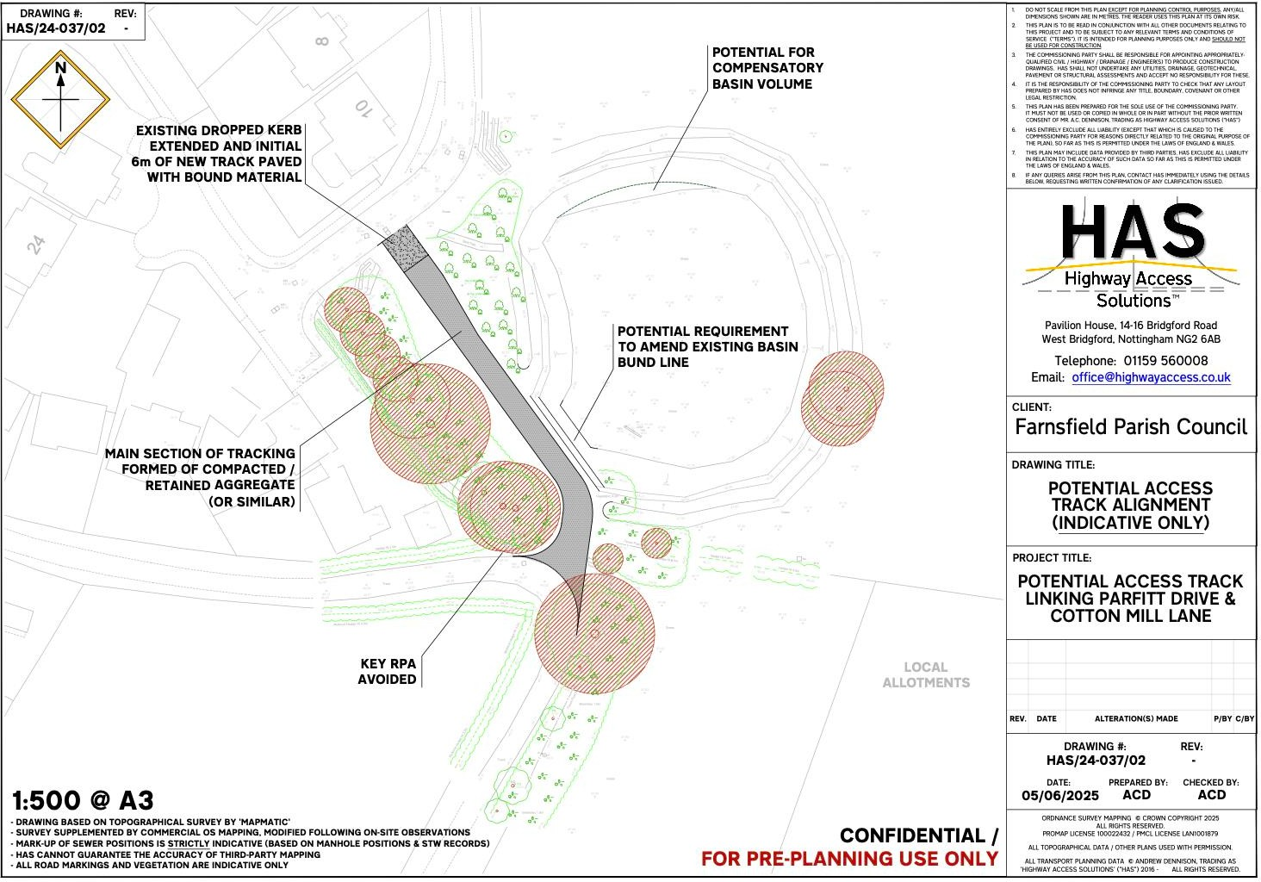

For References purposes only, the A2R Committee considered Option 2 of the “East Side Project Project Brief 1” & “Design Options for Access Road”
Option 1 – Cotton Mill Lane This would consist of using the existing route of Cotton Mill Lane from its junction with Quaker Lane to the Acres. The route would be resurfaced with tarmacadam
Option 2 – Parfitt Drive A new access joining Parfitt Drive, approximately 30 metres south from Carding Close. The road would then follow around the outside of the existing attenuation pond before connecting into Reynold’s Field and join the existing Cotton Mill Lane southwest to The Acres
Option 3 – Hadleigh Park Drive A new access to be taken from the existing Hadleigh Park car park, the road will then follow the eastern boundary of Hadleigh Park before connecting into Reynold’s Field and join the existing Cotton Mill Lane southwest to The Acres. As plan below
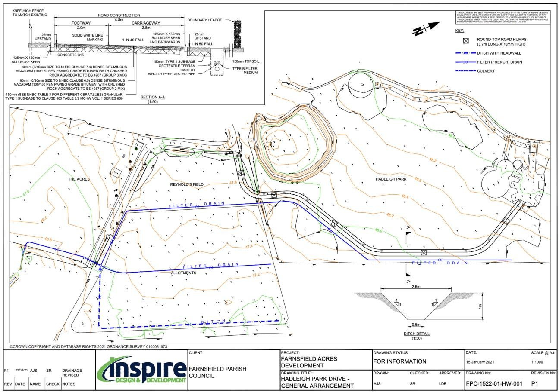

Section 4- Pre-Application Planning Letter Issued 30th July

Purpose of the Letter Issued to NSDC
The letter seeks pre-application advice from Newark & Sherwood District Council (NSDC) regarding a Community Infrastructure Levy (CIL) funded project. The project proposes a new access track to improve connectivity and reduce traffic conflicts during busy periods at local amenities.

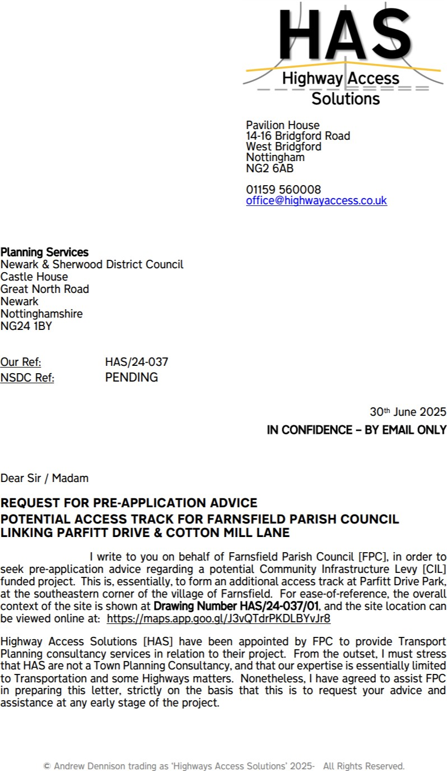

Site Context
Option 1 – Cotton Mill Lane This would consist of using the existing route of Cotton Mill Lane from its junction with Quaker Lane to the Acres. The route would be resurfaced with tarmacadam

Proposal Overview
A 65m long access track is proposed, primarily made of permeable aggregate, with the first 6m surfaced in bound material. The track is intended to support one-way traffic flow during events and improve emergency access.

Constraints and Risks Identified
- Tree Protection Order N234 (1993) and root protection areas
- Drainage/retention basin and Severn Trent sewer infrastructure
- Potential presence of protected species
- Compliance with highway design standards
- Possible need for planning consent

Legal Considerations
The land is subject to a covenant under the Open Spaces Act 1906, restricting use to 'open space amenity land'. FPC seeks clarification on whether the proposed track complies with this covenant or if a variation is needed.

Funding & Timeline
FPC has access to £15,000 in CIL funding, with a spend deadline of April 2026. Additional Parish Council funds may be used. NSDC previously indicated the project would be a 'good spend of CIL monies'.

Advice Requested from NSDC
- General impression of the proposal
- Compatibility with the Open Spaces Act 1906
- Planning requirements (consent, prior approval, etc.)
- Feedback on constraints and biodiversity net gain obligations
- Fee structure and timescales for pre-app advice

Section 5- Status of Pre-Application Planning Letter Issued 30th July

- NSDC Email issued 18th September 2025 as below
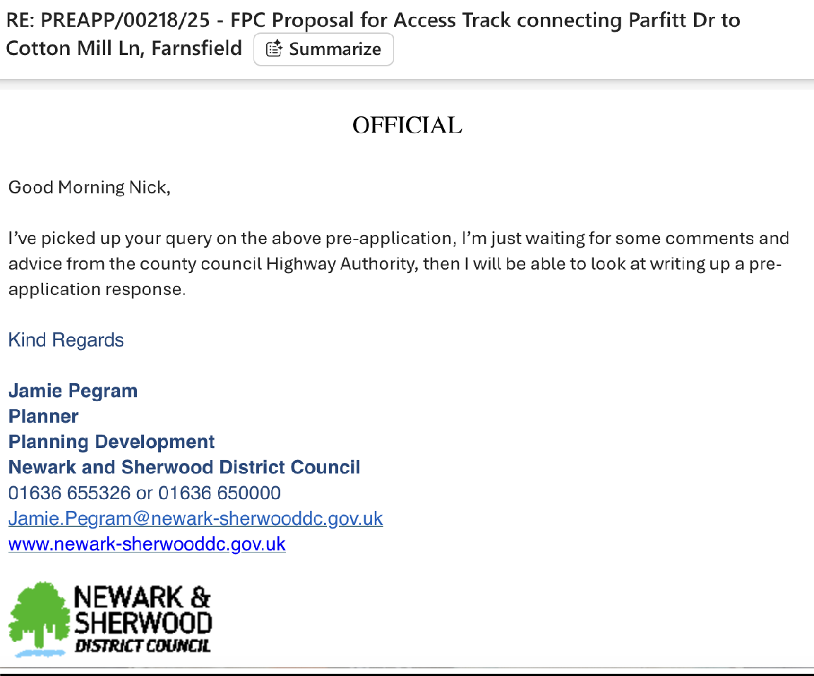
Section 6 – Possible Full Planning Application and Indicative Costs
- Indicative costs to include
  - Professional Planning Advice, Drawings and Application
  - Quantity Surveying costs to establish a whole project cost and Pre-Tender Estimate
  - Civil Engineer to engage with Severn Trent to establish basin and sewer remedials required
  - Environmental Engineer to carry out Tree Tree Survey & Arboricultural Impact Assessment & complete Tree Protection Plan
  - Environmental Engineer to carry will be undertaken on the site to assess baseline conditions and the potential presence of any protected habitats or species & carry out Biodiversity Metric Calculator
  - Civil Engineer the feasibility of the access and establish a suitable proposal with constraints highlighted or mitigated,
  - Open Spaces Act 1906 & obtain legal advice from Wellers Law Group https://www.wellerslawgroup.com/for-town-parish-councils/
  - Contingency and inflation allowed for at 15%
- Indicative Budget and Provisional Costs up to Full Planning Application only @ £14,281.39 exc. Vat as below summary
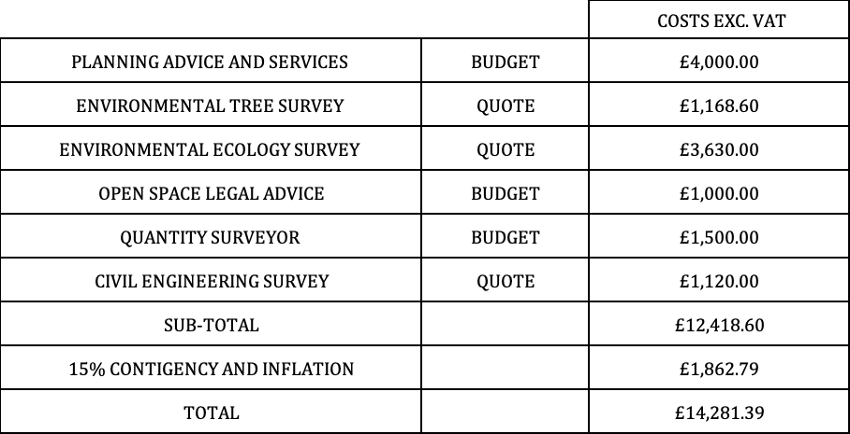

- Construction costs can only be fully established with a full planning application and pre-tender estimate
- Construction works will include the following
  - Enabling works and site surveys
  - Site set up, Site Compound, Site Fencing, Health & Safety, temporary power & water etc
  - Tree and vegetation removal and enabling works
  - Excavation, drainage and below ground works
  - Sewer and basin works
  - Subgrade and subbase layers, compaction and road finish
  - Remove all debris off site
  - Form road surface
  - New Road Signage
  - Bio-diversity & landscape renewal works
- Costs exclude any contingency and unforeseen groundworks
- We provide a Budget Construction and Project Management cost of
£35,000.00 plus vat to £70,000.00 plus vat
  - No formal approach has been made to a Highways Contractor to obtain a formal quote

Section 7- Actions and Next Steps to be Reviewed by the Farnsfield Parish Council
- FPC to review this Summary Report
- FPC to review and confirm if further public consultation is required
- FPC to review and confirm if a Full Planning Application is to be made and costs expended
- FPC has access to £15,000 in CIL funding and an action plan to facilitate this spend must be made April 26 to identify an infrastructure project. FPC to review and confirm if CIL money is to be spent on further planning applications or Alternative Infrastructure Projects

www.newark-sherwooddc.gov.uk
Mr A Dennison
Telephone: 01636 650000
Email: planning@nsdc.info
Highway Access Solutions
Pavilion House
1
4-16 Bridgford Road
14th October 2025
West Bridgford
Nottingham
NG2 6AB
Sent via email,
Dear Mr Andrew Dennison
Re: Pre-Application Enquiry
Application Ref: PREAPP/00218/25
Proposal: New access track linking Parfitt Drive with Cotton Mill Lane
Site Address: Land At Hadleigh Park Playground, Parfitt Drive, Farnsfield
Thank you for your request for pre-application advice relating to the above site received by
the District Council on 01st July 2025 and I apologise for the delay in our response.
I have undertaken a site visit, reviewed any site history and I have made an assessment of the
proposal against the current Development Plan taking account of any other material planning
considerations. For the avoidance of doubt, I can confirm that the following information was
submitted for consideration with your request:
•
•
•
•
•
•
•
•
•
Pre-App Form.
Supporting Statement
Site Location Plan
Potential Access Track Alignment plan
Site Constraints Plan
Geometry Plan
Visibility Plan
Title of Land
Severn Trent Plan
The Site
The site is located at Hadleigh Park and Playground. The area of the site relates to the
southwest corner of the park land between Cotton Mill Lane and Parfitt Drive.

The site is in flood zone 1 and at a very low risk of surface water flooding.
Site History
No relevant history
Development Plan Policies and other Material Policy Considerations
The Development Plan
Newark and Sherwood Amended Core Strategy DPD (adopted March 2019)
•
•
•
Spatial Policy 7: Sustainable Transport
Core Policy 9: Sustainable Design
Core Policy 12: Biodiversity and Green Infrastructure
Allocations & Development Management DPD (2013)
•
•
•
Policy DM5: Design
Policy DM7: Biodiversity and Green infrastructure
Policy DM12: Presumption in Favour of Sustainable Development
The above policy is only applicable if expressed consent is applied for, some mention of these
policies is made below however as set out below the proposal appears to fall within permitted
development of Schedule 2, Part 12, Class A of the General Permitted Development Order,
which is mentioned throughout the pre-application and conclusion of the advice.
The Draft Amended Allocations & Development Management DPD was submitted to the
Secretary of State on the 18th January 2024. Following the close of the hearing sessions as
part of the Examination in Public the Inspector has agreed a schedule of ‘main modifications’
to the submission DPD. The purpose of these main modifications is to resolve soundness and
legal compliance issues which the Inspector has identified. Alongside this the Council has
separately identified a range of minor modifications and points of clarification it wishes to
make to the submission DPD. Consultation on the main modifications and minor modifications
/
points of clarification is taking place between Tuesday 16 September and Tuesday 28 October
025. Once the period of consultation has concluded then the Inspector will consider the
2
representations and finalise his examination report and the final schedule of recommended
main modifications.
Tests outlined through paragraph 49 of the NPPF determine the weight which can be afforded
to emerging planning policy. The stage of examination which the Amended Allocations &
Development Management DPD has reached represents an advanced stage of preparation.
Turning to the other two tests, in agreeing these main modifications the Inspector has
considered objections to the submission DPD and the degree of consistency with national
planning policy. Therefore, where content in the Submission DPD is either not subject to a
proposed main modification or the modifications/clarifications identified are very minor in

nature then this emerging content, as modified where applicable, can now start to be given
substantial weight as part of the decision-making process.
Submission Amended Allocations & Development Management DPD
Schedule of Main Modifications and Minor Modifications / Clarifications
Other Material Planning Considerations
•
•
National Planning Policy Framework 2025
Planning Practice Guidance (online resource)
Consultation Responses
NCC Rights of Way - The upgraded link follows the alignment of Farnsfield Footpath 9 where
it joins the adopted highway known as Parfitt Drive to the north, and the privately owned
Cotton Mill Lane (which forms part of Farnsfield Bridleway 21) to the south. The legal status
of the footpath means that public access is restricted to pedestrians only, but extends to
cyclists and equestrian users on the Bridleway.
Permitting private rights of access by vehicle along both of these Ways may be possible by
the landowner. However, the constrained width of Cotton Mill Lane is such that we do not
want to encourage additional volumes of traffic along it, particularly those associated to a
one-way system that will increase the likelihood of vehicles being driven at higher speeds.
Furthermore, it is not clear how the safety of Bridleway users will be maintained particularly
when on horseback.
The layout of Parfitt Drive was designed with a residential nature in mind, and not as a means
to absorb through traffic. It would appear there is a parking facility nearby that could be
upgraded to alleviate existing practices without detriment to the highway. A formal
application to upgrade the link will attract a recommendation of refusal.
These comments have been offered in good faith, but are an informal opinion only, given on
a without prejudice basis, that does not commit the Highway Authority to any action,
recommendation or decision.
NCC Highways – No comments received.
Appraisal
Impact upon Visual Amenities of Area and trees
Core Policy 9 seeks development which achieves a high standard of sustainable design and
layout that is of an appropriate form and scale to its context complementing the existing built
and landscape environments.

Policy DM5 of the DPD supports Core Policy 9 seeking new development which respects the
rich distinctiveness of the district’s landscape and character of built form, and this should be
reflected in the scale, form, mass, layout, design, materials and detailing of proposals for new
development.
The proposal would involve the formation of a new access track linking Parfitt Drive with
Cotton Mill Lane. The road would potentially require the bung line of the existing basin on
site to be realigned. The access track would be approximately 3.7m wide widening to 4.8m at
the access either end of the track and would provide 2.4m by 17m visibility splays at either
end for traffic up to 15mph. It was also discussed that a gate could be installed and only
opened on event days to prevent continuous traffic using the lane.
The proposal would unlikely impact upon character given that it would be a change to the
ground material. It has been explored whether these works fall within Schedule 2 Part 12
Class A of the GPDO.
Permitted development
A. The erection or construction and the maintenance, improvement or other alteration by
or on behalf of a local authority or by or on behalf of an urban development corporation
of—
(a) any small ancillary building, works or equipment on land belonging to or maintained by
them required for the purposes of any function exercised by them on that land otherwise
than as statutory undertakers;
(b) lamp standards, information kiosks, passenger shelters, public shelters and seats,
telephone boxes, fire alarms, public drinking fountains, horse troughs, refuse bins or
baskets, barriers for the control of people waiting to enter public service vehicles, electric
vehicle charging points and any associated infrastructure, and similar structures or works
required in connection with the operation of any public service administered by them.
The relevant legislation is set out above and has been checked with our legal team. It has been
advised that a planning judgement can be made on whether the proposal represents ‘works
required’. In this case, it is considered that the proposal could be works that are considered
‘
required’. As advised via phone calls and emails, it is suggested that a small gate is put at the
entrance of the track to close it off from use when the parish doesn’t have an event on as well
as ensuring that bound material is used for at least 8m from the back edge of the highway to
avoid loose material being dragged onto the road.
It is advised that the parish undertake a lawful development certificate for formal
confirmation of the proposal as this would be the best step forward from the information
provided as part of this pre-app.
Overall given no protected trees would be harmed because of this, the proposed would likely
be acceptable in terms of character when assessed against council policy, however as
mentioned above the proposal is also likely to be permitted development under part 12 of
the GDPO and therefore a lawful development certificate is the best course of action moving
forward.

Impact upon Amenity
Policy DM5 seeks to ensure that development has regard for neighbouring uses and amenity
ensuring that development does not have Noise, Overbearing, Overshadowing or Privacy
impacts this is in line with what the NPPF seek from development.
The track would be further away from houses than the existing bridle way route, the idea
behind the track is to alleviate traffic from the bridleway which currently gets busy during
football club events. Overall whilst there may be slightly more traffic diverted on Parfitt drive
it is unlikely that it would result in amenity issues and would reduce impact in other areas
such as Quaker Lane.
Overall, it is not considered that the proposal would result in unacceptable amounts of noise
or impact upon residential amenity.
Highways Impacts
Spatial Policy 7 seeks to ensure that vehicular traffic generated does not create parking or
traffic problems. Policy DM5 requires the provision of safe access to new development and
appropriate parking provision.
The public rights of way team have raised concerns and advised that if a formal application
were submitted, they would likely object given that the bridleway is a non-traffic bridleway.
However, having spoken to the applicants and their advisor the lane has been used for many
years as a route to the parish councils play fields and allotments and the proposal would
reduce the intensity of the traffic using the bridleway. The legal background behind traffic use
of this road is something to be established with the County Council, however the
implementation of a track across the parishes field is not considered to impact upon highway
safety and would alleviate the intensity of traffic on event days on Quakers Lane.
Furthermore, as mentioned above the proposed track would likely fall within the parish
council’s permitted development rights. Other licenses may have to be obtained from the
County Council such as a dropped kerb licence onto Parfitt Drive and contact with the public
rights of way team may also be required to sign off on the use of the bridle way for access as
this is outside the district council’s realm.
Biodiversity Net Gain
The proposal is a track across parish council land. The applicant should be made aware that
Biodiversity Net Gain legislation has recently been brought into force for minor developments
of which this proposal would apply.
BNG is a way of creating and improving natural habitats, and makes sure development has a
measurably positive impact (‘net gain’) on biodiversity, compared to what was there before
the development took place. In England, BNG became mandatory (under Schedule 7A of the
Town and Country Planning Act 1990 (as inserted by Schedule 14 of the Environment Act
2021)) for major developments from 12 February 2024 (developments over 1Ha in area) and
for ‘minor sites’ on 2 April 2024.

The application could be exempt if the hard standing is less than 25m2 it was discussed that
grid force could potentially be used. Which would retain the grass through the track, however
as mentioned above, the proposal is likely to fall within the parish councils permitted
development rights and therefore would not require BNG in any event. It is therefore
recommended that the parish council submits a Lawful Development Certificate for the
proposed development.
Conclusion
The proposal for the access track is considered to potentially fall within permitted
development under Schedule 2, Part 12, Class A. The parish council should undertake a Lawful
Development Certificate for confirmation. Whilst it could also be acceptable against the
council development plan policies there is some concern raised by the public rights of way
team. The concerns fall outside the realm of the district council, and it is for the County
Council to establish whether the bridleway should be used for all traffic. From the information
provided this has been used as an all-traffic bridleway for many years, this however needs to
be established with the County Council. Overall, the track in question would appear to fall
within the realm of permitted development, therefore it is encouraged that a lawful
development certificate is undertaken. Please note other licenses should be obtained from
the County Council and the district council can only advise on the lawfulness of creating the
track on land owned by the parish council.
Submission Requirements
A submission for Lawful Development Certificate will require the following:
•
•
•
•
•
Application Form
A Site Location Plan (edged in red and blue)
A Block Plan/Layout Plan (existing and proposed)
Ownership Certificate
Fee
I have provided the following link to the council validation checklist to assist with what is
required should a formal application be forthcoming - Planning-Application-Validation-
Checklist-2024.pdf (newark-sherwooddc.gov.uk)
Other Matters
Please note that any views or opinions expressed are in good faith, without prejudice to the
formal consideration of any planning application, which will be subject to public consultation
and ultimately decided by the Council. It should be noted that subsequent alterations to local,
regional, and national policies may affect the advice given. Furthermore, caution should be
exercised in respect of pre-application advice for schemes that are not submitted within a 6-
month period of the date of the council’s advice letter.
You should be aware of the Statement of Community Involvement (SCI) which is available on
the council’s website www.newark-sherwooddc.gov.uk/planning. This explains the

importance engaging with the community prior to submitting a planning application to the
city council and sets out when you should normally undertake a community involvement
exercise. You may also wish to contact the ward councillors to explain the details of the
proposed development in order to seek their views. Involving the community to inform your
development proposal before it is submitted as part of a formal planning application can
significantly reduce the level of objection received and improve the quality of development
at application stage which can in turn speed up the decision-making process.
Please be aware that all planning permissions granted on or after the 1st December 2011 may
be subject to the Community Infrastructure Levy (CIL). Full details of CIL are available on the
Council’s website at http://www.newark-sherwooddc.gov.uk/cil/.
If you wish to submit a planning application, the forms can be found on the Council’s website
address
at
the
top
of
this
letter,
submitted
via
the
planning
portal
at
www.planningportal.gov.uk or by telephoning 01636 650 000.

Yours Sincerely,

_______________________________________________

Agenda item FC226a

From: Panos Kamperidis <panos.kamperidis@wise-energy.eu>
Sent: 07 July 2025 12:21
To: Judith Alcock <clerk@farnsfield-pc.gov.uk>
Cc: Roy Amner <Roy.Amner@starlight-energy.com>; James Jamieson <James.Jamieson@starlight-energy.com>; Ed Payne <ed.payne@nextenergycapital.com>
Subject: NextPower SPV 5 solar park - Community benefits payment

Dear all,

I hope all is well.

I am writing on behalf of NextPower SPV 5, the developer and owner of a solar PV plant in the Bilsthorpe area.
There is an existing agreement with the Farnsfield Parish Council for the payment of £15,000 worth of Community Benefits, please refer to the attached document.
We would like to let you know that our solar PV plant is currently up and running, exporting electricity onto the local distribution network.

In order to proceed with the payment of the agreed amount in earnest, can you please provide your bank account details?

Looking forward to your reply. Thank you.

Regards,
Panos Kamperidis
Project Manager

(Locum Clerk’s note: The relevant clause in the Agreement says: “The Community Body agrees to use the Payment for charitable, educational, environmental, amenity or other appropriate purposes within the areas of the Community. Wherever possible the Payment shall be applied towards the promotion of sustainable energy and users. For avoidance of doubt, the payment shall not be used for political, religious, entertainment or hospitality purposes, or for any purpose adverse to the Operator’s interest in the Scheme.”)

Agenda item FC227a (scan of hand-submitted document)

Agenda item FC227b

Funding Application Form
Section A: Eligibility of the Organisation/group for funding
Name of organisation/group: Farnsfield Branch of the Royal British Legion
Is your organisation/group a registered charity ☐ Yes x☐ No

Charity number:………………………………………………………………………………………………..

Main Contact for the application
Name: KIM DREW
Position in the organisation/group: SOCIAL CHAIR
Address of organisation/group including postcode:

This event is organized by
The Farnsfield Branch of the Royal British Legion
My address is
Chairman – Nigel Hamilton

Telephone number:
E-mail address:

Section B: Funding request
Please provide details of your event or project and its purpose. Please also indicate how you have gathered evidence of the need for this event or project and approximately how many of those who will benefit are Farnsfield parishioners.
This is an annual community event organised by the Farnsfield Branch of the Royal British Legion. Our Group is growing in numbers which is reflective in our community.
Last year’s Party in the Park event was a great success with record numbers (over 800 people) in attendance from all generation levels.
It has become the most anticipated village event of the year.
It is an opportunity for local businesses to sell refreshments and for uniformed groups such as scouts and guides to also raise awareness of the part they play in our community.
The cost of putting on this event this year looks like being circa ten thousand pounds - £10,000.
The RBL does not have direct income and is reliant on benefactors and grants to enable this event to proceed.
Our grant application is to cover various costs being :-
Marquee hire; Disco; Toilets; First Aiders; Refrigeration; BBQ; Waste Management; Generator hire; Magician; Face painting; Bouncy Castle; Bar stock; Van hire; Event Insurance; Advertising; Printing; Fuel; Drinks Licence; Raffle Prizes.
All the costings and requirements to put on this event are needed for the comfort of the public and to ensure a happy and safe environment for the public to participate in the event.
This event will cater for residents, including the elderly, disabled and families with children of all ages.
We are trying to keep ticket prices down to make it affordable to our community. This is again another reason why we are reliant on trust funding and donations to put on this event.
The organisation of this event is all done by volunteers who give their time freely. It takes a lot of time and many months of planning and we are currently in this process.
There are over 50 village residents that help in setting up, running and clearing up after the event.
It is a huge undertaking to put on Party in the Park.
Although Party in the Park is our biggest annual event by far, we host many events throughout the year with our Tea Party, VE Celebrations, Jazz Evening and of course our New Year’s Eve Disco Celebration. All these events are about community and bringing everyone together and giving them a feel-good experience.
I really do hope that you can support us which, in turn, will enable us to continue putting on these fabulous events for our village.

Please state the geographical location of the proposed event or project (for example the nearest road or postcode)

Reynolds Field Farnsfield Nottinghamshire NG22 8EJ

When will this project/event be held?

Saturday 18th July 2026

Please indicate that you understand that you will be responsible for all safety factors of the event or project, and you will be required to provide your own insurance, policies and risk assessments. The Council holds no liability for any event or project it provides funding towards ☐x Yes ☐ No

Amount being requested: £2,000.00 towards costs.
Is your organisation/group able to recover VAT? ☐ Yes x☐ No
What will be the total cost of the event or project? If the total cost of the event or project is more than the funding, how will the remainder be financed?
At the present time, costings for this event are heading towards Ten thousand pounds.
The event is funded by the paying public, sponsorship monies and donations towards the event.
This is Farnsfield’s most anticipated event of the year.
We had record numbers last year of over 800 people from all generation levels.
It is also an opportunity for local businesses to get involved and for uniformed groups such as scouts and guides to also raise awareness of the role they play in our community.

Please provide an explanation of what the funding will be spent on. (Please break down the cost of items if it is more than one)

To assist you I have put together some general costings together along with quotes received and based on previous year’s costs. Please see attached sheet.

Your sponsorship would be most appreciated and of course would be very happy to highlight your sponsorship through social media should you wish it to be known.

Your signature below indicates that you have read, understood, and agreed with Farnsfield Parish Council’s Funding Policy.
Signed:

Print name: KIM DREW

Position in organisation/group: SOCIAL CHAIR

Date: 6TH February 2026

ITEM | COSTS
INSURANCE | 472.10 | QUOTE REVISED
TOILETS | 516.00 | QUOTE
LOO PAPER | 50.00 | ESTIMATE
MARQUEES | 1,270.80 | QUOTE
VAN HIRE | 360.00 | QUOTE
FIRST AIDERS | 450.00 | ESTIMATE REVISED
ADVERTISING | UNKNOWN AT PRESENT
BUNTING | 200.00 | ESTIMATE
NCC PERMISSION FEE | UNKNOWN AT PRESENT
MARSHALLS | DONATION WOULD BE MADE
BAR LICENCE | 21.00
ENTERTAINMENT
BOUNCY CASTLE | 420.00 | QUOTE
DISCO | 850.00 | QUOTE
FACE PAINTERS | 250.00 | QUOTE
MAGICIAN | 300.00 | QUOTE
GENERATORS | 84.00 | QUOTE
BBQ & ICE BOXES | 322.00
PURCHASE OF ALL LIQUID REFRESHMENTS | 4,000.00 | ESTIMATE
ANCILLARY CATERING SUPPLIES | 300.00 | ESTIMATE
WASTE MANAGEMENT | 262.00 | LAST YEAR'S RATES - THIS WILL BE SUBSTANCIALLY MORE FOR 2026
RAFFLE PRIZES | DEPENDS ON FUNDS
TOTAL | 10,127.90

Agenda item FC228
(but see separate file for YTD expenditure against budget)

Farnsfield Parish Council 2025/2026
Bank Reconciliation Statement as at 31/01/2026 for Cashbook 1 - Unity Trust Bank

Bank Statement Account Name (s) Statement Date Balances
Unity Trust Bank 8713 31/01/2026 81,887.61

Unpresented Payments (Minus) Amount: 0.00

Unpresented Receipts (Plus) Amount: 0.00
81,887.61

Balance per Cash Book is: 81,887.61
Difference is: 0.00

Clerk/RFO:
Name…………………………………………………. Signed………………………………………………… Date ................................

Chair of Finance:
Name…………………………………………….…… Signed………………………………………………… Date ................................

Agenda item FC229
